STEO User GUIDe

Ministry of Education &
Tertiary Education Commission
Wednesday, 18 November 2020

Version 3.0.3

Contents
1 Contents 2
2 Figures 6
3 Document Overview 11
3.1 Background 11
3.2 Contacts 11
3.3 Revision History 11
4 Site Map 13
5 Glossary 14
6 Getting Started with STEO 16
6.1 Recommended Internet Browser 16
6.2 Education Service Desk 16
6.3 Tertiary Education Commission Customer Contact Group 16
6.4 Home Page Link 16
6.5 Main Menu Navigation 17
6.6 Wildcard Searching 17
6.7 Lookup Windows 18
6.8 Sorting Search Results 19
6.9 Navigating through Result Pages 20
6.10 Mandatory Inputs 21
6.11 Validation of Input 21
6.12 Discarding Unsaved Changes 22
6.13 Maximum File Size when Uploading 23
7 Logging In To STEO 24
7.1 Education Sector Logon (ESL) 24
7.2 Log In to STEO 24
7.2.1 Issues with Logging In 26
7.3 Log Out from STEO 27
8 Provider Contacts 28
8.1 Contacts List 28
8.2 View / Edit Contact Details 29
8.3 Add Contact 31
8.4 Delete Contact 33
8.5 Provider Contact Fields and Descriptions 34
9 Delivery Sites 37
9.1 Delivery Site Search 37
9.2 View / Edit / Delete Delivery Site Details 38
9.3 Add Delivery Site 40
9.4 Delivery Site Fields and Descriptions 42
9.5 Error Messages in Delivery Sites 42
10 Qualifications 44
10.1 Search Qualifications 44
10.1.1 View Qualification Details 46
10.1.2 View Courses under Qualification 48
10.1.3 Edit Qualification 49
10.1.4 Close Qualification 51
10.2 Add New Qualification 52
10.3 Pending Qualification CRs (Change Requests) 54
10.3.1 Search Qualification CRs 54
10.3.2 View / Edit Qualification CR 55
10.4 Concurrent Qualification 59
10.4.1 Search Concurrent Qualification 60
10.4.2 View / Edit Concurrent Qualification 61
10.4.3 Add New Concurrent Qualification 63
10.5 Qualification Fields and Descriptions 65
10.5.1 Qualification and Qualification CRs 66
10.5.2 Concurrent Qualifications 72
10.6 Error Messages in Qualifications 73
11 Courses 75
11.1 Search Course 75
11.1.1 View Course Details 77
11.1.2 Edit Course Details 78
11.2 Add New Course 80
11.3 Pending Course CRs (Change Requests) 83
11.3.1 Search Course CRs 84
11.3.2 View / Edit Course CR 85
11.4 Courses Fields and Descriptions 89
11.5 Error Messages in Courses 93
12 SDR Processing 94
12.2 SDR Validation Summary 95
12.3 Validate New SDR 95
12.3.1 Select SDR File Type 95
12.3.2 Upload SDR Files 97
12.3.3 Select SDR Return Month 97
12.3.4 Confirmation 98
12.3.5 Validating Other File Types 99
12.3.6 SDR Processing and Results 100
12.4 Summary Report 104
12.4.1 SDR Broad Summary Report 105
12.4.2 SDR Detailed Summary Report 107
12.4.3 Course Completion Summary Report 110
12.4.4 Qualification Completion Summary Report 113
12.5 Validation Error Report 115
12.5.1 View All Errors / View All Warnings 116
12.5.2 Validation Error Details 118
12.6 EFTS Forecast Update / View 119
12.6.1 Add EFTS Forecast Entry 122
12.6.2 Edit EFTS Forecast Entry 123
12.6.3 Set Forecast Growth 124
12.6.4 EFTS Forecast Upload 125
12.6.5 Zero EFTS Forecast 127
12.7 Course Difference Submit / View 129
12.8 Downloads 132
12.8.1 Course Completion Summary 133
12.8.2 EFTS by Course 134
12.9 SDR Submission 134
12.9.1 Forecast Validation 138
12.9.2 Check if Course Differences Exist 139
12.9.3 Check if Course Pending Change Requests Exist 139
12.9.4 Check if Workforce Questionnaire Submitted 140
13 IND Data Collection 142
13.1 IND Validation Summary 142
13.2 Validate New IND 143
13.2.1 Select Return Year and Notification Contacts 143
13.2.2 Upload IND ZIP File 144
13.2.3 Confirmation 145
13.2.4 IND Submission and Results 146
13.3 Validation Error Report 147
13.3.1 View All Errors 148
13.3.2 Validation Error Details 150
14 Workforce Questionnaires (WFQ) 152
14.1 WFQ History 152
14.2 WFQ Upload 154
14.3 Download WFQ Template 156
14.4 View WFQ Details 158
14.5 WFQ Error Report 159
15 Course Completion Summary 161
16 Communications 163
16.1 File Downloads 163
17 Non SDR Provider 164
17.1 RS20 164
17.1.1 RS20 History 164
17.1.2 RS20 Upload 165
17.1.3 Download RS20 Template 167
17.1.4 RS20 Error Report 168

Figures
Figure 1 – Home Page Link 17
Figure 2 – Main Menu Navigation 17
Figure 3 – Wild Card Search Example 17
Figure 4 – Lookup Field 18
Figure 5 – Funding Category Lookup Window 18
Figure 6 – Populated Lookup Field 19
Figure 7 – Default Sorting of Search Results 19
Figure 8 – Sorting of Search Results by Qualification Title 20
Figure 9 – Result Page Example 20
Figure 10 – Mandatory Fields Example 21
Figure 11 – Validation Error Box 21
Figure 12 – Validation Error Message on Hover 22
Figure 13 – Validation Error Box with Rectified Issues 22
Figure 14 – Unsaved Changes Warning 23
Figure 15 – Maximum File Size Exceeded Error Page 23
Figure 16 – STEO Unauthenticated User Home Page 24
Figure 17 – ESL Log In Page 25
Figure 18 – ESL Context Page 25
Figure 19 – STEO Authenticated User Home Page 26
Figure 20 – Inactive Provider Error Message 26
Figure 21 – Log Out, Help, and NSI Functionality 27
Figure 22 – Contacts Tab 28
Figure 23 – Contacts List 28
Figure 24 – Accessing Contact Details 29
Figure 25 – Contact Details Page 29
Figure 26 – CEO Contact Details Page 30
Figure 27 – Save Contact Confirmation 31
Figure 28 – Add Contact Page 32
Figure 29 – Add Contact Confirmation 33
Figure 30 – Accessing Delete Contact 33
Figure 31 – Delete Contact Page 33
Figure 32 – Delete Contact Confirmation 34
Figure 33 – Delivery Sites Tab 37
Figure 34 – Delivery Site Search Page 37
Figure 35 – Accessing Delivery Site Details 38
Figure 36 – View / Edit Delivery Site Details 38
Figure 37 – Roaming Checked on View / Edit Delivery Sites 39
Figure 38 – Delivery Site Save Confirmation 39
Figure 39 – Delivery Site Delete Confirmation Prompt 39
Figure 40 – Delivery Site Delete Confirmation 40
Figure 41 – Accessing Add Delivery Site using Main Menu 40
Figure 42 – Add Delivery Site 40
Figure 43 – Roaming Checked on Add Delivery Site 41
Figure 44 – Delivery Site Add Confirmation Prompt 41
Figure 45 – Delivery Site Add Confirmation 41
Figure 46 – Qualifications Tab 44
Figure 47 – Accessing Search Qualifications 44
Figure 48 – Qualifications Search Page 45
Figure 49 – Qualifications Search Results Page 45
Figure 50 – Accessing Qualification Details from Qualification Search 46
Figure 51 - View Qualification Details 46
Figure 52 – View Qualification Details with collapsed sections 47
Figure 53 – First Taught Date Missing Qualification Error Message 47
Figure 54 – Close Qualification and Edit Buttons on Qualification Details page 48
Figure 55 – Accessing Courses under Qualification 48
Figure 56 – No Courses under Qualification found notification 48
Figure 57 – Courses under Qualification 49
Figure 58 – Accessing Edit Qualification 49
Figure 59 – Edit Qualification Page 50
Figure 60 – Edit Qualification Confirmation Message 51
Figure 61 – Edit Qualification Confirmation Message for Auto Approved Fields 51
Figure 62 – Accessing Close Qualification 52
Figure 63 – Close Qualification Confirmation Prompt 52
Figure 64 – Close Qualification Confirmation Message 52
Figure 65 – Accessing Add New Qualification 52
Figure 66 – Add New Qualification Page 53
Figure 67 – Notification Message when Adding New Qualification 54
Figure 68 – Add New Qualification Confirmation Message 54
Figure 69 – Accessing Pending Qualification CRs 54
Figure 70 – Qualification CR Search 55
Figure 71 – Qualification CR Search Results 55
Figure 72 – Accessing View / Edit Qualification CR from Search Qualification CRs 56
Figure 73 – Accessing View / Edit Qualification CR from View Qualification Details 56
Figure 74 – Edit Qualification CR Page 57
Figure 75 - Qualification CR Highlighted Field 57
Figure 76 – Edit Qualification CR Confirmation Message 58
Figure 77 – View Qualification CR Page 59
Figure 78 - Accessing Concurrent Studies 60
Figure 79 – Search Concurrent Qualifications 60
Figure 80 – Concurrent Qualifications Search Results 60
Figure 81 – Accessing View / Edit Concurrent Qualification 61
Figure 82 – View Concurrent Qualification 61
Figure 83 – Edit Concurrent Qualification 62
Figure 84 – Confirmation Message when Saving Concurrent Qualification 63
Figure 85 - Accessing Add New Concurrent Qualification 63
Figure 86 – Add New Concurrent Qualification 64
Figure 87 – Qualification and Provider Code Lookups Behaviour 64
Figure 88 – Warning when Adding Duplicate Conjoint Qualification 65
Figure 89 – Add New Concurrent Qualification Confirmation Message 65
Figure 90 – Course Tab 75
Figure 91 – Default Course Search Page 75
Figure 92 – Course Search Results 76
Figure 93 – Accessing Course Details 77
Figure 94 – View Course Details 77
Figure 95 – View Course Details with Pending Change Request 78
Figure 96 – Accessing Edit Course Details 78
Figure 97 – Edit Course Details 79
Figure 98 – Warning Message when altering Start Year of Existing Course 80
Figure 99 – Edit Course Details Confirmation Message 80
Figure 100 – Newly Created Course Change Request Details 80
Figure 101 – Add New Course tab 81
Figure 102 – Add New Course page 81
Figure 103 – Warning to Close Existing Course when Adding New Course 82
Figure 104 – Add New Course Confirmation Message 82
Figure 105 – Newly Created Course Change Request Details 83
Figure 106 – Pending Course CRs tab 84
Figure 107 – Course Change Request Search page 84
Figure 108 – Course CR Search Results 85
Figure 109 – Accessing Course CR Details 86
Figure 110 – Accessing Course CR Details from View Course Details 86
Figure 111 – Edit Course CR 87
Figure 112 – Edit Course CR Confirmation Message 88
Figure 113 – View Course CR 88
Figure 114 – Course CR Highlighted Field 89
Figure 115 – Accessing SDR Validation 94
Figure 116 – SDR Validation Summary 95
Figure 117 – Accessing Validate New SDR 95
Figure 118 – Step 1 of SDR Validation 96
Figure 119 – Data Return Contacts 96
Figure 120 – Step 2 of SDR Validation (SDR Full) 97
Figure 121 – Step 3 of SDR Validation (SDR Full) 98
Figure 122 – Step 4 of SDR Validation 98
Figure 123 – Error Message when Processing Historical QUAL or COMP 99
Figure 124 – Step 2 of SDR Validation (Other File Types) 100
Figure 125 – Step 3 of SDR Validation (Other File Types) 100
Figure 126 – SDR Return Month Unavailable for Processing 100
Figure 127 – SDR Processing Queue 101
Figure 128 – SDR Validation Processing in Progress 101
Figure 129 – SDR Processed Successfully during SDR Round 101
Figure 130 – SDR Processed during SDR Round but round period is expired 102
Figure 131 – SDR Processed and Rejected 102
Figure 132 – SDR File Not Processed due to Unknown Error 102
Figure 133 – SDR Processed but Too Late for SDR 103
Figure 134 – SDR Processed but Too Early for SDR 103
Figure 135 – Qualification Completion Processed Successfully 103
Figure 136 – Course Completion Processed Successfully 104
Figure 137 – Course Register Processed Successfully 104
Figure 138 – Accessing Summary Report 104
Figure 139 – Summary Report Page for Successfully Validated SDR 105
Figure 140 – Summary Report Page for SDR Validation with Errors 105
Figure 141 – Accessing SDR Broad Summary Report 106
Figure 142 – SDR Broad Summary Report 106
Figure 143 – Accessing SDR Detailed Summary Report 107
Figure 144 – SDR Detailed Summary Report – Student Enrolment 108
Figure 145 – SDR Detailed Summary Report – EFTS Consumed 108
Figure 146 – SDR Detailed Summary Report – Actual and Forecasted EFTS 109
Figure 147 – SDR Detailed Summary Report – Monthly and Total Forecasted EFTS 110
Figure 148 – Accessing Course Completion Summary Report 110
Figure 149 – Course Completion Summary Report – Course Count for Each Year 111
Figure 150 – Course Completion Summary Report – Course Count for SDR Round 111
Figure 151 – Course Completion Summary Report – Course Count for PBRF Courses 112
Figure 152 – Course Completion Summary Report – Course Count for Historical Years 112
Figure 153 – Course Completion Summary Report – Future Completed Course Count 112
Figure 154 – Course Completion Summary Report – Future Completed PBRF Course Count 112
Figure 155 – Accessing Qualification Completion Summary Report 113
Figure 156 – Qualification Completion Summary Report – Qualification Count for 4 Years for Current SDR 114
Figure 157 – Qualification Completion Summary Report – Qualification Count for 4 Years not part of Current SDR 114
Figure 158 – Qualification Completion Summary Report – Qualification Count for Current SDR Year 115
Figure 159 – Qualification Completion Summary Report – Qualification Count for Historical Years 115
Figure 160 – Accessing Validation Error Report 116
Figure 161 – SDR Validation Errors 116
Figure 162 – Accessing View All Errors / View All Warnings 117
Figure 163 – View All Errors or View All Warnings 117
Figure 164 – Accessing Validation Error Details 118
Figure 165 – Validation Error Details 118
Figure 166 – Accessing EFTS Forecast Update / View 119
Figure 167 – EFTS Forecast View 119
Figure 168 – EFTS Forecast Data Export 120
Figure 169 – EFTS Forecast Update 121
Figure 170 – Accessing Add EFTS Forecast Entry 122
Figure 171 – Add EFTS Forecast Entry 122
Figure 172 – Add EFTS Forecast Entry Save Confirmation Message 123
Figure 173 – Accessing EFTS Forecast Entry 123
Figure 174 – Edit EFTS Forecast Entry 123
Figure 175 – Edit EFTS Forecast Entry Save Confirmation Message 124
Figure 176 – Accessing Set Forecast Growth 124
Figure 177 – Set Forecast Growth 125
Figure 178 – Set Forecast Growth Save Confirmation Message 125
Figure 179 – Importing EFTS Forecast 126
Figure 180 – EFTS Forecast Upload Error Message 127
Figure 181 – EFTS Forecast Upload Error Message with Line Numbers 127
Figure 182 – EFTS Forecast (Original) 127
Figure 183 – EFTS Forecast (After Zero) 128
Figure 184 – EFTS Forecast Entry (Original) 128
Figure 185 – EFTS Forecast Entry (After Zero) 129
Figure 186 – Accessing Course Difference View 130
Figure 187 – Accessing Course Difference Submit 130
Figure 188 – Course Difference View 131
Figure 189 – Course Difference Export 131
Figure 190 – Course Difference Submit 132
Figure 191 – Accessing Course Completion Summary 133
Figure 192 – Course Completion Summary 133
Figure 193 – Accessing EFTS by Course 134
Figure 194 – EFTS by Course 134
Figure 195 – Submitting SDR Full 134
Figure 196 – Submitting SDR Full with Extension 135
Figure 197 – Extension Expired for Submitting SDR Full 135
Figure 198 – SDR Submission Confirmation Prompt 136
Figure 199 – SDR Full Submission 136
Figure 200 – SDR Full Submission with Extension Granted 137
Figure 201 – SDR Full Submitted 137
Figure 202 – SDR Full Submitted with Extension Granted 137
Figure 203 – SDR Full Failed to Submit 138
Figure 204 – SDR Full Failed to Submit with Extension Granted 138
Figure 205 – Forecast Validation Failed Error Message 139
Figure 206 – Course Difference Check Failed Error Message 139
Figure 207 – Course Pending Change Request Check Failed from Current SDR 140
Figure 208 – Course Pending Change Request Check Failed from Edit Courses 140
Figure 209 – Workforce Questionnaire Check Failed 141
Figure 210 – Accessing IND Data Collection 142
Figure 211 – IND Validation Summary 142
Figure 212 – Accessing Validate New IND 143
Figure 213 – Data Return Contacts 144
Figure 214 – Step 2 of IND Validation 145
Figure 215 – Step 3 of IND Validation 145
Figure 216 – IND Processing Queue 146
Figure 217 – IND Processing In Progress 146
Figure 218 – IND Data Submitted Successfully 147
Figure 219 – IND Files Rejected 147
Figure 220 – Accessing IND Validation Error Report 147
Figure 221 – IND Validation Error Report 148
Figure 222 – Accessing View All Errors 148
Figure 223 – IND Validation View All Errors 149
Figure 224 – IND Validation Error Export 150
Figure 225 – Accessing IND Validation Error Details 150
Figure 226 – IND Validation Error Details 151
Figure 227 – Accessing Workforce Questionnaires 152
Figure 228 – WFQ History Page 153
Figure 229 – Using the WFQ Upload Functionality 154
Figure 230 – WFQ Upload Incorrect File Type Error Message 154
Figure 231 – WFQ Upload Incorrect Template Error Message 155
Figure 232 – WFQ Upload Invalid Provider Type Template 155
Figure 233 – WFQ Successfully Uploaded 155
Figure 234 – WFQ Uploaded and Processed without Errors 155
Figure 235 – WFQ Uploaded and Rejected with Errors 156
Figure 236 – WFQ Upload Rejected 156
Figure 237 – Historical WFQ Uploaded and Processed with Errors 156
Figure 238 – Downloading the Workforce Questionnaire Template 157
Figure 239 – Workforce Questionnaire Template 158
Figure 240 – Accessing WFQ Details 158
Figure 241 – WFQ Details 159
Figure 242 – Accessing WFQ Error Report 160
Figure 243 – WFQ Error Report 160
Figure 244 – Accessing Course Completion 161
Figure 245 – Course Completion Summary Search 161
Figure 246 – Course Completion Summary Search Results 161
Figure 247 – Expanding Courses in Course Completion Summary 162
Figure 248 – Expanded Course Completion Summary 162
Figure 249 – Accessing Communications Tab 163
Figure 250 – File Downloads Page 163
Figure 251 – Downloading a File 163
Figure 252 – Non SDR Provider Main Menu 164
Figure 253 – Accessing RS20 164
Figure 254 – RS20 Overview 164
Figure 255 – Accessing RS20 Download/Upload 164
Figure 256 – RS20 Download/Upload Page 165
Figure 257 – Using the RS20 Upload Functionality 166
Figure 258 – RS20 File Not Valid Excel Spreadsheet Error Message 166
Figure 259 – RS20 File Invalid Error Message 167
Figure 260 – RS20 File Successfully Uploaded 167
Figure 261 – Accessing the RS20 Return Template 167
Figure 262 – RS20 Return Template 168
Figure 263 – Accessing RS20 Error Report 168
Figure 264 – RS20 Validation Errors 169

Document Overview

Background
This document is primarily designed to address STEO functions available to Provider users.
The STEO website is used by Tertiary Education Organisations (TEOs, or Providers) to submit SDR files three times a year, which is core business for Providers in reporting to MOE about the students and courses taken as well as the outcomes of the study.
Based on the permissions granted, Provider users can upload and process WFQ and RS20 Excel files, and so on. Provider users are also able to maintain their Qualifications, Courses, Delivery sites and Contacts via STEO. The STEO functions available to Providers are discussed in this document to provide guidance and instructions to Providers when interacting with the STEO website.
The STEO website can be found at the following address: https://services.education.govt.nz/.

Contacts
If you have any further queries about the STEO website, please contact the MoE or TEC helpdesk:
Education Service Desk
Phone: 0800 422 599
Email: service.desk@education.govt.nz
Post: Education Service Desk
Ministry of Education
PO Box 1666
Wellington

Tertiary Education Commission Customer Contact Group
Phone: 0800 601 301 or +64 4 462 5201 (for international callers)
Email: CustomerService@tec.govt.nz
Post: The Tertiary Education Commission
Te Amorangi Mātauranga Matua
PO Box 27048
Wellington 6141
New Zealand

Revision History
Version | Date | Author | Changes
0.0.0 | 09/03/2016 | Gabriel Loh | - Initial internal draft
0.1.0 | 20/04/2016 | Gabriel Loh | - Substantive changes following review by Lydia J and Gregory Y.
1.0.0 | 12/05/2016 | Lydia Jesudas | - Versioned for release
1.0.1 | 29/06/2016 | Lydia Jesudas | - Updates after review by Sarah W and Nick O  - Minor updates from Gregory
2.0.0 | 03/08/2016 | Lydia Jesudas | - Final release
2.0.1 | 11/12/2018 | Chirag Patel | - Rewrite – Updated screenshots and content to match latest STEO changes
3.0.0 | 07/01/2019 | Gregory Yanovsky | - Review, updates from GY and versioned for release
3.0.0 | 30/01/2019 | Gregory Yanovsky | - Minor changes following Jan Sheppard review (no version change)
3.0.1 | 16/07/2019 | Chirag Patel | - EEL Summary Report and Menu changes and version for release
3.0.2 | 03/09/2020 | John Maria Antony | - Removed EEL summary report
3.0.3 | 18/11/2020 | Chirag Patel | - Removed Provider Code 6003 and replaced it with 1111. Minor changes to the text

Site Map
The STEO website is organised into the following tabs as shown below:
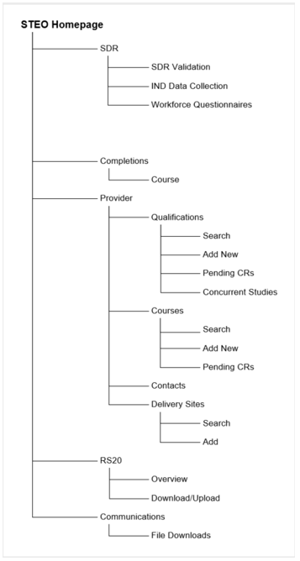

Glossary
This glossary may be helpful in defining some commonly encountered terms in this document:
Term | Description
EEL | Education Export Levy. The Export Education Levy (EEL) is collected from all TEOs that enrol international fee-paying students. The levy funds export education industry development, promotion, quality assurance and research. TEOs may recover the cost of the EEL through the tuition fee charged to international students.
EFTS | Equivalent Full Time Student. This is a rating indicating how much of a full-time course of study a particular course or paper is expected to require.
ESL | Education Sector Login. This is an education sector log on that permits access secure education sector related services such as the NSI, with a single sign-on.
IND | Indicative Single Data Return (SDR). A set of data files given to the Ministry of Education to give early indicators of demand shifts and trends that may impact vote management and tertiary education policy.
ISCED | International Standard Classification of Education. ISCED is a statistical framework for organising information on education developed and maintained by UNESCO.
MoE | Ministry of Education.
NSI | National Student Index. This is the New Zealand education sector's core database of student identity data and the way in which the National Student Number (NSN) is allocated to individual students.
NZQF Level | This refers to the qualification level on the NZ Qualification Framework of Quality Assured Qualifications.
NZSCED | New Zealand Standard Classification of Education. This is a subject-based classification system for courses and qualifications in New Zealand.
PBRF | Performance-Based Research Fund. It is a performance-based funding system to encourage and reward excellent research in New Zealand’s degree-granting organisations (apart from PTEs).
PTE | Private Training Establishment
SDR | Single Data Return. A set of data files that are specifically required by the Ministry of Education and the Tertiary Education Commission (TEC) for funding, monitoring performance against Investment Plans, publishing performance information, as well as statistical reporting and policy development purposes.
SDR Window | The time interval between 2 consecutive SDR data collection start dates. The SDR Year is divided into 3 SDR Rounds – April, August and December.
SDR Round | The time period within the SDR Window where providers should process SDR files. The processing consists of 2 stages – SDR Validation and SDR Submission. Outside of this time period (but within SDR Window), SDR Validation is allowed, but SDR Submission is not permitted unless granted by TEC.
SMS | A SMS (Student Management System) is a system which can process and store digital information relating to students’ personal and study details. SMS also supply data (such as the SDR files) that are required by the Government.
STEO | Services for Tertiary Education Organisations both a website and the name of a secure application where SDRs are securely submitted.
TEC | Tertiary Education Commission
TEI | Tertiary Education Institution
TEO | Tertiary Education Organisation
Workforce Questionnaire | An annual aggregated return of staff employed at TEOs.

Getting Started with STEO
The STEO secure website has some interactive elements that you may need to know about in order to use it better.

Recommended Internet Browser
The following browser is recommended for browsing STEO:
- Internet Explorer 11

Education Service Desk
Assistance with the processing of the SDR, is available from the Education Service Desk. Other matters relating to the scope and nature of the data collection, definitions, and interpretation of instructions should also be directed to the Ministry, via the Education Service Desk.
The contact details for the Education Service Desk are as follows:
Phone: 0800 422 599
Email: service.desk@education.govt.nz
Post: Education Service Desk
Ministry of Education
PO Box 1666
Wellington

Tertiary Education Commission Customer Contact Group
For matters relating to the setting of course EFTS, course register differences, qualification register, funding approvals and other funding issues contact the Tertiary Education Commission Customer Contact Group.
The contact details for the Tertiary Education Commission Customer Contact Group are as follows:
Phone: 0800 601 301 or +64 4 462 5201 (for international callers)
Email: CustomerService@tec.govt.nz
Post: The Tertiary Education Commission
Te Amorangi Matauranga Matua
PO Box 27048
Wellington 6141
New Zealand

Home Page Link
The text “Services for Tertiary Education Organisations” is a link to the home page of the STEO website, as shown bordered in blue in the figure below:
Figure 1 – Home Page Link
Clicking on it at any time will redirect you to the home page of STEO. You will still remain logged in until you log out.

Main Menu Navigation
The Main Menu groups the various pages in STEO into headings that are organised by function. You can navigate between the tabs and sub tabs by clicking on the desired heading at any level of the main menu:
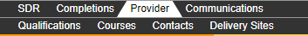
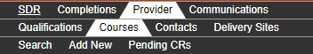
Figure 2 – Main Menu Navigation

Wildcard Searching
Some search fields you encounter in the STEO website allow wildcard searching. This means that it will perform a search that matches all or some of the search string you enter.
For example:
We are trying to search for a course which has a Course Title “Panel and Paint”.
In the Course Search page (see the Search Course section), we will enter “pain” into Course Title as shown below:
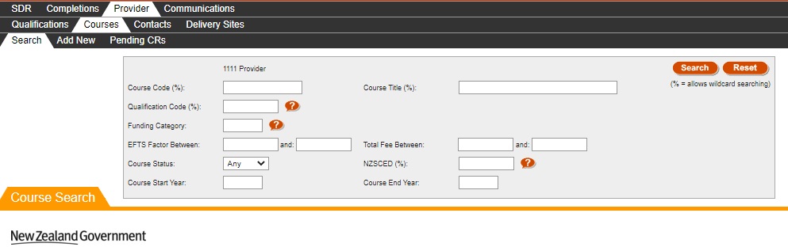
Figure 3 – Wild Card Search Example
This search yields two courses that have a Course Title with the letters “pain” in it, with the second course being the desired result.

Lookup Windows
Some input fields and search fields in STEO provide lookup functionality. This allows you to search for data that may be difficult to remember, such as Qualification Codes or NZSCED Codes. These are represented by the button, as shown below:
Figure 4 – Lookup Field
Once you click the button, a lookup window will be opened containing all the data that is relevant to the field. You can select one of these entries by clicking on it, which will close the window and automatically populate the field.
In this example, if you cannot remember the funding category, you can click the button next to the Funding Category field, which will open the corresponding lookup window:
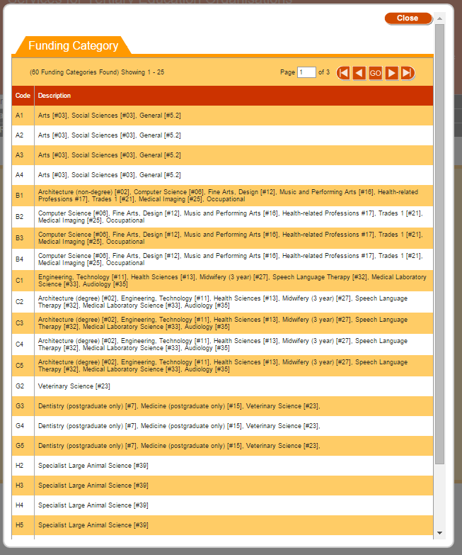
Figure 5 – Funding Category Lookup Window
If you click on one of the funding categories (for example A1 – Arts [#03], Social Sciences [#03], General [#5.2]), it will be populated into the Funding Category field, as shown below:
Figure 6 – Populated Lookup Field
Alternatively, you can click if you wish to close the lookup window. The field will not be overwritten if you do so.
You can open the lookup window more than once to change the value.

Sorting Search Results
When you perform a search, STEO will display the search results to you sorted in a default order. You can change this sort order by clicking on the column header you wish to sort by:
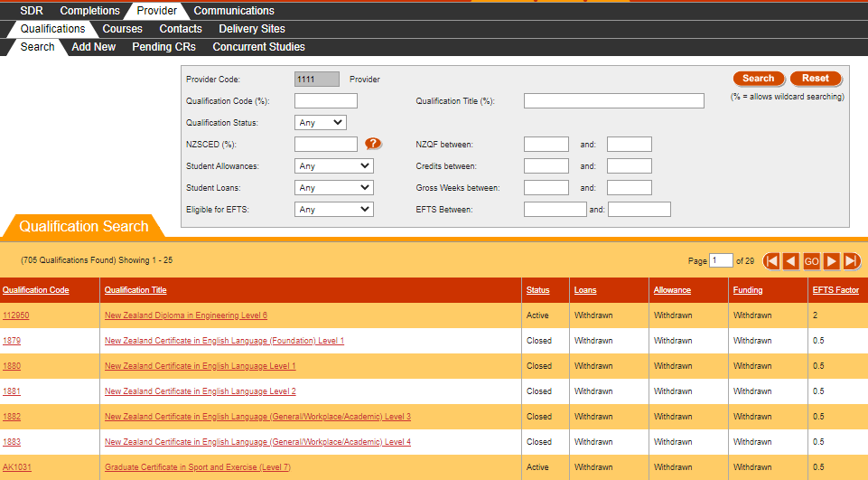
Figure 7 – Default Sorting of Search Results

In this example, when we click on the column header “Qualification Title”, the results resort themselves by Qualification Title in ascending order:
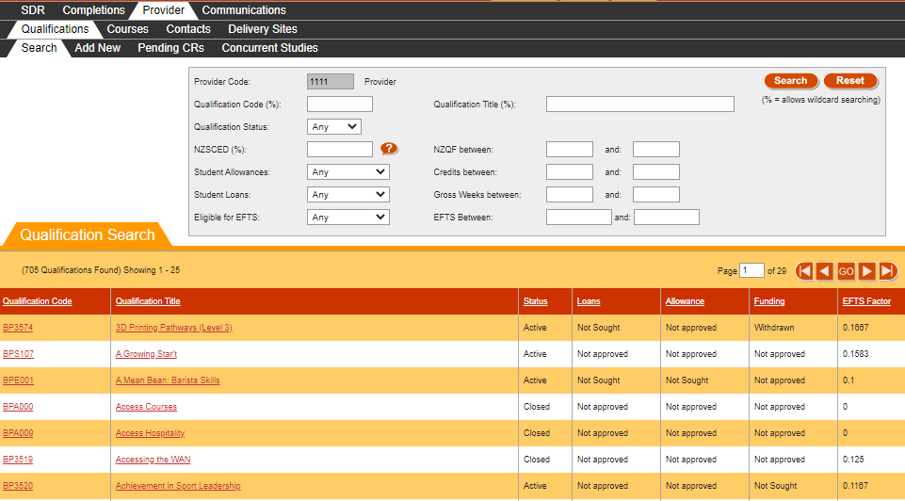
Figure 8 – Sorting of Search Results by Qualification Title
Clicking on Qualification Title again will resort the results by Qualification Title in descending order.

Navigating through Result Pages
Some pages in STEO, such as the lookup pages and the search result pages may contain more results than are shown in one page. In this situation, the bar will usually denote how many results are shown of the possible total:
Figure 9 – Result Page Example
The figure above indicates that there are 659 qualification results found, but only the first 25 results are currently shown.
In addition, there are 27 pages of results.
You can navigate through the pages by clicking on the navigation buttons, or entering a specific page number and clicking.
The navigation buttons perform the following actions:
Clicking will take you to the very first page of results.
Clicking will take you to the previous page of results.
Clicking will take you to the next page of results.
Clicking will take you to the very last page of results.

Mandatory Inputs
Some input fields in STEO are required to proceed with data entry or searching (these are called mandatory fields). This means that you will be unable to proceed with the action you’re attempting, e.g. creating a new qualification, without filling in all mandatory input fields.
Mandatory input fields are denoted by a red asterisk (*), as shown in the example below:
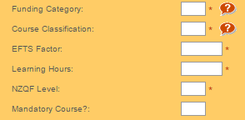
Figure 10 – Mandatory Fields Example
In the figure above, all the fields aside from Mandatory Course? are required and must be filled in.

Validation of Input
The STEO website will validate the values you enter in input fields as well as some search fields.
If there are any issues with the values that are being entered, these will be displayed on the screen in a red bordered box, as shown below:
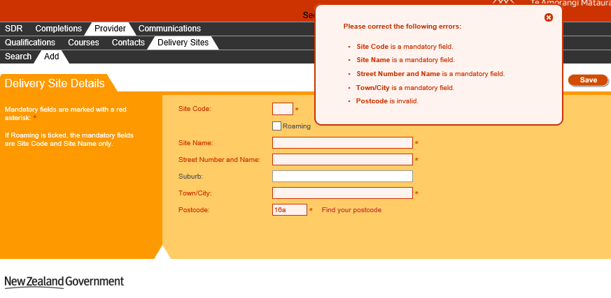
Figure 11 – Validation Error Box
This box will only appear if there are any issues after you click .
You can also hover your mouse over the erroneous field to view the error message as shown below:
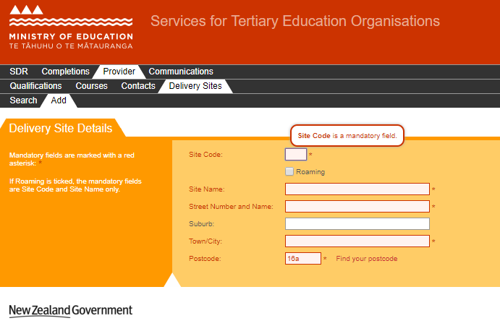
Figure 12 – Validation Error Message on Hover
When the validation error box appears, fields that have issues with the data entry will also be highlighted in red. You can edit these fields to rectify the issues. The errors will disappear from the validation error box (and the input fields) as these issues are rectified, as shown below:
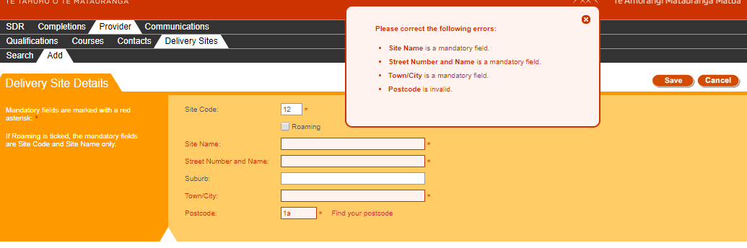
Figure 13 – Validation Error Box with Rectified Issues

Discarding Unsaved Changes
Some pages in STEO require you to input some data which is saved (like editing a course). Should you wish to abandon making any changes, you can navigate away from the page. However, the website will prompt you with a warning reminding you that there are unsaved changes, as shown below:
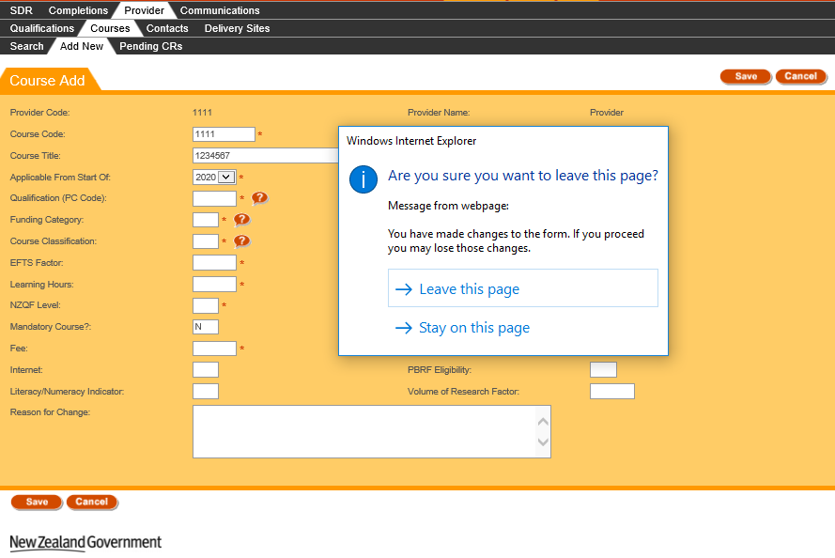
Figure 14 – Unsaved Changes Warning
This warning message may look different depending on the browser you are using.
Clicking “Leave this page” will discard the unsaved changes and navigate you away from the page.
If you click “Stay on this page”, you will remain on this page, and are free to continue editing the form.

Maximum File Size when Uploading
The maximum file size when uploading any file to STEO is 20 megabytes (MB). If you upload a file greater than 20MB, you will be shown the following page:
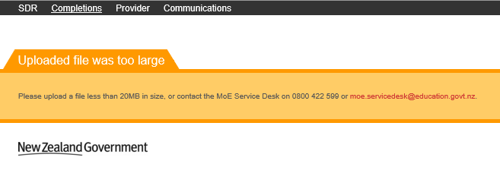
Figure 15 – Maximum File Size Exceeded Error Page
Please note that if you are uploading a .zip file where the contents are greater than 20MB, this is permitted as long as the uploaded .zip file is less than 20MB.

Logging in to STEO

Education Sector Logon (ESL)
STEO uses the Education Sector Logon (ESL) system for security and access. ESL is used by the Ministry of Education and other government Tertiary Education agencies to simply the log in service as a Single Sign On (SSO) service. You need to have an ESL User ID and Password, and be associated with a valid TEO to log in to STEO.

Log in to STEO
To log on using an ESL User ID and Password, go to https://steo.education.govt.nz/ and the following home page will be shown:
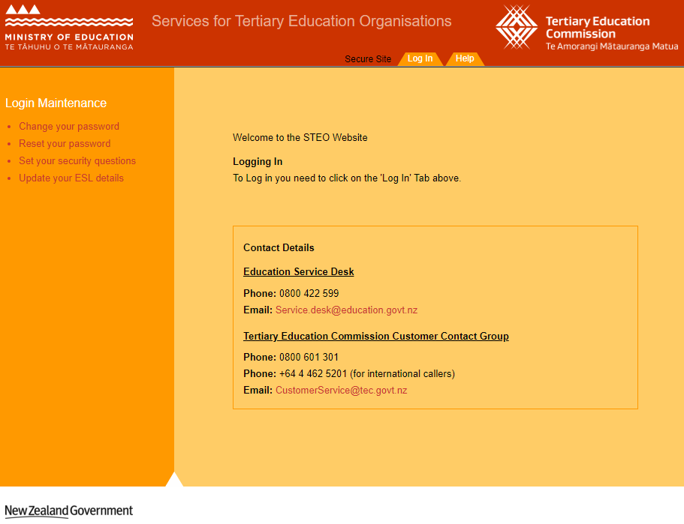
Figure 16 – STEO Unauthenticated User Home Page
This screen contains important and general information regarding the MoE and TEC Help Desk Contact details and the STEO website. If there are any important messages the MoE or TEC need to communicate out to TEOs, these will be posted on this page.
To continue to log in, click Log In.

When you click Log In, you will be brought to the Education Sector Logon (ESL) log in page.
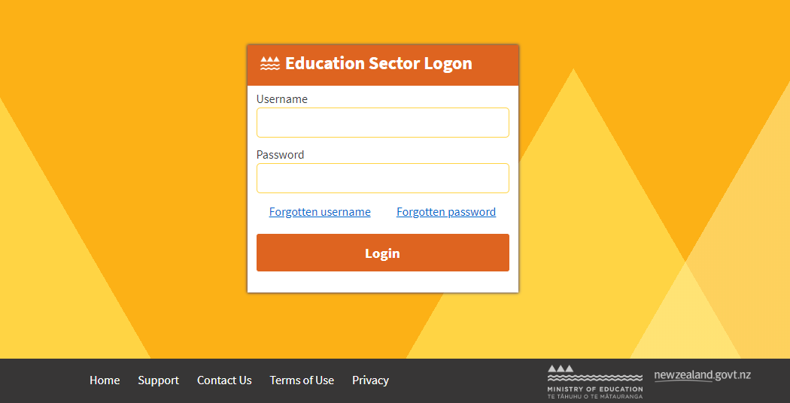
Figure 17 – ESL Log In Page
First enter your User ID here.
Then enter your Password here.
Then click Login button to log in and begin your validation process.

If you are associated with more than one organisation, you will be asked to select a context before proceeding to STEO website:
Figure 18 – ESL Context Page
Once authenticated you will be greeted by the following welcome screen:

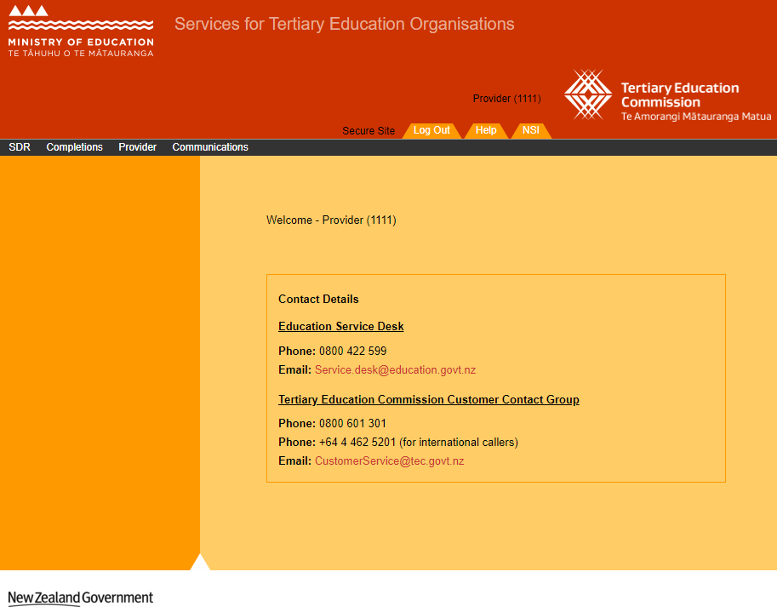
Figure 19 – STEO Authenticated User Home Page
You are now successfully logged in to the STEO website.

Issues with logging in
If your organisation has been listed as inactive in STEO, you will see an error message that is similar to that shown in the figure below:
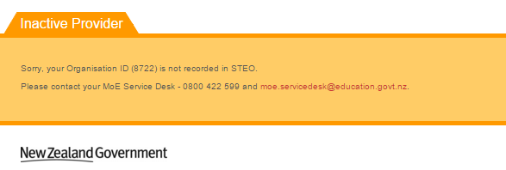
Figure 20 – Inactive Provider Error Message

Log out from STEO
Once you are logged in to STEO, there will be new links at the top of the page.

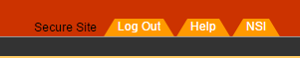
Figure 21 – Log Out, Help, and NSI Functionality
Clicking on Help will direct you to the ‘Services for Tertiary Education Organisations’ portal that is designed to provide further information and documentation.
Once you are logged on to STEO, you will be able to access the National Student Index (NSI) website without needing to log in through ESL again. You can access the NSI by clicking on the NSI link.
To log out from STEO, you can click the Log Out button at the top of the page. Once logged out, you will be directed back to the STEO Log In homepage (see Figure 16).

Provider Contacts
Provider contacts are used to define and nominate contacts that will be notified during various processes that you may perform in STEO (like SDR Validation). The Contacts tab contains all contacts affiliated with your organisation. You can use this tab to view and alter information relating to these contacts, and you can also add or delete contacts.
The Contacts tab allows you to access the following pages and associated functionalities:
- Contacts List
- View / Edit Contact Details
- Add Contact
- Delete Contact
You can navigate to this section by clicking on Provider, then Contacts in the main menu.
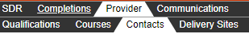
Figure 22 – Contacts Tab

Contacts List
The Contacts List page is the default page that you will land on when you navigate to the Contacts tab.
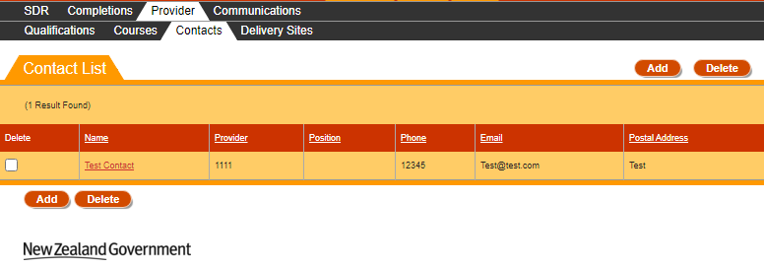
Figure 23 – Contacts List
You can sort the contacts list by clicking on the column header titles as previously described in the Sorting Search Results section.
If there is more than one page of contacts, you can browse through the other pages using the navigation buttons as described in Navigating through Result Pages.
You may navigate to a Contact by clicking on the Name of the contact, which will allow you to View / Edit Contact Details.
Clicking will allow you to add a contact, as described in the Add Contact section.
If you select one or more contacts using the checkboxes in the Delete column and click , it will allow you to delete contacts, as described in the Delete Contact section.
Please note that if you have an EDUMIS contact, you will be unable to select that contact for deletion.

View / Edit Contact Details
The Contact Details page contains more information for a given contact. You can access the Contact Details page by clicking on a contact’s Name from the Contacts List page, as shown below:
Figure 24 – Accessing Contact Details

The following page will be shown when you access Contact Details:
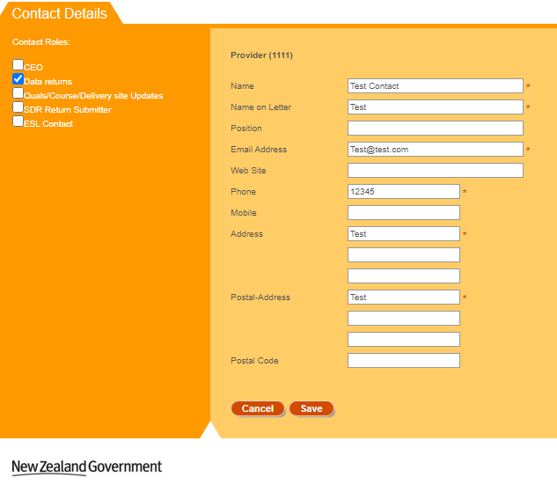
Figure 25 – Contact Details Page
The Roles assigned to this Contact are shown in the left pane with the checkboxes ticked.
If the Contact has the CEO Contact Role then additional fields will be displayed, as shown below:
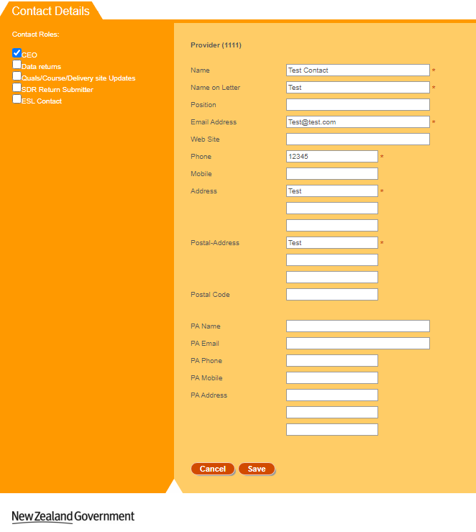
Figure 26 – CEO Contact Details Page
You can enter values as needed into the editable fields. Mandatory (required) fields are denoted by the asterisks (*), as described in the Mandatory Inputs section.
You can also assign and un-assign contact roles to the contact by checking or unchecking the Contact Roles checkboxes.
Please note that if you are viewing an EDUMIS contact, you will be unable to edit any field on the page.
You can abandon updating the contact details at any time by clicking the button. A warning message will be shown if you have unsaved changes as described in the Discarding Unsaved Changes section. Clicking will return you to the Contacts List page.
When you are finished with updating the contact details, you can click the button. If there are any errors with data entered into the fields, you will be able to view and rectify the error as described in the Validation of Input section.
You may refer to Provider Contact Fields and Descriptions for a more detailed explanation on what values are expected for each field.
Upon successfully updating the contact details, you will remain on the same page and you will be shown the following confirmation message:
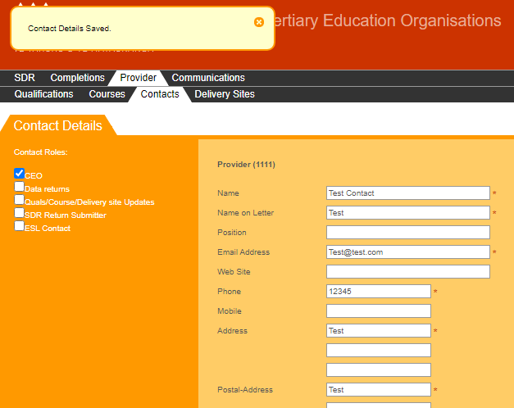
Figure 27 – Save Contact Confirmation
If you’ve checked the CEO contact role, the additional fields shown in Figure 26 will be visible after you’ve successfully updated the contact.

Add Contact
The Add Contact page allows you to add a new contact to your list of Contacts in STEO. You can access the Add Contact page by clicking on the button from the Contacts List page.
The following page is shown when you navigate to the Add Contact page:
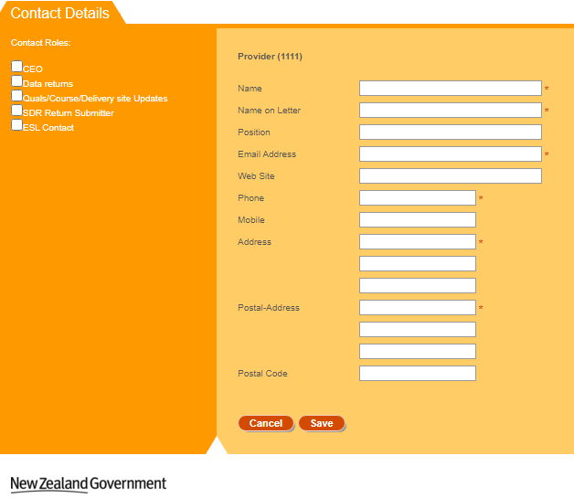
Figure 28 – Add Contact Page
All fields will be left blank, and all Contact Role checkboxes will be left unticked.
You can enter values as needed into the editable fields. Mandatory (required) fields are denoted by the asterisks (*), as described in the Mandatory Inputs section.
You can also assign and un-assign contact roles to the contact by checking or unchecking the Contact Roles checkboxes.
You can abandon updating the contact details at any time by clicking the button. A warning message will be shown if you have unsaved changes as described in the Discarding Unsaved Changes section. Clicking will return you to the Contacts List page.
When you are finished with adding the new contact details, you can click the button. If there are any errors with data entry into the fields, you will be able to view and rectify the error as described in the Validation of Input section.
You may refer to Provider Contact Fields and Descriptions for a more detailed explanation on what values are expected for each field.
Upon successfully adding the contact, you will remain on the same page, and you will be shown the following confirmation message:
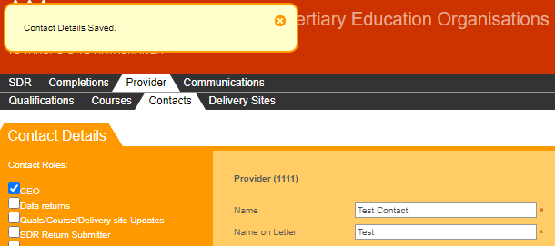
Figure 29 – Add Contact Confirmation
If you’ve checked the CEO contact role, the additional fields shown in Figure 26 will be visible after you’ve successfully added the contact.

Delete Contact
The Delete Contact page is a confirmation page that you will see when you attempt to delete one or more contacts. You can access the Delete Contact confirmation dialog by selecting at least one contact using the Delete column, and clicking from the Contacts List page, as shown below:
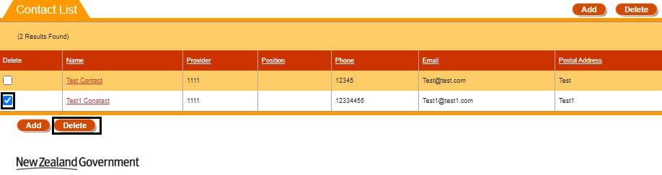
Figure 30 – Accessing Delete Contact
The following confirmation dialog box is shown when you attempt to delete a contact:
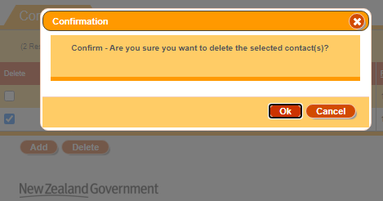
Figure 31 – Delete Contact Page
Clicking will return you to the Contacts List page and will untick any previously selected delete checkbox(es) without deleting the contact(s).
Clicking will proceed with deleting the contact(s). After the contact(s) have been deleted, you will return to the updated Contacts List page (the contact(s) you deleted will not show up). You will also be shown the following confirmation message:
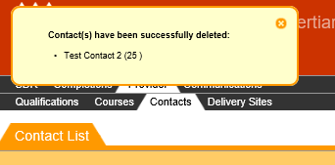
Figure 32 – Delete Contact Confirmation

Provider Contact Fields and Descriptions
When you are filling in the forms to add or edit provider contacts you will encounter the following fields. This table may assist in providing some guidance as to how to fill in the fields correctly to avoid erroneous entries.
Field | Value
Contact Roles  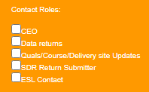 | Select at least one contact role for the contact.  The following active contact roles are available for selection:  - CEO – The Chief Executive Officer for the organisation  - Data returns – This is the preferred contact for SDR Submission emails  - Quals/Course/Delivery site Updates – This is the contact role that TEC will correspond with for any Course changes  - SDR Return Submitter – This is the contact who submits the SDR files  - ESL Contact - This is the contact who can sign off the ESL request form for the organisation
Name | Enter the name of the contact.  This is a mandatory field, which accepts a maximum of 50 characters.
Name on Letter | Enter the name of the contact that should appear on any official letters.  This is a mandatory field, which accepts a maximum of 50 characters.
Position | Enter the position of the contact within your organisation.  This is not a mandatory field, and accepts a maximum of 50 characters.
Email Address | Enter the email address that the contact can be reached by.  This is a mandatory field, which accepts a maximum of 50 characters, and it should be in an email format
Web Site | Enter the web site for the contact.  This is not a mandatory field and accepts a maximum of 105 characters. It should also be in a typical web site link format.
Phone | Enter the phone number of the contact  This is a mandatory field and accepts a maximum of 30 characters.
Mobile | Enter the mobile number of the contact  This is not a mandatory field and accepts a maximum of 30 characters.
Address | Enter the address of the contact  This is a mandatory field.  There are three separate field lines, each field line accepts a maximum of 100 characters.
Postal Address | Enter the postal address of the contact  This is a mandatory field.  There are three separate field lines, each field line accepts a maximum of 100 characters.
Postal Code | Enter the postal code for the contact  This is not a mandatory field, which accepts up to 4 digits.
PA Name | Enter the name of the CEO’s personal assistant.  This is not a mandatory field. This field accepts a maximum of 100 characters.  This field is only visible if the CEO Contact Role checkbox is ticked.
PA Email | Enter the email address of the CEO’s personal assistant.  This is not a mandatory field. This field accepts a maximum of 50 characters.  This field is only visible if the CEO Contact Role checkbox is ticked.
PA Phone | Enter the phone number of the CEO’s personal assistant.  This is not a mandatory field. This field accepts a maximum of 20 characters.  This field is only visible if the CEO Contact Role checkbox is ticked.
PA Mobile | Enter the mobile number of the CEO’s personal assistant  This is not a mandatory field. This field accepts a maximum of 20 characters.  This field is only visible if the CEO Contact Role checkbox is ticked.

Delivery Sites
Delivery sites are locations or campuses where the majority of the teaching, instruction or learning occurs for a course or module of a formal programme. The campus or site must be a recognised centre of learning by the provider that is geographically separate from other sites or campuses. The Delivery Site is used by the Ministry of Education for tertiary sector reporting and policy purposes.
The Delivery Sites tab contains all delivery sites affiliated with your organisation. You can use this tab to view and alter information relating to these delivery sites, and you can also add delivery sites.
The Delivery Sites tab allows you to access the following pages and associated functionalities:
- Delivery Site Search
- View / Edit / Delete Delivery Site Details
- Add Delivery Site
You can navigate to this section by clicking on Provider, then Delivery Sites in the main menu.
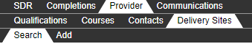
Figure 33 – Delivery Sites Tab

Delivery Site Search
The Delivery Site Search page is the default page that you will land on when you navigate to the Delivery Sites tab. You can also access it by clicking on the Search tab under Delivery Sites.
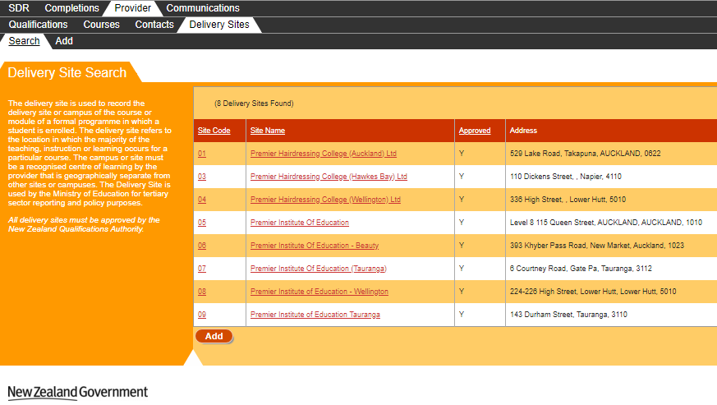
Figure 34 – Delivery Site Search Page
All Delivery Sites affiliated with your organisation will be shown here, limited to 25 Delivery Sites per page.
You can sort the delivery sites list by clicking on the column header titles as previously described in the Sorting Search Results section.
If there is more than one page of delivery sites, you can browse through the other pages using the navigation buttons as described in Navigating through Result Pages.
You may navigate to a Delivery Site by clicking on the Site Code or Site Name of the delivery site, which will allow you to View / Edit / Delete Delivery Site Details.
Clicking will allow you to add a delivery site, as described in the Add Delivery Site section.

View / Edit / Delete Delivery Site Details
The Delivery Site Details page contains more information for a given delivery site which you can edit. You can access the Delivery Sites Details page by clicking on a delivery site’s Site Code or Site Name from the Delivery Site Search page as shown below:
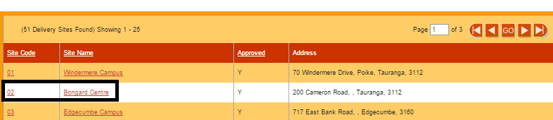
Figure 35 – Accessing Delivery Site Details
The following page will be shown when you access Delivery Site Details:
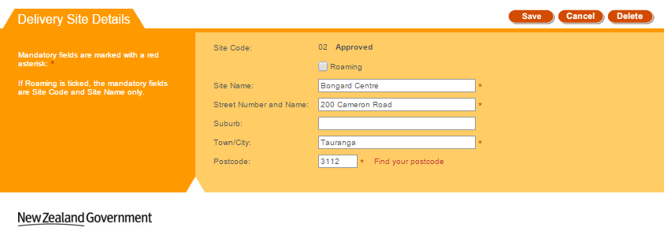
Figure 36 – View / Edit Delivery Site Details
Clicking on the “Find your postcode” link will take you to NZ Post’s Post Code Finder Tool (https://www.nzpost.co.nz/tools/address-postcode-finder) where you can find the correct postcode. Please note that this is a view-only website, and you will still have to manually enter the postcode into the Delivery Site Details page after you located the required postcode on the NZ Post website.
You can enter values as needed into the editable fields. Mandatory (required) fields are denoted by the asterisks (*), as described in the Mandatory Inputs section. If you tick the Roaming checkbox field, only Site Name will be mandatory, as shown below:
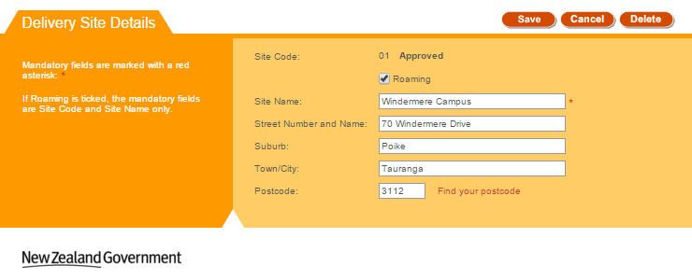
Figure 37 – Roaming Checked on View / Edit Delivery Sites
You can abandon updating the delivery site details at any time by clicking the button. A warning message will be shown if you have unsaved changes as described in the Discarding Unsaved Changes section. Clicking will return you to the Delivery Site Search page.
When you are finished with updating the delivery site details, you can click the button. If there are any errors with data entered into the fields, you will be able to view and rectify the error as described in the Validation of Input section.
You may refer to Delivery Site Fields and Descriptions for a more detailed explanation on what values are expected for each field. Additionally, if you encounter further issues, the section Error Messages in Delivery Sites explains commonly encountered problems.
Upon successfully updating the delivery site details, you will be returned to the Delivery Site Search page, with the following confirmation message shown:
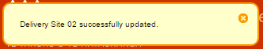
Figure 38 – Delivery Site Save Confirmation
You can also delete the delivery site by clicking the button, and confirming on the warning message. This will prompt you to confirm deletion as shown below:
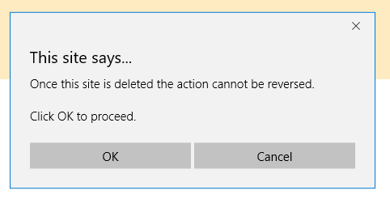
Figure 39 – Delivery Site Delete Confirmation Prompt
Upon successfully deleting the delivery site, you will be returned to the Delivery Site Search page with the following confirmation message shown:
Figure 40 – Delivery Site Delete Confirmation

Add Delivery Site
You can add a new delivery site using the Add Delivery Site page. You can access the Add Delivery Sites page by clicking on the button from the Delivery Site Search page, or clicking on the “Add” tab in the main menu as shown below:
Figure 41 – Accessing Add Delivery Site using Main Menu
The following page will be shown when you access the Add Delivery Site page:
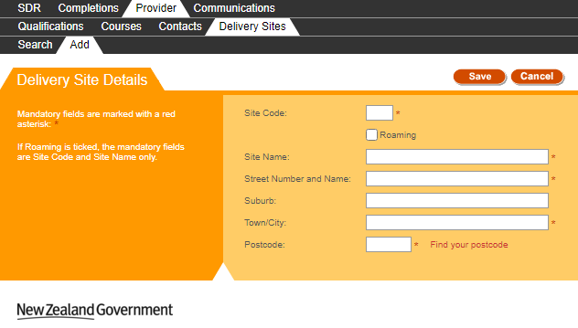
Figure 42 – Add Delivery Site
Clicking on the “Find your postcode” link will take you to NZ Post’s Post Code Finder Tool (https://www.nzpost.co.nz/tools/address-postcode-finder) where you can find the correct postcode. Please note that this is a view-only website, and you will still have to manually enter the postcode into the Add Delivery Site page.
You can enter values as needed into the editable fields. Mandatory (required) fields are denoted by the asterisks (*), as described in the Mandatory Inputs section. If you tick the Roaming checkbox field, only Site Code and Site Name will be mandatory, as shown below:
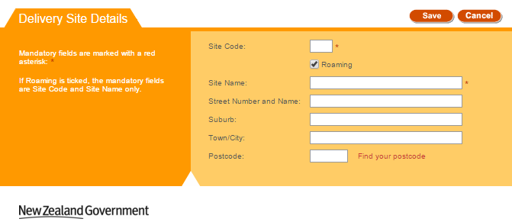
Figure 43 – Roaming Checked on Add Delivery Site

You can abandon adding the delivery site at any time by clicking the button. A warning message will be shown if you have unsaved changes as described in the Discarding Unsaved Changes section. Clicking will return you to the Delivery Site Search page.
When you are finished with entering the new delivery site details, you can click the button. If there are any errors with data entered into the fields, you will be able to view and rectify the error as described in the Validation of Input section.
You may refer to Delivery Site Fields and Descriptions for a more detailed explanation on what values are expected for each field. Additionally, if you encounter further issues, the section Error Messages in Delivery Sites explains commonly encountered problems.
You will also be shown the following confirmation message:
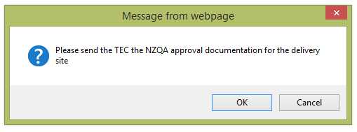
Figure 44 – Delivery Site Add Confirmation Prompt
Upon successfully adding the delivery site, you will be returned to the Delivery Site Search page, with the following confirmation message shown:
Figure 45 – Delivery Site Add Confirmation

Delivery Site Fields and Descriptions
When you are filling in the forms to add or edit delivery sites you will encounter the following fields. This table may assist in providing some guidance as to how to fill in the fields correctly to avoid erroneous entries.
Field | Value
Site Code | Enter in a unique Site Code.  The site code needs to be two-digit code between 01-99 in accordance with the CRS_SITE field in the SDR manual.  This field has a maximum of 2 numeric characters.
Site Name | Enter in the name of the delivery site.  This field accepts has a maximum of 200 characters
Street Number | Enter in the Physical Address of the delivery site.  This field accepts a maximum of 50 alpha-numeric characters.
Suburb | Enter in the suburb the delivery site is located in.  Please not this is not a mandatory field, and has a maximum of 25 alpha characters.
Town/City | Enter the Town/City the delivery site is located in.  This field has a maximum of 25 alpha characters.
Postcode | This is the postcode of the delivery site.  Valid post codes should be used. The field has a maximum of 4 numeric characters.  A link for users to find their post code (Find your post code) is provided, which redirects users to an external page located at https://www.nzpost.co.nz/tools/address-postcode-finder. This does not result in any data being transmitted back to the original page.
Roaming | Tick this field if the delivery site is a roaming site.  If Roaming is ticked, the mandatory fields are Site Code and Site Name only.

Error Messages in Delivery Sites
Most errors can be avoided by following the guidelines outlined in Delivery Site Fields and Descriptions. However, in some cases you may encounter additional error messages:
Error Message | Description
Enrolments exist for this combination of Provider Code and Location Code (<Provider Code>, <Delivery Site Code>). Deletion is not possible.  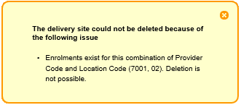 | The SDR Submission process creates enrolment records for courses being taught at delivery sites.  You will not be able to delete the delivery site if any students were ever enrolled in courses that are taught at the delivery site you are attempting to delete.  You must first ensure that there was/is no study enrolments at the delivery site before you proceed with deletion.
Site Code already exists for provider  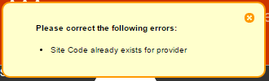 | The Site Code must be unique before you can create it. You may not create a Delivery Site that shares a duplicated Site Code.  Please use a different Site Code if you are trying to add a new Delivery Site, or edit the existing Delivery Site instead.

Qualifications
The Qualifications tab and underlying functionality gives you access to your organisation’s offered qualifications (current and prior qualifications), including any change requests (to add/update the qualifications) that have been lodged against these qualifications. You can use this tab to view and alter the qualification details and their lodged change requests. This tab also allows you to search for and edit concurrent qualifications.
Some fields in this section may also be used to provide data for the Key Information Set (KIS) for this qualification published to support students' enrolment decisions. See here for more information about the Key Information Set.
KIS data is provided by the TEC data service for all active TEC funded qualifications. The KIS data for each qualification is published on the TEO website and also on the TEC website. Use the close process to ensure a KIS is not published for any qualifications no longer delivered.
The Qualifications tab allows you to access the following pages and functions:
- Search Qualifications
- View Qualification Details
- View Courses under Qualification
- Edit Qualification
- Close Qualification
- Add New Qualification
- Search Qualification CRs
- View / Edit Qualification CR
- Search Concurrent Qualification
- View / Edit Concurrent Qualification
- Add New Concurrent Qualification
You can navigate to this section by clicking on Provider, then Qualifications in the main menu.
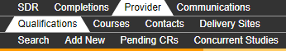
Figure 46 – Qualifications Tab

Search Qualifications
The Qualifications Search page allows you to search for qualifications that your organisation offers (both Active and Closed) as defined in the Qualifications Register. You can access it by clicking on the Search tab under Qualifications.
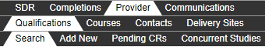
Figure 47 – Accessing Search Qualifications
The following page is shown when you navigate to the Search Qualifications tab:
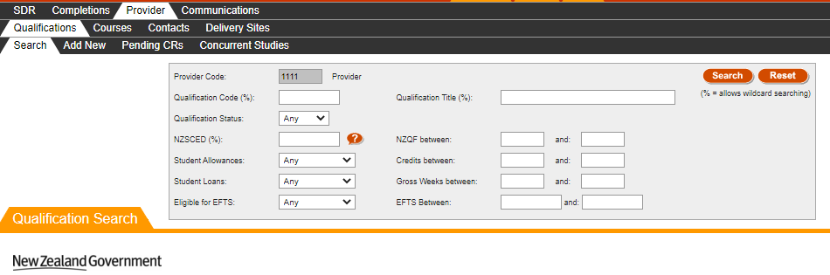
Figure 48 – Qualifications Search Page
Your organisation name and provider code will be shown in the Provider Code field (the example in Figure 48 uses “1111 Provider”).
The Qualifications Search page is blank the first time it is accessed when logging in. After that, it will retain the search results of the last performed search when you return to the page.
You can search for all existing qualifications against your organisation by optionally entering search criteria into any of the fields shown in the search box and clicking . The Qualification Code, Qualification Title, and NZSCED fields will allow for wildcard searching which match partial characters entered into the field (these fields are denoted by the % sign) as described in the Wildcard Searching section. The NZSCED field also allows you to look up existing entries by clicking on the button. This will direct you to the relevant lookup as described in the Lookup Windows section.
If there are any errors with data entry into the search fields, you will be able to view the error as described in the Validation of Input section.
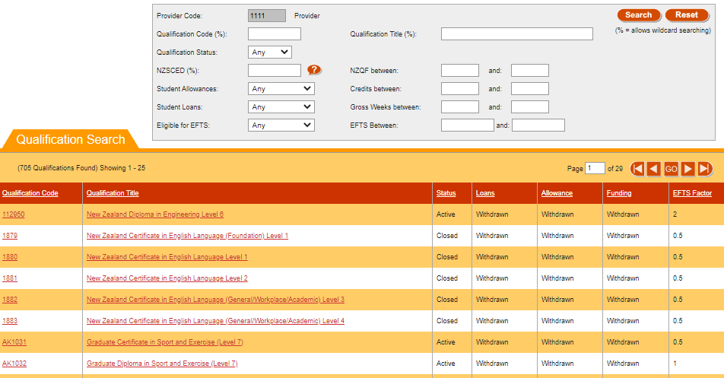
Figure 49 – Qualifications Search Results Page
The search results based on the criteria entered will be shown as per Figure 49, with 25 qualifications shown per page.
You can sort the results by clicking on the column header titles as previously described in the Sorting Search Results section.
If there is more than one page of qualifications, you can browse through the other pages using the navigation buttons as described in Navigating through Result Pages.
You may View Qualification Details of a Qualification by clicking on the Qualification Code or the Qualification Title.
Clicking will clear the search results page and return the search fields back to their defaults so you can start a fresh search, as shown in Figure 48.

View Qualification Details
The Qualification Details page contains information related to a given qualification. You can access the Qualification Details page by clicking on a qualification’s Qualification Code or Qualification Title from the Search Qualifications page, as shown in the figures below:
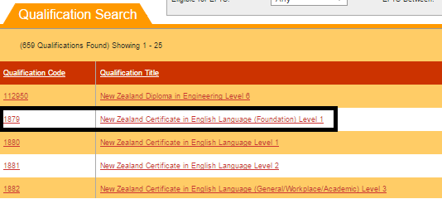
Figure 50 – Accessing Qualification Details from Qualification Search

When you access the Qualification Details page, the following page will be shown:
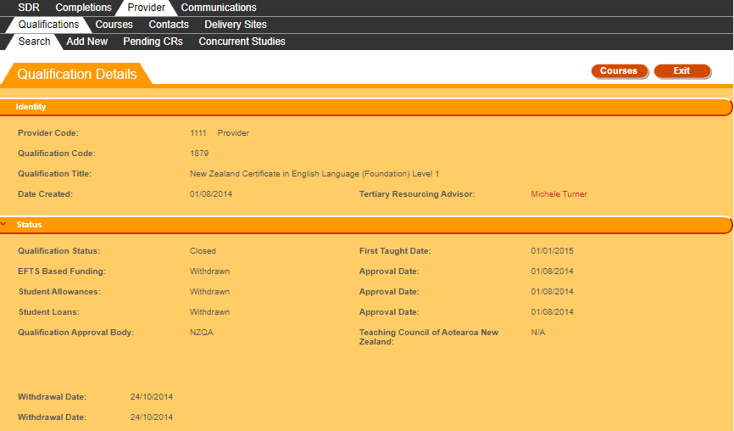
Figure 51 - View Qualification Details

You can collapse or expand some of the sections on this page by clicking on the headers (e.g. Status, or Duration). However, the Identity section will always be expanded. The expandable and collapsible
will have chevrons or next to the header title as shown below:
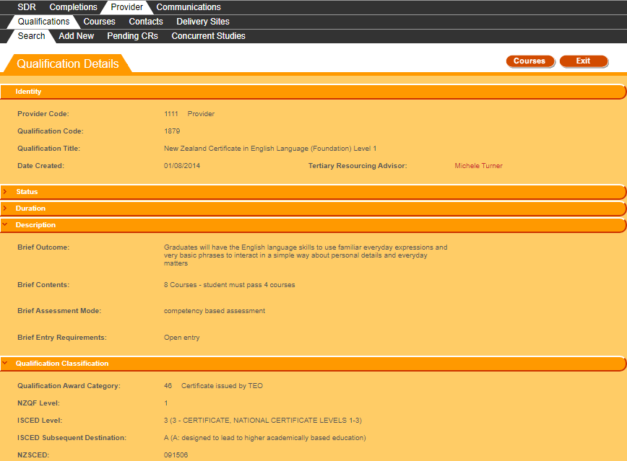
Figure 52 – View Qualification Details with collapsed sections
Clicking on the name of the Tertiary Resourcing Advisor will open your email client application with a new email addressed to the email of the contact.
Some buttons are conditionally visible, as shown in Figure 54.
The button is shown if the Qualification Status is Active and the EFTS Based Funding, Student Allowances and Student Loans are not currently Approved. Clicking on it will allow you to close the qualification, as described in Close Qualification.
The button is shown when the Qualification Status is Active, and there are no pending qualification change requests lodged against the qualification. Clicking on it will allow you to Edit Qualification. Please note that if an existing Qualification does not have the First Taught Date defined, you will see the following error message:
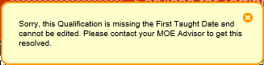
Figure 53 – First Taught Date Missing Qualification Error Message
Clicking on will take you to the View Courses under Qualification page.
Clicking on will return you to the Search Qualifications page.
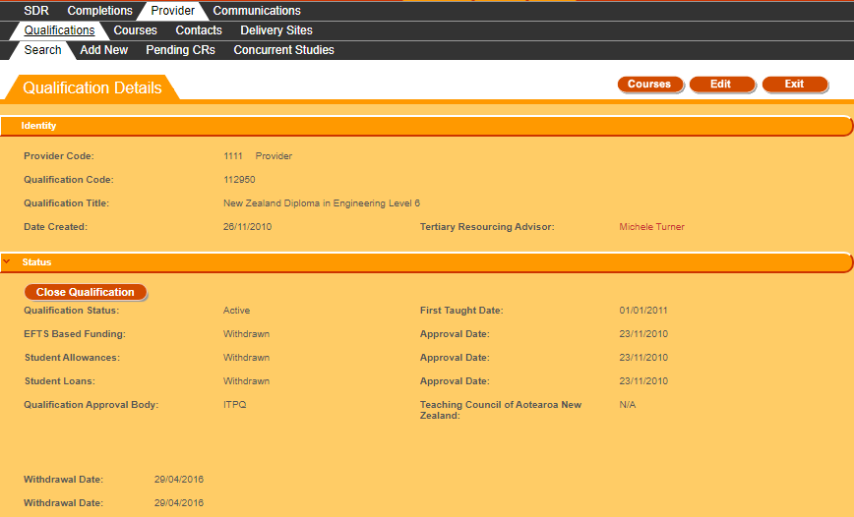
Figure 54 – Close Qualification and Edit Buttons on Qualification Details page

View Courses under Qualification
The View Courses under Qualification page contains all the latest courses (both Active and Inactive) that are associated with a particular qualification. It can be accessed by clicking from the View Qualification Details or the Edit Qualification pages, as shown below:
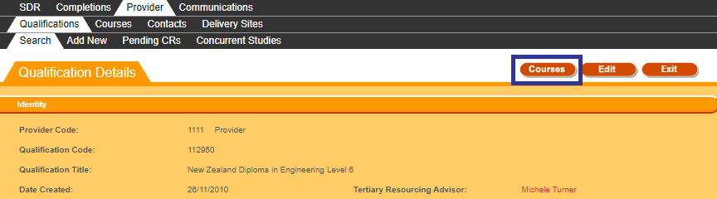
Figure 55 – Accessing Courses under Qualification
It is possible that there may be no courses associated with the qualification. In this scenario, you will be shown the following message when you click on :
Figure 56 – No Courses under Qualification found notification
Otherwise, if there are courses associated with the qualification, the following page will be opened in a new tab or window in your internet browser:
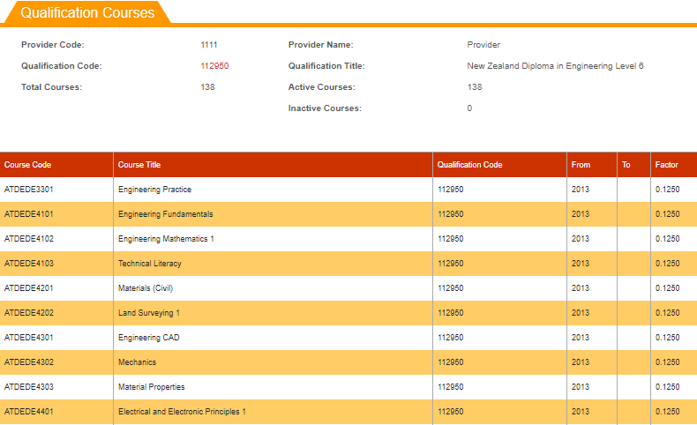
Figure 57 – Courses under Qualification
Only the most recent course instances will be shown in this page (if there are multiple courses with the same Course Code, only the most recent one is shown). The Courses will be shown sorted by Course Code in ascending order.
Please note that Inactive Courses are shown in grey text, whereas Active Courses are shown with black text.
Should you wish to return to View Qualification Details or Edit Qualification, you can close this tab.

Edit Qualification
The Edit Qualification page, allows you to edit the details of an existing active qualification. You can access it by clicking the button from the View Qualification Details page:
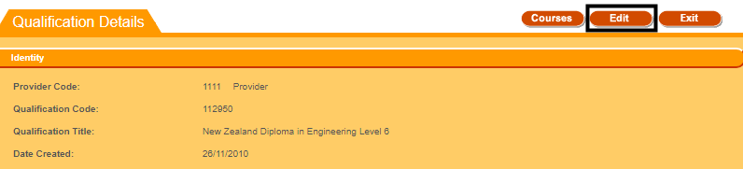
Figure 58 – Accessing Edit Qualification
Please note that if the Qualification has a pending Change Request, the button will not be shown, and instead a button will be shown, as described in View / Edit Qualification CR.
The following page will be shown when you access the Edit Qualification page:
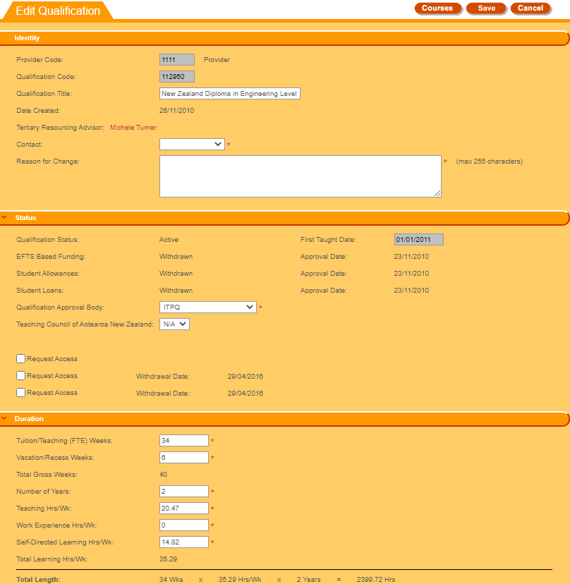
Figure 59 – Edit Qualification Page
The following sections will be visible for you to edit:
- Identity
- Status
- Duration
- Description
- Qualification Classification
Please note that the First Taught Date and Qualification Code fields are disabled when editing a local qualification, the Qualification Title field is also disabled when editing a national qualification.
Clicking on the name of the Tertiary Resourcing Advisor will open your email client with a new email addressed to the email of the contact.
You can enter values as needed into the editable fields. Mandatory (required) fields are denoted by the asterisks (*), as described in the Mandatory Inputs section.
The Qualification Award Category, NZSCED, Source of Funding, and Certifying Authority fields allow you to look up existing entries by clicking on the button. This is described in further detail in the Lookup Windows section.
You can abandon updating the qualification details at any time by clicking the button. A warning message will be shown if you have unsaved changes as described in the Discarding Unsaved Changes section. Clicking will return you to the View Qualification Details page.
When you are finished with updating the qualification details, you can click the button. If there are any errors with data entry into the fields, you will be able to view and rectify the error as described in the Validation of Input section.
You may refer to Qualification Fields and Descriptions for a more detailed explanation on what values are expected for each field. Additionally, if you encounter further issues, the section Error Messages in Qualifications explains commonly encountered problems.
Upon successfully updating the qualification details, a new qualification change request will be created and you will be taken to the View / Edit Qualification CR page, with the following confirmation message shown:
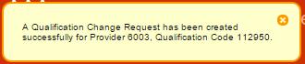
Figure 60 – Edit Qualification Confirmation Message
Alternatively, if you only make changes to fields that will be automatically approved, a Qualification Change Request that is automatically approved will be created. These fields are:
- Brief Outcome
- Brief Contents
- Brief Assessment Mode
- Brief Entry Requirements
- Certifying Authority
No further review and approval needs to be performed by the Agency. You will be shown the following message and remain on the same Edit Qualification page:
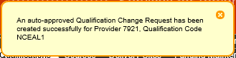
Figure 61 – Edit Qualification Confirmation Message for Auto Approved Fields
You may continue to edit the qualification should you wish to do so.

Close Qualification
The Close Qualification function allows you to close a qualification. To do so, the qualification must have a Qualification Status of Active, and the EFTS Based Funding, Student Allowance and Student Loans must not be Approved (either Withdrawn, Not Approved, or Not Sought). In addition, there must be no pending Qualification Change Requests lodged against the Qualification. If these conditions are met, the button will be visible.
You can close the qualification by clicking the button on the View Qualification Details page, as shown below:
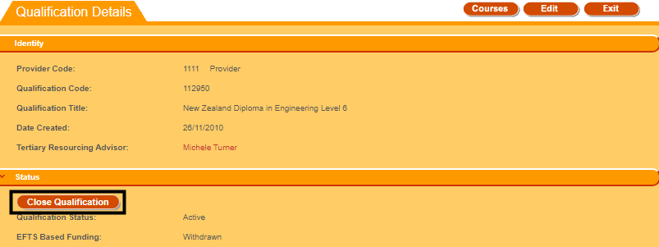
Figure 62 – Accessing Close Qualification
You will be shown a warning message asking you to confirm:
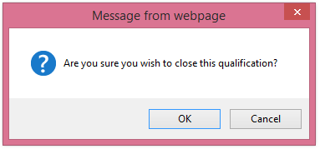
Figure 63 – Close Qualification Confirmation Prompt
If you proceed with closing the qualification, you will remain on the View Qualification Details page and the following confirmation message will be shown:
Figure 64 – Close Qualification Confirmation Message

Add New Qualification
The Add New Qualification page allows you to add new qualifications. You can access it by clicking Add New from the Qualifications tab under Provider:
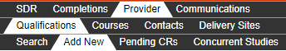
Figure 65 – Accessing Add New Qualification
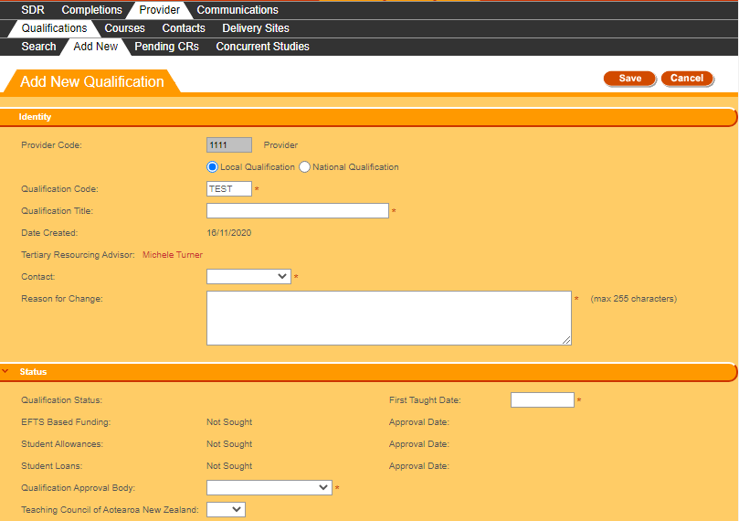
Figure 66 – Add New Qualification Page
The following sections will be visible:
- Identity
- Status
- Duration
- Description
- Qualification Classification
Please note that the Qualification Code may be partially pre-populated if the code prefix is recorded for your organisation by MoE or TEC.
Clicking on the name of the Tertiary Resourcing Advisor will open your email client with a new email addressed to the email of the contact.
You can enter values as needed into the editable fields. Mandatory (required) fields are denoted by the asterisks (*), as described in the Mandatory Inputs section.
The Qualification Award Category, NZSCED, Source of Funding, and Certifying Authority fields allow you to look up existing entries by clicking on the button. This is described in further detail in the Lookup Windows section.
You can abandon updating the qualification details at any time by clicking the button. A warning message will be shown if you have unsaved changes as described in the Discarding Unsaved Changes section. Clicking will return you to the View Qualification Details page.
When you are finished with updating the qualification details, you can click the button. If there are any errors with data entry into the fields, you will be able to view and rectify the error as described in the Validation of Input section.
You may refer to Qualification Fields and Descriptions for a more detailed explanation on what values are expected for each field. Additionally, if you encounter further issues, the section Error Messages in Qualifications explains commonly encountered problems.
If there are no data entry errors, you will be shown the following notification message:
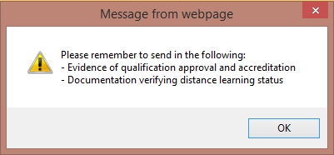
Figure 67 – Notification Message when Adding New Qualification
Upon successfully updating the qualification details, a new qualification change request will be created and you will be taken to the View / Edit Qualification CR page, with the following confirmation message shown:
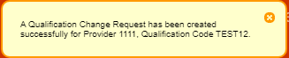
Figure 68 – Add New Qualification Confirmation Message

Pending Qualification CRs (Change Requests)
Qualification CRs (Change Requests) are created whenever you create a new qualification or modify an existing qualification. Pending change requests have to be reviewed and approved by TEC Advisors.
The Pending Qualification CRs tab allows you to search for Qualification CRs, and view or edit Qualification CRs. You can access it by clicking on Pending CRs under Qualifications as shown below:

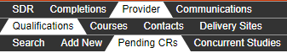
Figure 69 – Accessing Pending Qualification CRs

Search Qualification CRs
The Qualification Change Request Search page is the default page shown when you navigate to the Pending CRs tab.
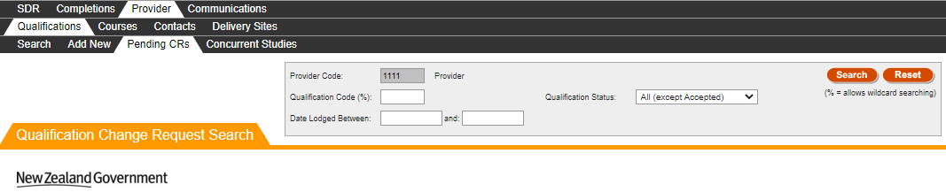
Figure 70 – Qualification CR Search
Your organisation name and provider code will be shown in the Provider Code field (the example in Figure 70 uses “1111 Provider”).
The Qualification Change Request Search page is blank the first time it is accessed when logging in. After that, it will retain the search results of the last performed search when you return to the page.
You can search for all recorded qualification change requests (whether pending or finalised) against your organisation by optionally entering search criteria into any of the fields shown in the search box and clicking . The Qualification Code field will allow for wildcard searching which match partial characters entered into the field (these fields are denoted by the % sign) as described in Wildcard Searching section.
If there are any errors with data entry into the search fields, you will be able to view the error as described in the Validation of Input section.

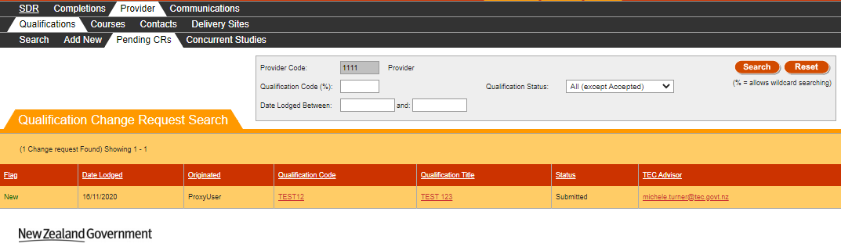
Figure 71 – Qualification CR Search Results
Clicking will clear the search results page and return the search fields back to their defaults so you can start a fresh search.

View / Edit Qualification CR
The Qualification Change Request View or Edit page contains the details of a particular qualification CR. You can access this page by clicking on the Qualification Code or Qualification Title in Search Qualification CRs page, or by clicking on the button for a Qualification that has a Pending Change Request in the View Qualification Details page.
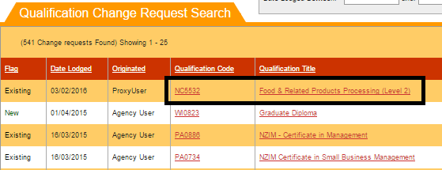
Figure 72 – Accessing View / Edit Qualification CR from Search Qualification CRs
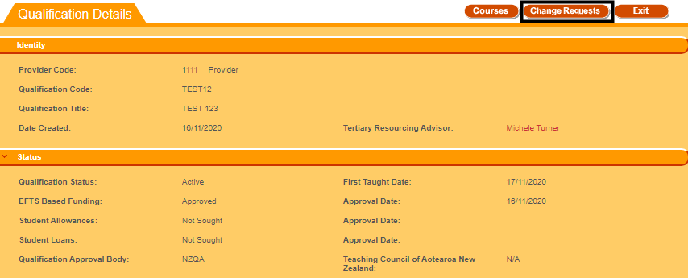
Figure 73 – Accessing View / Edit Qualification CR from View Qualification Details
If the Qualification CR you’re accessing has a status of “Submitted” or “Provider Action Required”, you will be directed to the Qualification Change Request Edit page.
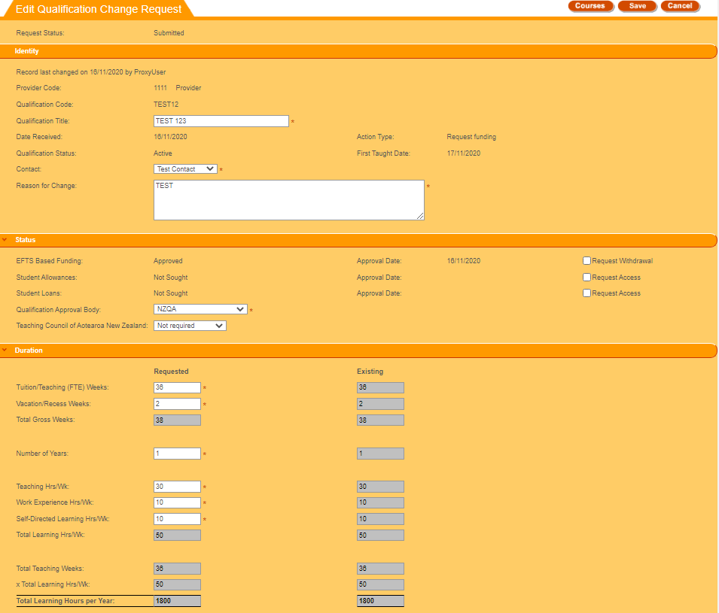
Figure 74 – Edit Qualification CR Page
You will be able to edit the fields with white backgrounds in the Qualifications Change Request Edit page. Please note that the Total Length field has been replaced with the Total Learning Hours per Year field.
The values in the Requested column on the left denote the qualification values that you entered (whether for updating an existing qualification or creating a new qualification), and the values in the Existing column on the right denote the qualification values that are currently recorded for this qualification in the Qualification Register.
If the Qualification Change Request is for a newly created qualification, there will be no existing values.
Differences between the existing qualification field (if it exists) and the requested change will be highlighted by a border around the changed field as shown in Figure 75.
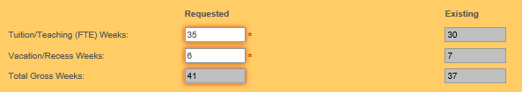
Figure 75 - Qualification CR Highlighted Field
You can enter values as needed into the editable fields. Mandatory (required) fields are denoted by the asterisks (*), as described in the Mandatory Inputs section.
The Qualification Award Category, NZSCED, Source of Funding, and Certifying Authority fields allow you to look up existing entries by clicking on the button. This is described in further detail in the Lookup Windows section.
You can abandon updating the qualification CR details at any time by clicking the button. A warning message will be shown if you have unsaved changes as described in the Discarding Unsaved Changes section. Clicking will return you to the Search Qualification CRs or the View Qualification Details page, depending on how you accessed the Qualification CR.
When you are finished with updating the qualification CR details, you can click the button. If there are any errors with data entry into the fields, you will be able to view and rectify the error as described in the Validation of Input section.
You may refer to Qualification Fields and Descriptions for a more detailed explanation on what values are expected for each field. Additionally, if you encounter further issues, the Error Messages in Qualifications explains commonly encountered problems.
Upon successfully updating the qualification CR details, you will remain on the same View / Edit Qualification CR page for the newly updated qualification change request, with the following confirmation message shown:
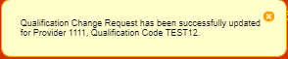
Figure 76 – Edit Qualification CR Confirmation Message
You may make further updates to the Qualification CR if you wish.
Please note that if the TEC Advisors set the status of the Qualification CR to Provider Action Required to request further updates from you, an email will be sent to the Provider’s contact assigned to the Qualification CR.
Alternatively, if the Qualification CR you’re accessing has any of the final statuses (“Accepted”, “Declined”, “Open”, or “No Action Required”), you will be directed to the Qualification Change Request View page.
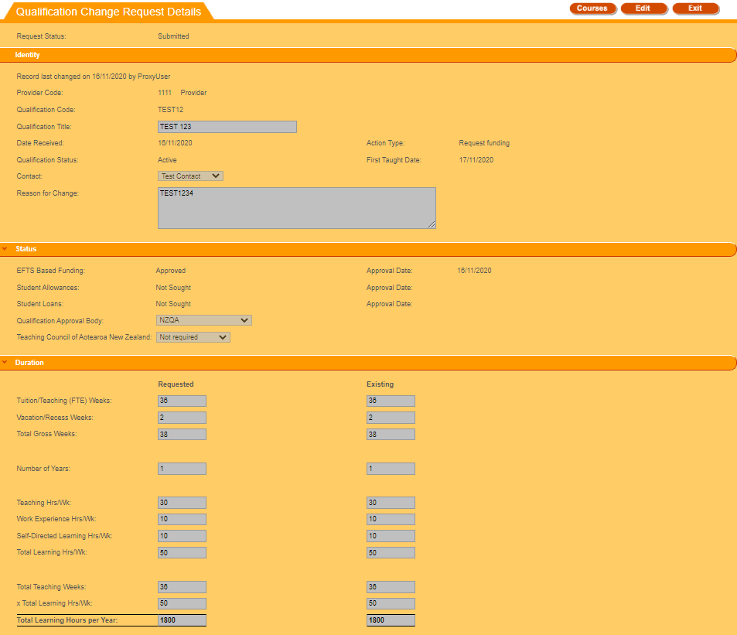
Figure 77 – View Qualification CR Page
You will be unable to edit any fields in the View Qualification CR page.
Clicking will return you to the Search Qualification CRs or the View Qualification Details page, depending on how you accessed the Qualification CR.

Concurrent Qualification
Frequently, a student is enrolled in more than one qualification. On occasion, these qualifications may be undertaken at different TEOs (with the approval of the TEO academic staff and student administration). A concurrent (or conjoint) qualification is defined as a single entity comprised of qualifications (up to a maximum of three) associated with one or more providers.
The primary purpose of the Concurrent Qualification function on STEO is to allow a TEO the ability to join previously approved qualifications together. By convention, all concurrent qualification codes start with ‘CO’ in order to be easily identified. Please note that you cannot search for Concurrent Qualifications from the Search Qualifications page.
The Concurrent Studies tab allows you to search for Concurrent Qualifications that your organisation offers (either solely or jointly with other organisations), and add, view or edit some details of the conjoint qualifications. You can access it by clicking on Concurrent Studies under Qualifications as shown below:
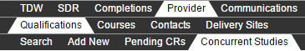
Figure 78 - Accessing Concurrent Studies

Search Concurrent Qualification
The Search Concurrent Qualification page is the default page that you will land on when you navigate to the Concurrent Studies tab.
By default, your organisation code and Approved status will be selected.
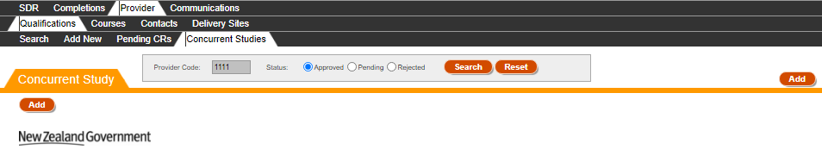
Figure 79 – Search Concurrent Qualifications
You can search for Approved or Pending or Rejected Concurrent Qualifications by clicking on the appropriate radio button and clicking .
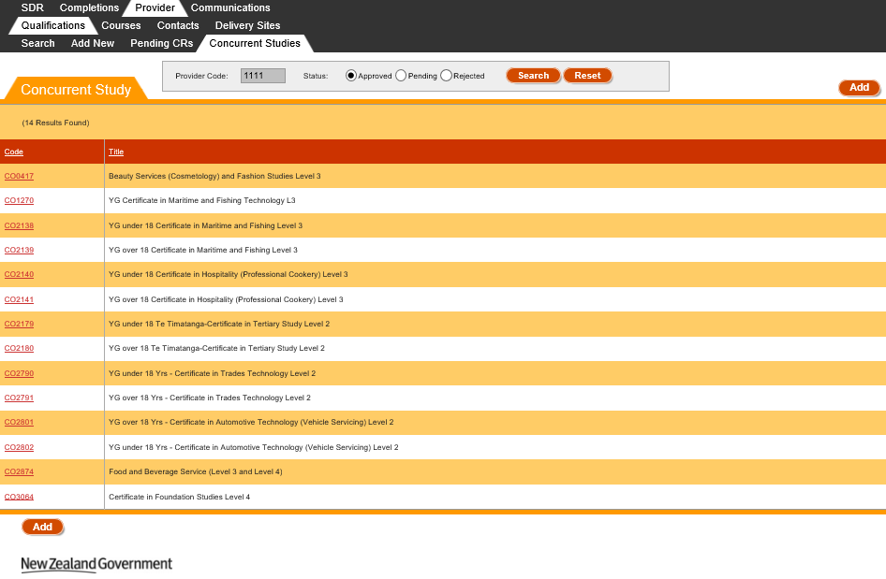
Figure 80 – Concurrent Qualifications Search Results

Clicking will clear the search results page and return the search fields back to their defaults so you can start a fresh search.
You may navigate to the View / Edit Concurrent Qualification page of a Concurrent Qualification by clicking on the Code.
Clicking will allow you to add a Concurrent Qualification, as described in the Add New Concurrent Qualification section.

View / Edit Concurrent Qualification
The View / Edit Concurrent Qualification page contains the details of a particular concurrent qualification. You can access this page by clicking on the Code from the Search Concurrent Qualification page.

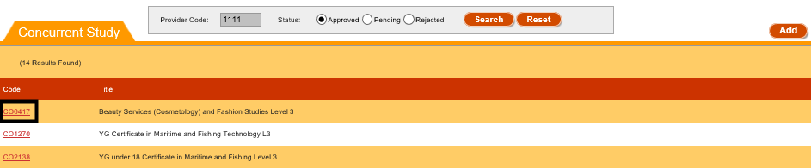
Figure 81 – Accessing View / Edit Concurrent Qualification
If the Concurrent Qualification you’re accessing does not have your organisation listed as the lead provider (denoted by the Provider Code in the black box in Figure 82) you will instead be directed to the View Concurrent Qualification page. Hence, you will be unable to edit any fields.
The example below is the View Concurrent Qualification for when the user that is logged in belongs to the organisation with a code of 1111.
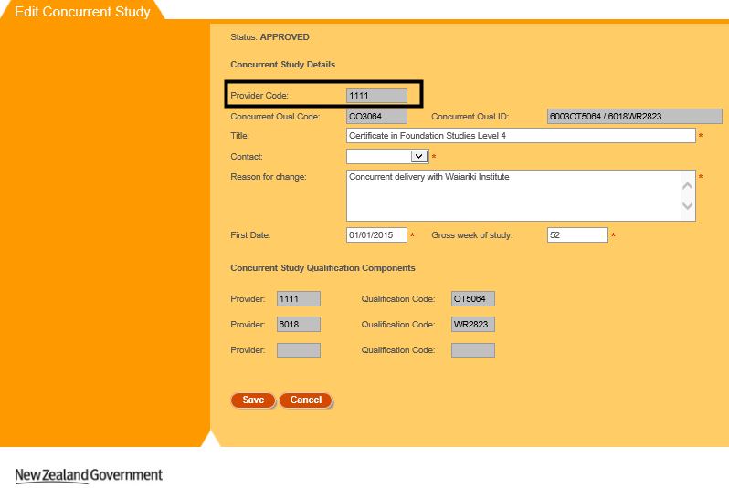
Figure 82 – View Concurrent Qualification
Clicking will return you to the Search Concurrent Qualification page.
Alternatively if you access a concurrent qualification for which you are the lead provider, you will be directed to the Edit Concurrent Qualification page, as shown in Figure 83 below:
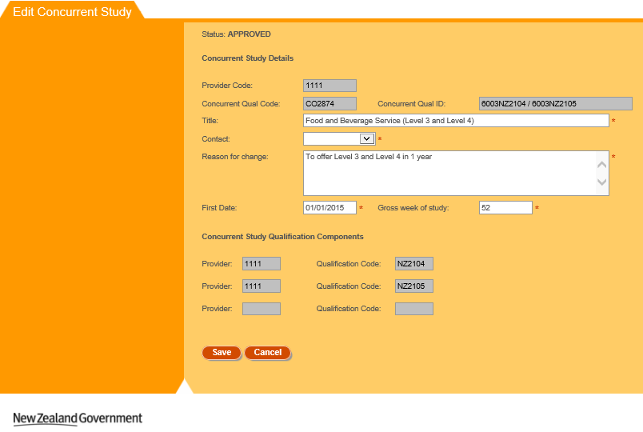
Figure 83 – Edit Concurrent Qualification
You will be able to edit the fields with white background in the Edit Concurrent Qualification page. Please note that you will be unable to edit the Concurrent Study Qualification Components.
You can enter values as needed into the editable fields. Mandatory (required) fields are denoted by the asterisks (*), as described in the Mandatory Inputs section.
You can abandon updating the concurrent qualification details at any time by clicking the button. A warning message will be shown if you have unsaved changes as described in the Discarding Unsaved Changes section. Clicking will return you to the Search Concurrent Qualification page.
When you are finished with updating the concurrent qualification details, you can click the button. If there are any errors with data entry into the fields, you will be able to view and rectify the error as described in the Validation of Input section.
You may refer to Qualification Fields and Descriptions for a more detailed explanation on what values are expected for each field.
Please note that if you update a previously Approved or Rejected Concurrent Qualification, it will be set to Pending after it has been successfully edited, and must be reviewed and approved by the TEC.
Upon successfully updating the concurrent qualification details, you will remain on the page for the newly updated concurrent qualification, with the following confirmation message shown:
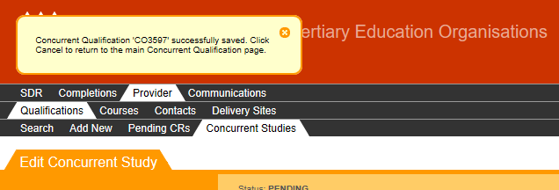
Figure 84 – Confirmation Message when Saving Concurrent Qualification
You may continue to make further changes to the newly Pending Concurrent Qualification.

Add New Concurrent Qualification
The Add Concurrent Qualification page allows you to add a new concurrent qualification for which you will be the lead provider. You can access this page by clicking on the button from the Search Concurrent Qualification page.
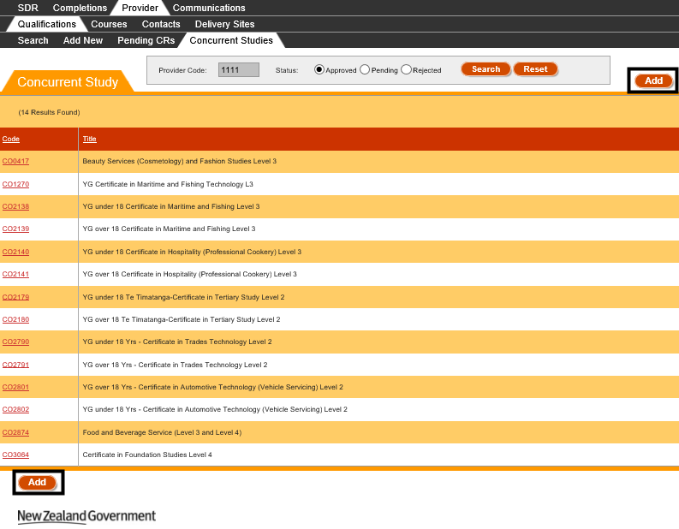
Figure 85 - Accessing Add New Concurrent Qualification
You will be shown the following page when you navigate to the Add New Concurrent Qualification page:
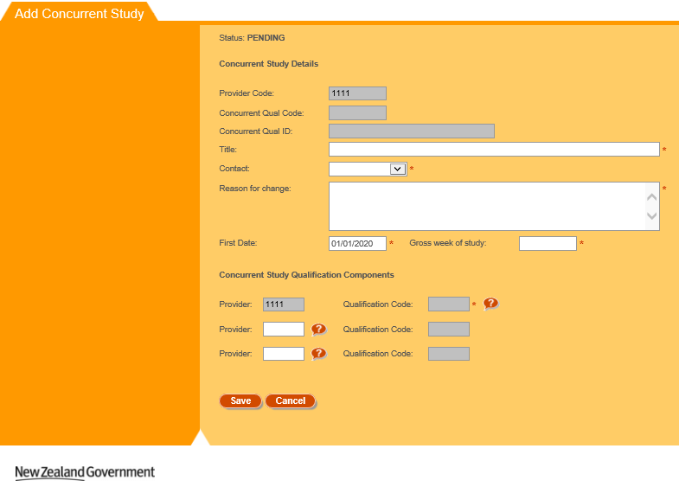
Figure 86 – Add New Concurrent Qualification
You will be able to edit the fields with white background in the Add New Concurrent Qualification page.
You can enter values as needed into the editable fields. Mandatory (required) fields are denoted by the asterisks (*), as described in the Mandatory Inputs section.
Some fields also allow you to look up existing entries by clicking on the button. This is described in further detail in the Lookup Windows section. Please note that for the second and third Provider Code and Qualification Code fields (as shown in Figure 87), the button against Qualification Code will only be displayed after you have entered a Provider Code.
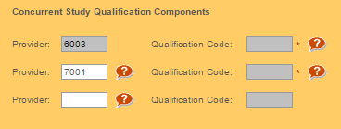
Figure 87 – Qualification and Provider Code Lookups Behaviour
You can abandon adding the concurrent qualification at any time by clicking the button. A warning message will be shown if you have unsaved changes as described in the Discarding Unsaved Changes section. Clicking will return you to the Search Concurrent Qualification page.
When you are finished with adding the new concurrent qualification details, you can click the button. If there are any errors with data entry into the fields, you will be able to view and rectify the error as described in the Validation of Input section.
You may refer to Qualification Fields and Descriptions for a more detailed explanation on what values are expected for each field.
Please note that if you create a new Concurrent Qualification that has the same Concurrent Study Qualification Components as a previously Approved Concurrent Qualification, you will be warned if you wish to proceed, as shown below:
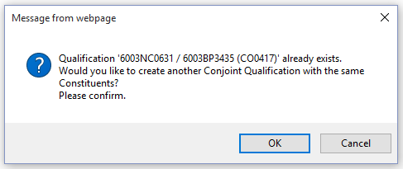
Figure 88 – Warning when Adding Duplicate Conjoint Qualification
Please note that if you add a new Concurrent Qualification, it will be set to Pending after it has been successfully added, and must be reviewed by the TEC before it is approved or rejected.
Upon successfully adding the concurrent qualification, you will remain on the page for the newly added concurrent qualification, with the following confirmation message shown:
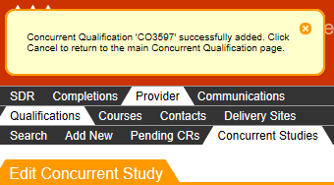
Figure 89 – Add New Concurrent Qualification Confirmation Message

Qualification Fields and Descriptions
When you are filling in the forms to add or edit qualifications, or alter a pending qualification change request, you will encounter the following fields. This table may assist in providing some guidance as to how to fill in the fields correctly to avoid erroneous entries.

Qualification and Qualification CRs
Section 1: Identity
Field | Value
Qualification Code | Select 1 of the 2 radio buttons.  If National Qualification is selected, click on to be taken to list of valid National and/or New Zealand Qualification codes.  National and/or New Zealand qualifications must use the qualification code assigned by the New Zealand Qualification Authority (NZQA) which can be selected from the list of valid National Qualification codes.  If Local Qualification is selected, you can either leave the qualification code blank and the system will allocate a qualification code to the new qualification for you, or you can enter a six lettered qualification code of your choice.  The convention AANNNN where A = alpha and N = numeric is usually followed, for example AB1234. However, if you wish, you can enter a fully numeric, six-digit qualification code.  This field is mandatory. The qualification code cannot be edited after saving the qualification.
Qualification Title | This field has slightly different requirements depending on what you selected in the radio button for Qualification Code  - If Local Qualification is selected, Title must be supplied and must not be left blank.  - If National Qualification is selected, this field is not editable and is instead auto populated when you select a NCND code which is selected from lookup for Qualification Code  A maximum of 255 characters is allowed.  This field is mandatory.
Contact | This is the nominated contact person from your organisation, as defined by the list of contacts in your organisation.  This field is mandatory.
Reason for Change | Enter the reason for change or reason for request.  A maximum of 255 characters is allowed.  This field is mandatory.

Section 2: Status
Field | Value
Qualification Status | Displays the Qualification Status – Active or Closed.  (The status will be blank if you are adding a new qualification).
First Taught Date | The date the qualification will first be taught. A calendar is displayed when you click on the First Taught Date textbox.  You can only enter a date when you are creating a new qualification. This field is mandatory, and only future dates are allowed.
EFTS Based Funding, Student Allowances, Student Loans  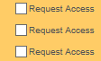 | The type of funding that the qualification is eligible for.  When adding a qualification, the left hand column will show the status “Not Sought” for these fields. Remember to tick the right hand tick boxes for what funding you will be applying for. Note that if the qualification you are opening will be used exclusively for Youth Guarantee then please do not tick the Student Loans box.  Please note that if you are editing an existing qualification you cannot request both Funding Access and Funding Withdrawal in the same qualification change request.
Qualification Approval Body | This field is mandatory.  Click on the dropdown arrow to select the relevant Approval Body. Each approval body has a number code. In general Youth Guarantee providers should choose 1 (NZQA).  - NZQA  - CUAP  - ITPQ  - CEAC  - Academic Board  - SkillNZ  - Maritime Safety Authority  - Other  - Awaiting Confirmation
Teaching Council of Aotearoa New Zealand Approval | Select the appropriate option regarding Teaching Council of Aotearoa New Zealand Approval.

Section 3: Duration
Field | Value
Tuition/Teaching (FTE) Weeks | The overall number of full time equivalent weeks during which students studying for a particular qualification are being taught, including study breaks, from the first tuition date until after the last assessment or examination, but excluding holidays.  This field must be numeric with no decimals, and must be between 0-104.  This field will be used to provide duration data for the Key Information Set (KIS) for this qualification. This field is mandatory.
Vacation/Recess Weeks | This field must be numeric with no decimals, and must also be between 0-104.  Note that any qualifications with vacation or recess of more than 3 weeks will not be eligible for student allowances.  This field will be used to provide duration data for the Key Information Set (KIS) for this qualification. This field is mandatory.
Total Gross Weeks | This field will be automatically populated with the sum of the values entered in the Tuition/Teaching (FTE) Weeks and the Vacation/Recess Weeks fields.
Number of Years | The total duration for a qualification can be entered as whole numbers and decimals.  Note that if your qualification is for less than 1 year, then this field is not as critical as the system will use the number of tuition weeks to calculate the correct length for the qualification.  This field will be used to provide duration data for the Key Information Set (KIS) for this qualification. This field is mandatory.
Teaching Hrs/Wk | The total number of teaching hours per week.  This field must be numeric and must be between 0-99.99. This field is mandatory.
Work Experience Hrs/Wk: | Number of work experience hours per week required for the qualification.  This field must be numeric and must be between 0-99.99. This field is mandatory.
Self-Directed Learning Hrs/Wk: | This includes the time an average student is expected to spend in unsupervised and independent study such as research, study groups, preparation and homework per week.  This field must be numeric and must be between 0-99.99. This field is mandatory.
Total Learning Hrs/Wk | This field will automatically populate with the sum of the values entered in the Teaching Hrs/Wk, Work Experience Hrs/Wk and Self-Directed Learning Hrs/Wk fields.
Total Length (or Total Learning Hours per Year) | This field will automatically populate with the total number of hours for the qualification when Adding or Editing a qualification. If you are viewing or editing a Qualification Change request, this is instead automatically populated with the Total Number of Hours per year.  It is calculated by the following formulae:  Qualifications  Total Length (Hours) = Tuition/Teaching (FTE) Weeks * Total Learning Hrs/Wk * Number of Years  OR  Qualification Change Requests  Total Learning Hours per Year = Total Teaching Weeks * Total Learning Hrs/Wk
Provider Credit/Points | Credit Points are the number of credits or points that indicate the amount of learning required, on average, to complete the qualification. This field requires you to enter credit points allocated to a qualification that is not encompassed by NQZF Credit points.  This field has a maximum of 4 digits and no decimals are allowed. Numbers must be between 1-1200. This field is mandatory.
NZQF Credits | Refers to qualification made up of unit standards and is encompassed within the NZQF.  In most cases, the NZQF system equates 120 credits with 1 full-time year of study and 1.0 EFTS unit.  This field has a maximum of 4 digits, has no decimals and must be between 1-1200. This field is mandatory.
EFTS Value | The EFTS value is expressed in numbers of EFTS units and is established by the Tertiary Education Commission (TEC). Calculations are based on full-time student workload.  This value is calculated on the basis of credits, and/or full time teaching weeks, but the calculation based on credit values takes precedence.  This field has a maximum of 6 characters, must be numeric and between 0.0001-9.9999. This field is mandatory.  This field will be used to provide data for the Key Information Set (KIS) for this qualification.
Full/Part Time | You can select either of the radio buttons to denote whether the qualification is delivered full time or part time. This field is mandatory.  Note: If the qualification is delivered both full time and part time, please make sure you select Full Time.

Section 4: Description
Field | Value
Brief Outcome | Enter details of any minimum or preferred entry requirements for this qualification.  Information should be clear and concise and contain no more than 255 characters for KIS quality purposes.  This field will be used to provide data for the Key Information Set (KIS) published on your website for this qualification. Any additional entry requirements can be presented via the Additional requirements link in the KIS.  Please note this field is mandatory for publication of the KIS.
Brief Contents | Enter in contents of the qualification. This field is mandatory.  Information should be clear and concise and allows a maximum of 2000 characters.  Changing only this field in Edit Qualification will result in an auto approved qualification change request. These changes will be automatically saved to the Qualification Register with no need for TEC approval.
Brief Assessment Mode | Enter in details of assessments. This field is mandatory.  Information should be clear and concise and allows a maximum of 2000 characters.  Changing only this field in Edit Qualification will result in an auto approved qualification change request. These changes will be automatically saved to the Qualification Register with no need for TEC approval.
Brief Entry Requirements | Enter details of any minimum or preferred entry requirements for this qualification.  Information should be clear and concise and allows a maximum of 2000 characters.  Changing only this field in Edit Qualification will result in an auto approved qualification change request. These changes will be automatically saved to the Qualification Register with no need for TEC approval.  This field will be used to provide data for the Key Information Set (KIS) published on your website for this qualification. Any additional entry requirements can be presented via the additional requirements link in the KIS.

Section 5: Qualification Classification
Field | Value
Qualification Award Category | Click on to view list of valid Qualification Award Categories. This field is mandatory.  For Youth Guarantee qualifications, please choose 41 or 46 on the Qualification Code styles.  Note: If QAC is any of 90, 97 or 99, then Qualification can be submitted with NZQF Level, ISCED Level and ISCED Subsequent Destination as blank.
NZQF Level | The valid NZQF value depends on the Qualification Award Category selected and the valid values will be available for selection in the dropdown list once a Qualification Award Category is selected/entered.
ISCED Level | International Standard Classification of Education (ISCED) is a classification of level of education ranging from 0-9.  The valid ISCED value depends on the Qualification Award Category selected and the valid values will be available for selection in the dropdown list once a Qualification Award Category is selected/entered.
ISCED Subsequent Destination | The valid ISCED Subsequent Destination values will be populated in the dropdown for selection once an ISCED Level is selected and mapping is defined.  If mapping is available, a value must be selected and cannot be left blank; alternatively ISCED Subsequent Destination will be blank.
NZSCED | Click on to select a valid NZSCED that relates to the qualification. This field is mandatory.  The NZ Standard Classification of Education is a subject based classification system for TEOs. This system was developed by the Ministry of Education (MoE) with the aim of improving the quality and consistency of statistics collected by agencies regarding tertiary education.  This field will be used to provide data for the Key Information Set (KIS) for this qualification. The NZSCED provides the field of study to match the employment outcomes of tertiary education data to the qualification.
Source of Funding | Click on to select a valid Source of Funding code. Please note this field is not mandatory, and accepts a maximum of 2 characters.  If a Youth Guarantee provider has received NZQA approval for the qualification, choose ‘M’ from the list of codes.
Distance Learning Available | Enter in ‘Y’ or ‘N’ if distance learning is available. Please note this field is not mandatory.
Certifying Authority | Click on to select a certifying authority for the qualification. Please note this field is not mandatory, and accepts a maximum of 4 characters.  Changing only this field in Edit Qualification will result in an auto approved qualification change request. These changes will be automatically saved to the Qualification Register with no need for Agency approval.

Concurrent Qualifications
Section 1: Concurrent Study Details
Field | Value
Provider Code | This field denotes who the lead provider is.  When you add a new concurrent qualification, it will always be populated with your provider code.
Concurrent Qual Code | This field is automatically populated after you create a new concurrent qualification.  It will always start with the letters “CO” and is immediately followed by a 4 digit number.
Concurrent Qual ID | This field is automatically populated after you create a new concurrent qualification.  It is generated by joining all the provider code and qualification codes of the Concurrent Study Components.  E.g. if I create a new concurrent qualification with the following components:  1111 – BP3410  1111 – AGRI1007  7001 – AC1053  The resulting Concurrent Qual ID will be  1111BP3410 / 1111AGRI1007 / 7001AC1053
Title | Enter the title of the concurrent qualification.  Please note that this is a mandatory field and has a maximum of 200 characters.
Contact | Contacts that belong to your organisation will be populated in this dropdown.  You must select a contact, this field is mandatory.
Reason for change | Enter the reason for creating or editing the concurrent qualification.  This field is mandatory, and only accepts a maximum of 255 characters.
First Date | The date the concurrent qualification will first be taught. A calendar is displayed when you click on the First Taught Date textbox.  When you add a new concurrent qualification, this field will default to the 1st January of the current year.  This field is mandatory.
Gross week of study | The total number of teaching and vacation weeks the concurrent qualification will take.  This field is, and only accepts numeric whole numbers up to 3 digits between 1-999.

Section 1: Concurrent Study Qualification Components
Field | Value
Provider (1) | This field denotes who the lead provider is. This field is not editable.  When you add a new concurrent qualification, it will always be populated with your provider code.
Qualification Code (1) | Please click on to be taken to a list of valid Qualification codes for your provider.
Provider (2) | Please click on to be taken to a list of valid Provider Codes.  This field is not mandatory and accepts up to 4 digits.
Qualification Code (2) | This field is not mandatory if you did not define a provider in Provider (2).  Please click on to be taken to a list of valid Qualification codes for the chosen provider in Provider (2).
Provider (3) | Please click on to be taken to a list of valid Provider Codes.  This field is not mandatory and accepts up to 4 digits.
Qualification Code (3) | This field is not mandatory if you did not define a provider in Provider (3).  Please click on to be taken to a list of valid Qualification codes for the chosen provider in Provider (3).

Error Messages in Qualifications
Most errors can be avoided by following the guidelines outlined in Qualification Fields and Descriptions. However, in some cases you may encounter additional error messages:
Error Message | Description
The changes you have made are not sufficient to create a Qualification Change Request.  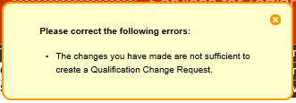 | When you are creating a new qualification, you must update more than the Contact and Reason for Change fields for a change request to be created.
Cannot make changes to Qualification that is already closed  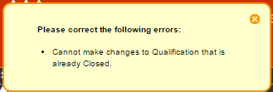 | If you are trying to create a new Qualification where the Qualification Code already exists, but the existing qualification is Closed, you will be unable to proceed.  Please create a new qualification that does not have the same code as the closed qualification.
Qualification <Qualification Code> already exists.  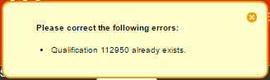 | You cannot create a qualification that has the same qualification code as an existing Active Qualification.  Please create a new qualification that does not share the same code.
Pending Request for this Qualification already exists.  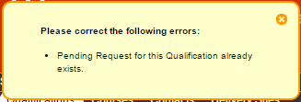 | You cannot create a qualification if there is a pending change request that exists for the proposed qualification code.  This error may occur if you’ve already created a new qualification and are trying to repeat the process.
Sorry, this Qualification is missing the First Taught Date and cannot be edited. Please contact your MOE Advisor to get this resolved. | STEO now requires that all Qualifications have a First Taught Date defined when they are created or edited. Previously, this requirement was not strictly enforced.  There may be some historical qualifications that are missing a First Taught Date. You must contact the TEC Sector Helpdesk to enter a First Taught Date before you can proceed with editing the qualification.

Courses
The Courses tab contains all the information about your organisation’s courses (current and prior courses), including any change requests that have been lodged against these courses. You can use this tab to view and alter information relating to courses and their lodged change requests.
Some fields in this section may also be used to provide data for the Key Information Set (KIS) for the qualifications published to support students' enrolment decisions. Click here for more information about the Key Information Set.
KIS data is provided by the TEC data service for all active TEC funded qualifications. The KIS data for each qualification is published on the TEO website and also on the TEC website. Use the close process to ensure a KIS is not published for any qualifications no longer delivered.
The Courses tab allows you to access the following pages:
- Search Course
- View Course Details
- Edit Course Details
- Add New Course
- Search Course CRs
- View / Edit Course CR
You can navigate to this section by clicking on Provider, then Courses in the main menu.
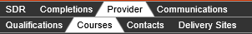
Figure 90 – Course Tab

Search Course
The Course Search page allows you to search for courses that your organisation offers, both Active and Closed as defined in the Course Register. The Course Search page is the page that you will land on when you navigate to the Search sub tab under the Course tab.
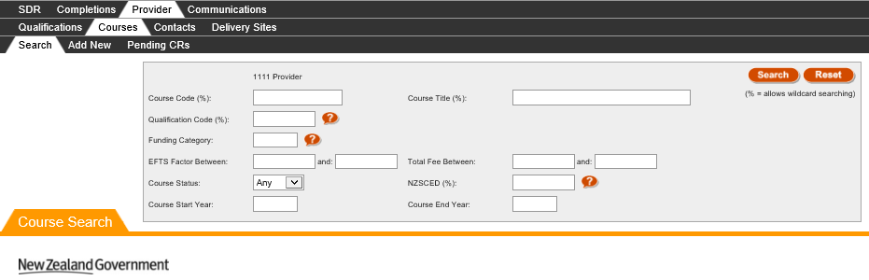
Figure 91 – Default Course Search Page
Your organisation name and provider code will be shown above the Course Code field (the example in Figure 91 uses “1111 Provider”).
The Course Search page is blank the first time it is accessed when logging in. After that, it will retain the search results of the last performed search when you return to the page.

You can search for all existing courses against your organisation by optionally entering search criteria into any of the fields shown in the search box and clicking.
The Course Code, Course Title, Qualification Code, and NZSCED fields will allow for wildcard searching which match partial characters entered into the field (these fields are denoted by the % sign) as described in the Wildcard Searching section. The Qualification Code, Funding Category, and NZSCED fields also allow you to look up existing entries by clicking on the button. This will direct you to the relevant lookup as described in the Lookup Windows section. The EFTS Factor Between and Total Fee Between fields will allow you to narrow your search between certain ranges.
If there are any errors with data entry into the search fields, you will be able to view the error as described in the Validation of Input section.
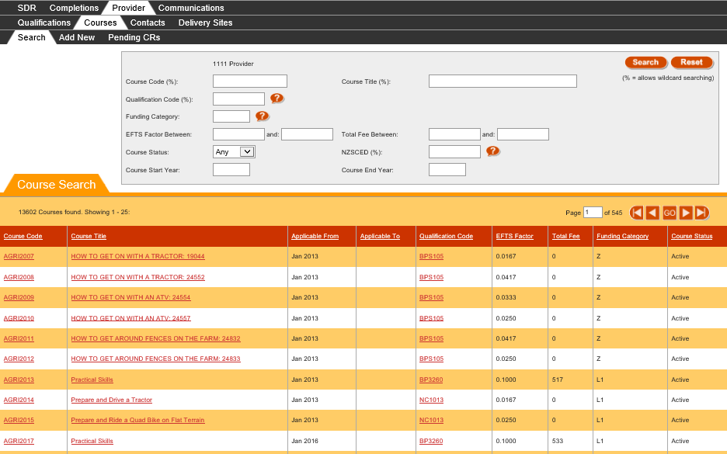
Figure 92 – Course Search Results
The search results based on the criteria entered will be shown as per Figure 92, with 25 courses shown per page.
You can sort the results by clicking on the column header titles as previously described in the Sorting Search Results section.
If there is more than one page of courses, you can browse through the other pages using the navigation buttons as described in Navigating through Result Pages.
You may navigate to a Course by clicking on the Course Code or Course Title.
You may also navigate to the View Qualification Details page for the Qualification the Course belongs to by clicking on the Qualification Code.
Clicking will clear the search results page and return the search fields back to their defaults so you can start a fresh search, as shown in Figure 91.

View Course Details
The Course Details page contains a more detailed view of a particular course. You can access the Course Details page by clicking on a Course Code or Course Title from the Search Course page, as shown below:
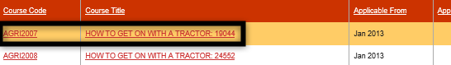
Figure 93 – Accessing Course Details

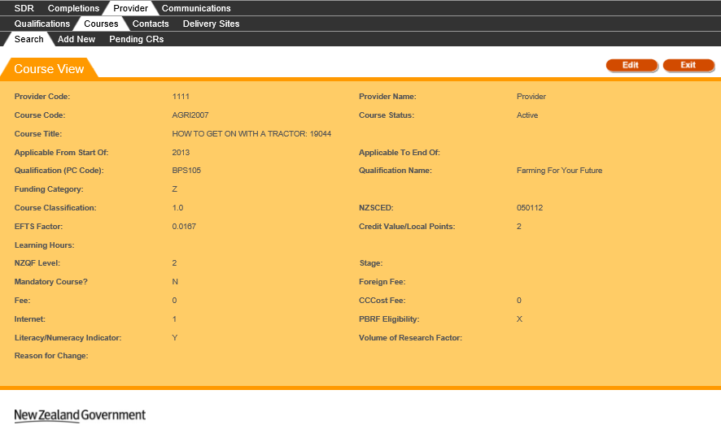
Figure 94 – View Course Details

You can click to Edit Course Details.
You can also click to return to the Search Course page.
Some courses may already have a pending Course CR lodged against it. In this scenario, there will be no button, but there will instead be a button, as shown below:
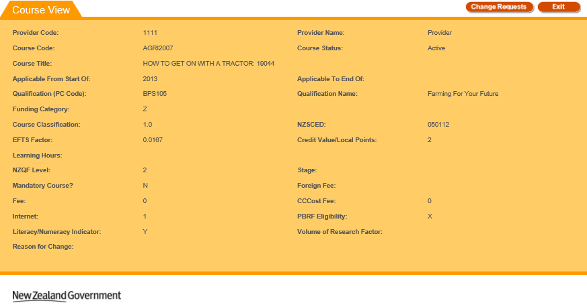
Figure 95 – View Course Details with Pending Change Request
Clicking on the button will take you to the View / Edit Course CR page for the course change request.

Edit Course Details
The Course Update page allows you to update the details of a specific course. You can access the Course Update page by clicking on the Edit button from the View Course Details page.
Figure 96 – Accessing Edit Course Details
Please note that if the Course has a pending Change Request, the button will not be shown, and instead a button will be shown, as described in View / Edit Course CR.

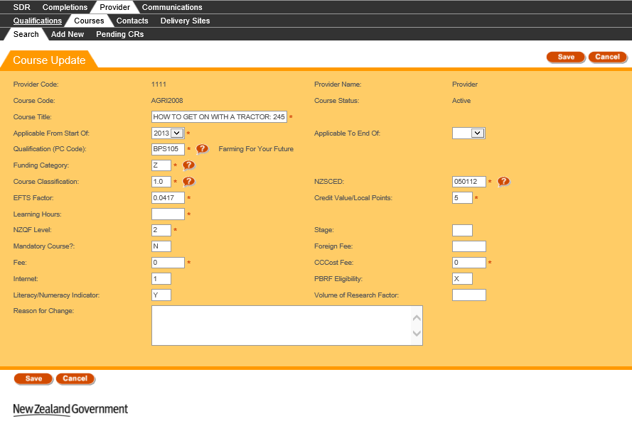
Figure 97 – Edit Course Details

You can enter values as needed into the editable fields. Mandatory (required) fields are denoted by the asterisks (*), as described in the Mandatory Inputs section.
The Qualification (PC Code), Funding Category, Course Classification, and NZSCED fields also allow you to look up existing entries by clicking on the button. This is described in further detail in the Lookup Windows section.
You can abandon updating the course details at any time by clicking the button. A warning message will be shown if you have unsaved changes as described in the Discarding Unsaved Changes section. Clicking will return you to the View Course Details page.
When you are finished with updating the course details, you can click the button. If there are any errors with data entry into the fields, you will be able to view and rectify the error as described in the Validation of Input section. You may refer to Courses Fields and Descriptions for a more detailed explanation on what values are expected for each field. Additionally, if you encounter further issues, the section Error Messages in Courses will explain commonly encountered problems.
Please note that if you modify the Applicable From Start Of field (Start Year) of the course, you will create a new course, and the current course will be closed when the change request is approved by the Agency. You will also be shown the following message:
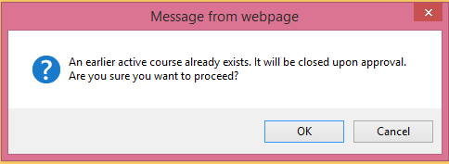
Figure 98 – Warning Message when altering Start Year of Existing Course
Upon successfully updating the course details, a new course change request will be created and you will be taken to the View / Edit Course CR page, with the following confirmation message shown:
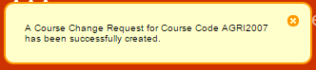
Figure 99 – Edit Course Details Confirmation Message

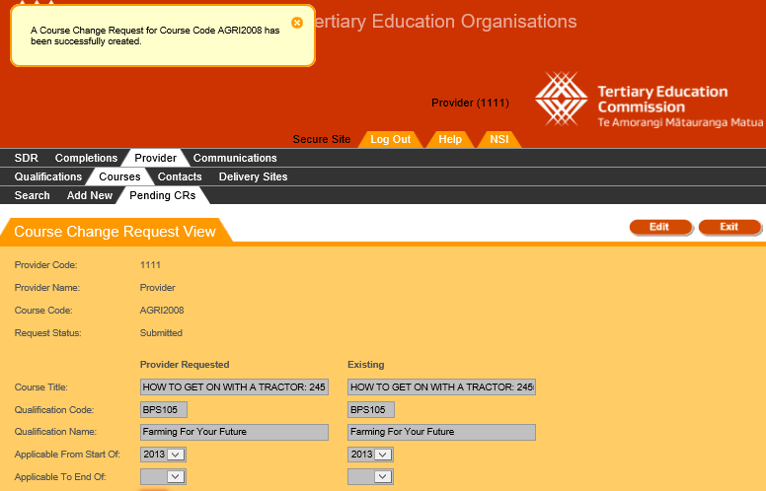
Figure 100 – Newly Created Course Change Request Details

Add New Course
The Course Add page allows you to add a new course for your organisation. You can access the Course Add page by clicking the “Add New” tab under Courses:
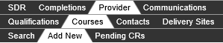
Figure 101 – Add New Course tab

The following page will be shown when you access the Course Add page:
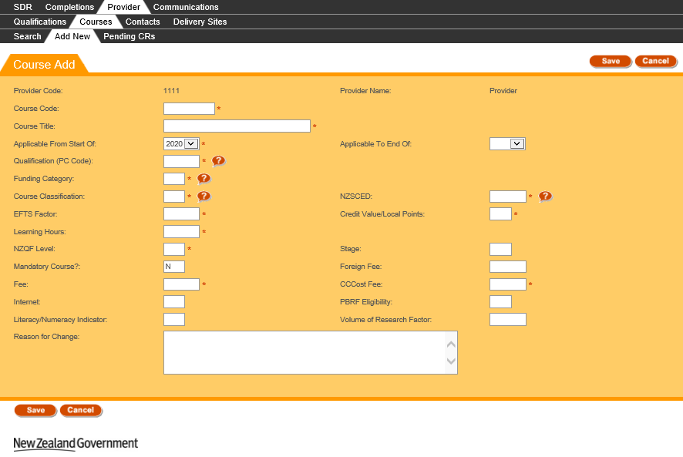
Figure 102 – Add New Course page
The Provider Code and Provider Name at the top of the form will be populated with the values for your organisation (in this example we have “1111” and “Provider”). In addition, the current year is populated into the Applicable From Start Of field, and the Mandatory Course? field is populated with N (No).
You can enter values as needed into the editable fields. Mandatory (required) fields are denoted by the asterisks (*), as described in the Mandatory Inputs section.
The Qualification (PC Code), Funding Category, Course Classification, and NZSCED fields also allow you to look up existing entries by clicking on the button. This is described in further detail in the Lookup Windows section.
You can abandon updating the course details at any time by clicking the button. A warning message will be shown if you have unsaved changes as described in the Discarding Unsaved Changes section. Clicking will return you to the last page you were on before navigating to the Course Add page.
When you are finished with entering the new course details, you can click the button. If there are any errors with data entry into the fields, you will be able to view and rectify the error as described in the Validation of Input section. You may refer to Courses Fields and Descriptions for a more detailed explanation on what values are expected for each field. Additionally, if you encounter further issues, the section Error Messages in Courses will explain commonly encountered problems.
Please note that if you are creating a new course but there is an existing course that has the same course code, it will be closed when the course creation is approved by the TEC. You will also be shown the following message:
Figure 103 – Warning to Close Existing Course when Adding New Course
Upon successfully saving the new course details, a new course change request will be created and you will be taken to the View / Edit Course CR page, with the following confirmation message shown:
Figure 104 – Add New Course Confirmation Message

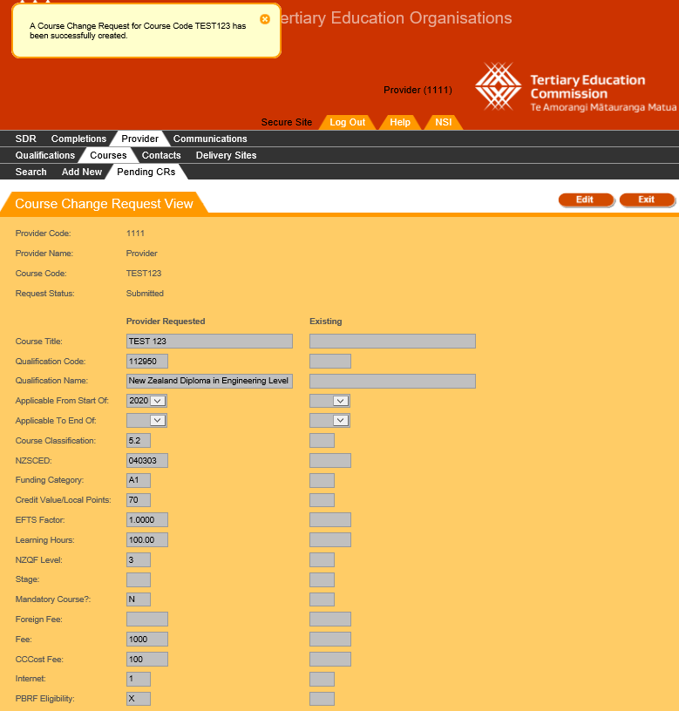
Figure 105 – Newly Created Course Change Request Details
Please note that this course must be approved by the TEC before it will be active.

Pending Course CRs (Change Requests)
Course CRs (Change Requests) are created whenever you create a new course, modify an existing course, or submit course changes using the Course Register files (as described in Validate New SDR). Pending change requests have to be reviewed and approved by TEC Advisors.
The Pending Course CRs tab allows you to search for Course CRs, and view or edit Course CRs. You can access it by clicking on Pending CRs under Courses as shown below:
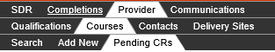
Figure 106 – Pending Course CRs tab

Search Course CRs
The Course Change Request Search page is the default page shown when you navigate to the Pending CRs tab.
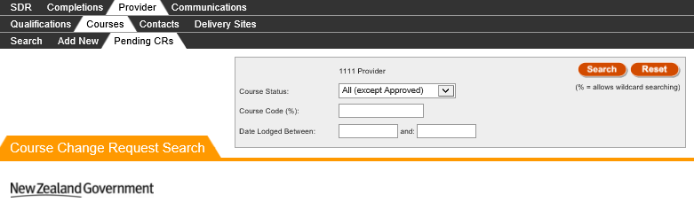
Figure 107 – Course Change Request Search page
Your organisation name and provider code will be shown above the Course Status field (the example in Figure 107 uses “1111 Provider”).
The Course Change Request Search page is blank the first time it is accessed when logging in. After that, it will retain the search results of the last performed search when you return to the page.
You can search for all recorded course change requests (whether pending or finalised) against your organisation by optionally entering search criteria into any of the fields shown in the search box and clicking.
The Course Code field allows for wildcard searching which match partial characters entered into the field (these fields are denoted by the % sign) as described in Wildcard Searching section.
If there are any errors with data entry into the search fields, you will be able to view the error as described in the Validation of Input section.
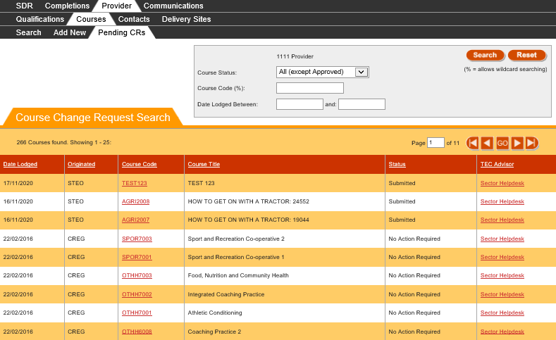
Figure 108 – Course CR Search Results
The search results based on the criteria entered will be shown as per Figure 108, with 25 change requests shown per page.
You can sort the results by clicking on the column header titles as previously described in the Sorting Search Results section.
If there is more than one page of course change requests, you can browse through the other pages using the navigation buttons as described in Navigating through Result Pages.
You may navigate to View / Edit Course CR by clicking on the Course Code of a Change Request.
You may also email the TEC Advisor responsible for reviewing the Course Change Request by clicking on the TEC Advisor name. This will open a blank email addressed to the TEC Advisor in your default email client application (e.g. Microsoft Outlook).
Clicking will clear the search results page and return the search fields back to their defaults so you can start a fresh search, as shown in Figure 107.

View / Edit Course CR
.
The Course Change Request View page contains the details of a particular course CR. You can access this page by clicking on the Course Code in the Search Course CRs page or by clicking on the button for a Course that has a Pending Change Request in the Course View page.
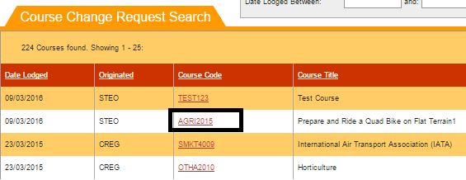
Figure 109 – Accessing Course CR Details
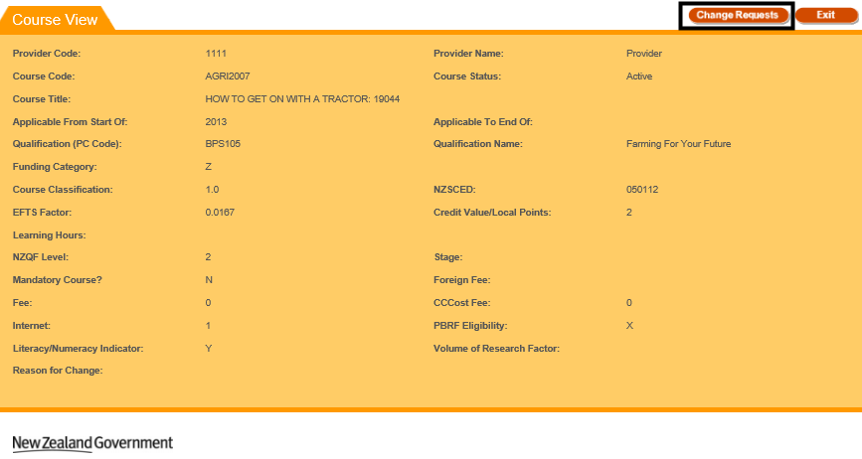
Figure 110 – Accessing Course CR Details from View Course Details
If the Course CR you’re accessing has a status of “Submitted” or “Provider Action Required”, you will be directed to the Course Change Request Edit page.
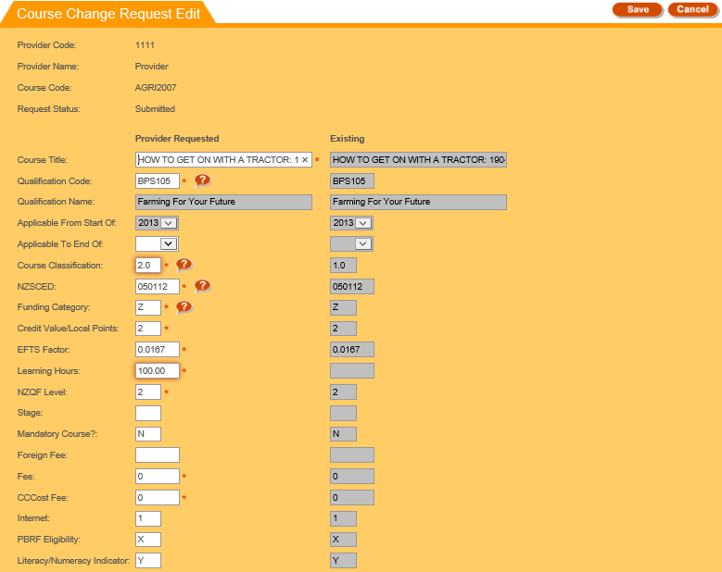
Figure 111 – Edit Course CR
You will be able to edit the fields with a white background in the Course Change Request Edit page. However, the Applicable From Start Of field cannot be edited.
The values in the Provider Requested column on the left denote the course values that were entered by you (whether for updating an existing course or creating a new course), and the values in the Existing column on the right denote the course values that are currently recorded for this course in the Course Register.
If the Course Change Request is for a newly created course, there will be no existing values.
Differences between the existing course field (if it exists) and the requested change will be highlighted by a border around the changed field as shown in Figure 114.
You can enter values as needed into the editable fields. Mandatory (required) fields are denoted by the asterisks (*). The Qualification Code, Course Classification, NZSCED, and Funding Category fields also allow you to look up existing entries by clicking on the button. This is described in further detail in the Lookup Windows section.
You can abandon updating the course CR details at any time by clicking the button. A warning message will be shown if you have unsaved changes as described in the Discarding Unsaved Changes section. Clicking will return you to the Search Course CRs page.
When you are finished with updating the course CR details, you can click the button. If there are any errors with data entry into the fields, you will be able to view and rectify the error as described in the Validation of Input section. You may refer to Courses Fields and Descriptions for a more detailed explanation on what values are expected for each field. Additionally, if you encounter further issues, the section Error Messages in Courses will explain commonly encountered problems.
Upon successfully updating the course CR details, you will remain on the same View / Edit Course CR page for the newly updated course change request, with the following confirmation message shown:
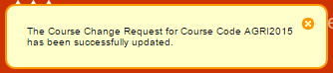
Figure 112 – Edit Course CR Confirmation Message
You may continue make further updates to the Course CR if you wish.
Please note that if the TEC Advisors set the status of the Course CR to Provider Action Required to request further updates from you, an email will be send to Provider’s contacts that have been assigned the Contact Role “Quals/Course/Delivery site updates”.
Alternatively, if the Course CR you’re accessing has any of the final statuses (“Approved”, “Approved with Change”, “Open”, or “No Action Required”), you will be directed to the Course Change Request View page.
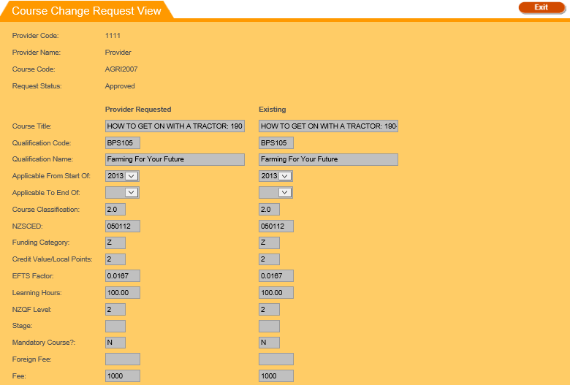
Figure 113 – View Course CR
You will be unable to edit any fields in the Course Change Request View page.
The values in the Provider Requested column on the left denote the course values that were entered by you (whether for updating an existing course or creating a new course), and the values in the Existing column on the right denote the course values that are currently recorded for this course in the Course Register.
If the Course Change Request is for a newly created course, there will be no existing values.
Differences between the existing course field (if it exists) and the requested change will be highlighted by a border around the changed field as shown in Figure 114:
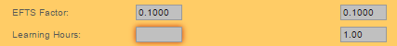
Figure 114 – Course CR Highlighted Field
Clicking will return you to the Search Course CRs page.

Courses Fields and Descriptions
When you are filling in the forms to add or edit courses, or alter a pending course change request, you will encounter the following fields. This table may assist in providing some guidance as to how to fill in the fields correctly to avoid erroneous entries.
Field | Value
A unique code for this course/subject/unit that is assigned by you. The code should remain the same for the course regardless of delivery context, time or location.
It is a mandatory field, has a maximum of 20 characters and must be a unique course code.
Note: Once approved the course code cannot be edited.
The course title should give a fair representation of the subject matter of the course.
It is a mandatory field, and has a maximum of 75 characters.
This is the year from which enrolments under this course code will be counted in the SDR under the parameters described in this entry in the course register.
This field will be default to 2020. It is a mandatory field, and must be in the format of yyyy, e.g. 2020
This is the year for instances in which you know that the set of parameters assigned to this course have a finite life span. The date for ceasing course details must be the end of a calendar year and must be in the format yyyy, e.g. 2020.
Please note this is not a mandatory field.
Note: Do not fill this field in until a course has closed.
Clicking on the will give you a list of all active qualifications available on your qualification register.
This qualification is the ‘home’ qualification nominated for this course. The course may be delivered under a number of qualifications without requiring multiple entries in the course register, but the ‘home’ qualification is the qualification under which the course is recognised for quality assurance purposes.
This is a mandatory field with a maximum of 6 characters.
Clicking on the will give you a list of all the valid funding categories.
The funding category field denotes the funding rate that enrolments in the course will generate. TEC sets the funding category for courses, but you are required to propose a funding category.
The funding category you enter must be valid for the course classification it falls into. This is a mandatory field with a maximum of 2 characters.
Clicking on the will give you a list of all the valid course classifications.
Course classification indicates the subject matter covered by the majority of the course in question. TEC sets course classification for courses, but you must propose a course classification based on the content of the course.
This classification must be valid, and must also have a valid funding category. This is a mandatory field with a maximum of 4 numeric characters.
Clicking on the will give you a list of all the valid NZSCED codes.
This is a mandatory field with a maximum of 6 digits.
This is the EFTS factor that you believe the courses study requirements represents.
TEC sets the course EFTS factor, but you must propose a factor based on the proportion of the requirements for the attainments of the qualification that the course represents.
This field accepts a maximum of 6 numeric characters, with up to 4 decimal places, and must be a value between 0.0001 – 2.0000.
Note: Please check the EFTS factor calculation on TEC website: http://www.tec.govt.nz/Funding/Fund-finder/SAC3/Funding-and-payments/

This field refers to either the NZQF credits the course involves, or, for non-NZQF courses, the points or credits as defined by your organisation.
The credit value cannot exceed 240. This field also has a maximum of 3 numeric characters.
This field records the learning hours involved in the course.
This field has a maximum of 7 numeric characters, up to 2 decimal places, and must be between 0-2400.99.
NZQF (register level) was formerly (and commonly) referred to as the NQZF level. It indicates the level/complexity of the learning undertaken in the course. The entry must be between 0-9.
- NZQF Level must be 0 when PBRF value is C or D
- NZQF Level must be 8 or 9 when PBRF value is L or M
- The NZQF Level must be between 1 and 5 if the Literacy/Numeracy indicator is set to Y.
This field denotes the year of study that a course falls into, and is included specifically for pre-service teacher education courses.
Please note this is not a mandatory field. The entry must be between 1-6.
This field indicates whether the course in question is mandatory for the successful completion of the ‘home’ qualification, or if the course is an elective/optional course.
The field will either accept a Y for yes, or N for no. Please note the this field will default to N.
This field is required for Export Education Levy (EEL) purposes.
The foreign fee must always exceed the fee for domestic students.
This fee covers all domestic tuition fees, as well as the costs of sale such as agent’s fees and marketing costs, as well as recovering the cost of EEL.
Please note this is not a mandatory field and allows 5 digits and can have an integer value between 0 and 99999.
This field contains the standard fee that domestic students normally pay for tuition and costs associated with enrolment in a course. It is GST inclusive.
This is a mandatory field has a maximum of 5 digits and must have an integer value between 0 and 99999.
Note: if the course is to be exclusively used for Youth Guarantee, the provider must enter the Fee as Zero (0).
This field will be used to provide data for the Key Information Set (KIS) for relevant qualifications.
The Compulsory Course Costs Fee includes such costs as compulsory administration charges, examination fees, other charges associated with a course or program of study, material charges, costs of field trips and any compulsory purchase of equipment or books through the TEO. It is GST inclusive.
This is a mandatory field has a maximum of 5 digits and must have an integer value between 0 and 99999.
Note: if the course is to be exclusively used for Youth Guarantee, the provider must enter the Compulsory Course Costs Fee as 0 (zero).
This field will be used to provide data for the Key Information Set (KIS) for relevant qualifications.
This field is used to indicate whether teaching and learning in the course is currently available in part or as a whole via the internet. There are 4 codes you can use:
- No Access
- Web-Supported
- Web-Enhanced
- Web-Based
Please note this field is not mandatory and has a maximum of 1 numeric character.
This field is used to indicate whether the course is eligible for Performance Based Research Fund (PBRF). There are 5 codes available for use:
- M Masters (greater than 0.75 EFTS)
- D Doctorate (greater than 0.75 EFTS)
- L Part-time Masters
- C Part-time Doctorate
- X Not PBRF Eligible
Please note this field is not mandatory and has a maximum of 1 character. If left blank, the field will be saved as ‘X’ by default for a newly created course.
The VRF is associated with the PBRF eligibility flag and is a multiplier that gives a measure of the research content of a course. Allows a maximum of 6 numeric characters with 4 decimal places.
The valid PBRF/VRF range for PBRF eligible courses is defined as follows:
- if PBRF is set to ‘C’ or ‘D’ the valid VRF value is blank or 0.0 to 3.0 inclusive
- if PBRF is set to ‘L’ or ‘M’ the valid VRF range is blank or 0.75 to 1.0 inclusive
- if PBRF is set to ‘X’ then VRF value must be blank
- if PBRF is set (‘C’, ‘D’, ‘L’ or ‘M’), VRF value can be set to blank.
Note – this field is not applicable to Youth Guarantee
This field allows you to briefly explain why the course is being added or changed.
This field accepts a maximum of 255 characters.
This field will hold a Y or N to indicate if the course includes embedded literacy and/or numeracy.
Specifically, a course that embeds literacy and numeracy will deliver deliberate teaching of literacy and numeracy that is contextualised to the relevant curriculum and in response to the diagnosed learner needs.

Error Messages in Courses
Most errors can be avoided by following the guidelines outlined in Courses Fields and Descriptions. However, in some cases you may encounter additional error messages:
Error Message | Description
A course instance already exists (Start Year = yyyy, End Year = yyyy).  New course instance must have a Start Year after yyyy.  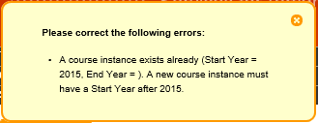 | When you are creating a new course (either by adding a course or altering the Start Year of an existing course) that has the same course code as another existing course, the year entered in the “Applicable From Start Of“ (Start Year) field must be after the start year of the latest instance of the course.  E.g. if you are creating a new course with Course Code AGRI2007, and there is an existing course AGRI2007 with a start year of 2013, the new course you are creating must have an “Applicable From Start Of“ value of 2014 or later.
New course instance must not overlap with the latest course instance (Start Year = yyyy, End Year = yyyy).  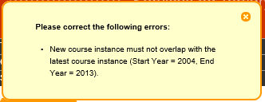 | When you are creating a new course (either by adding a course or altering the Start Year of an existing course) that has the same course code as another prior course, the year entered in the “Applicable From Start Of“ (Start Year) field cannot be the same as or before the “Applicable To End Of“ (end year). This is because it will cause an overlap of the periods the courses are taught.  E.g. if you are creating a new course with Course Code AGRI2008, and there is an existing course AGRI2008 with an end year of 2015, the new course you are creating must have an “Applicable From Start Of“ value of 2016 or later.
Another pending course change request already exists for this course. | Editing or adding a new course creates a course change request that must be approved by the Agency.  If there is an existing pending course change request that is awaiting approval for a course that has the same Course Code, you cannot add a new course until the pending change request has been reviewed and approved.  E.g. if you are creating a new course with Course Code AGRI2009, and there is a pending Course Change Request for a prior instance of AGRI2009, you will not be able to create this course until it has been approved.
End date cannot overlap with the next course instance (Start Year = yyyy).  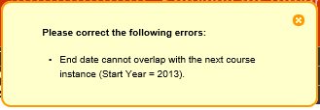 | When updating an existing course, you cannot have the Applicable To End Of (End Year) field overlap with the Start Year of any subsequent instances. This applies to all course instances that share the same course code, not just the latest instance.  E.g. if you are editing an existing course with Course Code AGRI2015, the End Year cannot be set to be equal to or after the Start Year of the next instance of the course AGRI2015.

SDR Processing
The Single Data Return (SDR) is a set of data items that are specifically required by the Ministry of Education (MoE) and the Tertiary Education Commission (TEC) for funding, monitoring performance against Investment Plans, publishing performance information, as well as statistical reporting purposes.
All TEOs that receive the Student Achievement Component and/or have students with Student Loans or Allowances are required to complete an SDR.
The main benefit of the SDR is that it provides one central point for the collection, processing and delivery of information from TEOs to education agencies.
TEOs extract data from their SMSs, creating data files in the format specified in the SDR manual. The Single Data Return (SDR) is comprised of five data files as described:
            - Student (STUD)
            - Enrolment (COUR)
            - Course Register (CREG)
            - Course Completion (COMP)
            - Qualification Completion (QUAL)
A copy of the latest SDR Manual and Appendices can be found at http://www.steo.govt.nz/sdr/sdr-manuals/.
The SDR Validation tab allows you to access the following pages and functionalities:
- SDR Validation Summary
- Validate New SDR
- Summary Report
- SDR Broad Summary Report
- SDR Detailed Summary Report
- Course Completion Summary Report
- Qualification Completion Summary Report
- Validation Error Report
- EFTS Forecast Update / View
- Course Difference Submit / View
- Course Completion Summary
- EFTS by Course
- SDR Submission
You can navigate to this section by clicking on SDR, then SDR Validation in the main menu.
Figure 115 – Accessing SDR Validation

SDR Validation Summary
The SDR Validation Summary is the default page when you navigate to the SDR Validation tab. By default, the SDR Validation Summary of the current Return Month is displayed, which is a visual representation of SDR Round. Each SDR Year is divided into 3 consecutive SDR Rounds, referred to as the April, August and December SDR Rounds.
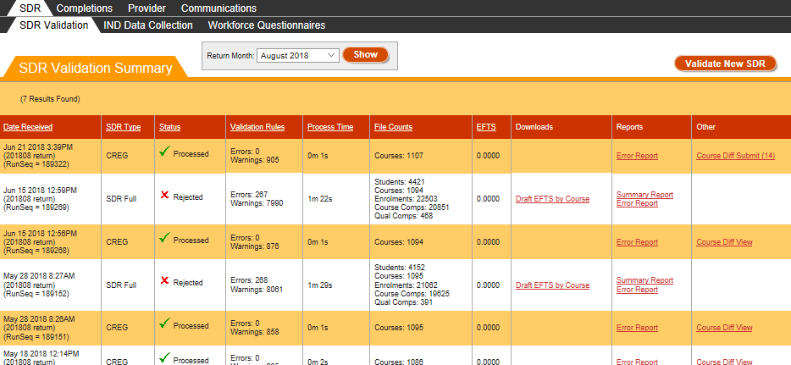
Figure 116 – SDR Validation Summary
You can sort the results by clicking on the column header titles as previously described in the Sorting Search Results section.
You can view returns from other Round periods by selecting a different month from the Return Month dropdown.

Validate New SDR
You can access the Validate New SDR page by clicking on the Validate New SDR button, as shown below:
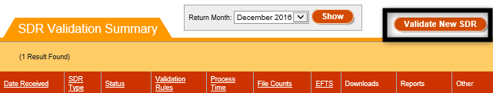
Figure 117 – Accessing Validate New SDR
The SDR Validation process is a multi-step process, with the following steps:
- Select SDR File Type
- Upload SDR Files
- Select SDR Return Month
- Confirmation

Select SDR File Type
The first step of the SDR Validation process is shown below:
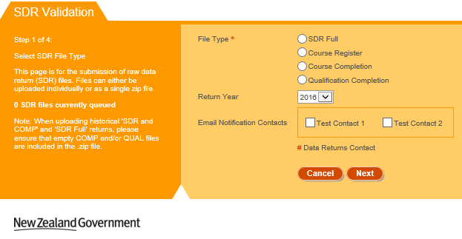
Figure 118 – Step 1 of SDR Validation
The Return Year will default to the year of the selected Return Month in the SDR Validation Summary page.
You must select a File Type to proceed. You can select from one of four File Types:
- SDR Full – comprised of STUD, COUR, CREG, COMP and QUAL files
- Course Register – CREG file only
- Course Completion – COMP file only
- Qualification Completion – QUAL file only
Please refer to the Validating Other File Types section for SDR Processing of the CREG, COMP or QUAL files.
You may optionally select one or more contacts to specify who receives email notifications of the progress of your SDR processing. The contacts are populated from the list of contacts in your organisation in the Contacts List who are not EDUMIS contacts.
Contacts marked with a red hash symbol (#) are contacts that have the Contact Role “Data returns” assigned to them, as shown below:
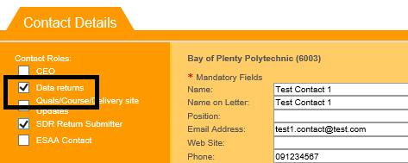
Figure 119 – Data Return Contacts
Clicking on will take you to the Upload SDR Files step of the Validate SDR Process.
Clicking will return you to the SDR Validation Summary page.

Upload SDR Files
The second step of the Validate New SDR process is shown below:
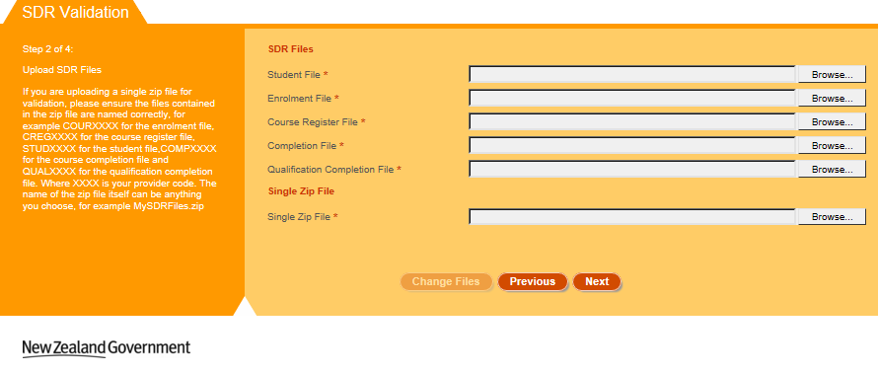
Figure 120 – Step 2 of SDR Validation (SDR Full)
Please note that the page shown in Figure 120 assumes that you have selected SDR Full in the Select SDR File Type page.
It is assumed at this stage that you will have created the required files, either manually or from your SMS. In addition, all qualifications and courses recorded in the files must already be created and approved in STEO (that is, they exist in Qualification Register and Course Register).
Click Browse and select the relevant files to upload.
Please note that if any of the files are larger than 20 megabytes (MB), you will have to compress them into a single .zip under 20 MB. Further details can be found in Maximum File Size when Uploading.
If a single zip file is selected, please ensure that the files in the .zip file are named correctly, e.g. for the provider code 1111 the following files are expected for SDR Full:
- STUD1111.txt
- COUR1111.txt
- CREG1111.txt
- COMP1111.txt
- QUAL1111.txt
Clicking on will take you to the Select SDR Return Month step of the Validate SDR Process.
Clicking on will take you to the Select SDR File Type step of the Validate SDR Process.
Clicking on will remove all uploaded files. You will remain on the same page.

Select SDR Return Month
The third step of the Validate New SDR process is shown below:
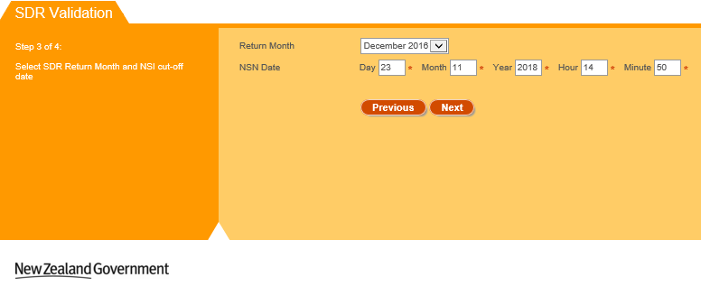
Figure 121 – Step 3 of SDR Validation (SDR Full)
The Return Month will default to the current Return Month of the selected year in the SDR Validation Summary page. For historical years, it will default to the December return of the selected year.
For SDR Full returns, the NSN Date will default to the current date and time.
Clicking on will take you to Confirmation step of the Validate SDR Process.
Clicking on will take you to the Upload SDR Files step of the Validate SDR Process.

Confirmation
This is the final step of the SDR Validation Process.
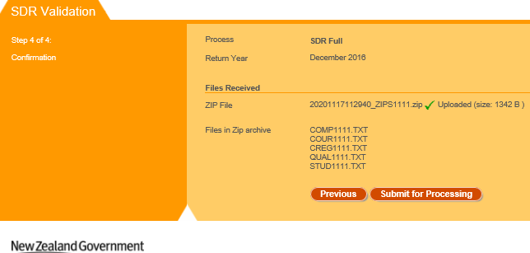
Figure 122 – Step 4 of SDR Validation
This page displays a brief summary of the uploaded files and the return month.
Clicking on will add the uploaded SDR files to the queue for processing. See SDR Processing and Results for more information.
Clicking on will take you to the Select SDR Return Month step of the Validate SDR Process.

Validating Other File Types
The pages shown will be slightly different if you elect to upload a file that is not a SDR Full type. These are:
- Course Register – CREG file only
- Course Completion – COMP file only
- Qualification Completion – QUAL file only
Please note: Some File Types may require you to have submitted a SDR Full for the current round (e.g. Course Completion and Qualification Completion).
The following restrictions apply to some of the File Types:
- CREG – A CREG file can be processed on its own at any time of the year and there is no requirement to process a SDR Full file first. New courses that do not exist in the Course Register can be added as part of CREG only processing. This creates course differences that can be submitted for approval as shown in Error! Reference source not found.Error! Reference source not found..
- COMP – A COMP file can be processed on its own as long as the SDR Full is submitted for the selected year and return
- QUAL – A QUAL file can be processed on its own as long as the SDR Full is submitted for the selected year and return
If you select Course Completion (COMP) or Qualification Completion (QUAL) as the File Type, please note that you cannot process a COMP or QUAL for a given Return Year if a SDR Full return has been successfully submitted for a later year. In this situation, you will get an error message as shown below:
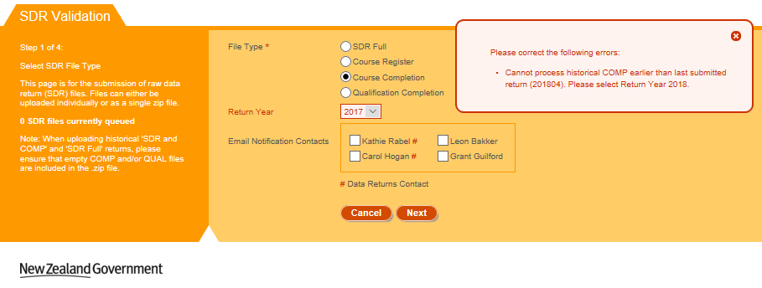
Figure 123 – Error Message when Processing Historical QUAL or COMP
Selecting any of the other File Type options such as Course Register, Completion, or Qualification Completion will only display one file for upload, as shown in Figure 124 below:
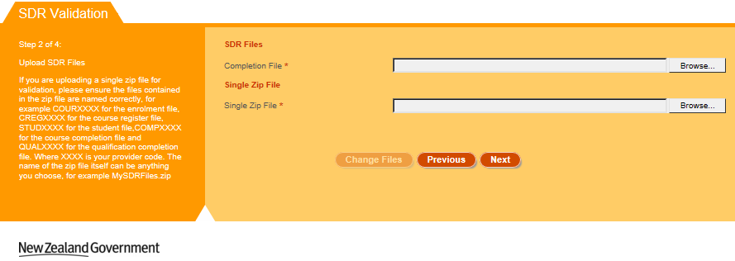
Figure 124 – Step 2 of SDR Validation (Other File Types)
Selecting any of the other File Type options such as Course Register, Completion, or Qualification Completion will only display the Return Month as shown in Figure 125 below:
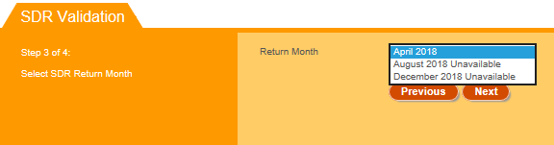
Figure 125 – Step 3 of SDR Validation (Other File Types)
Please note for Course Completion (COMP) or Qualification Completion (QUAL) file types, you must first process and submit SDR Full files for the given Return Month. If you have not submitted the SDR Full, the Return Month will be shown as “Unavailable” as shown in Figure 126:
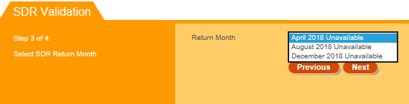
Figure 126 – SDR Return Month Unavailable for Processing

SDR Processing and Results
After you click in the final step of the SDR Validation process (Confirmation), the uploaded files will be added to the queue for processing, as shown below:
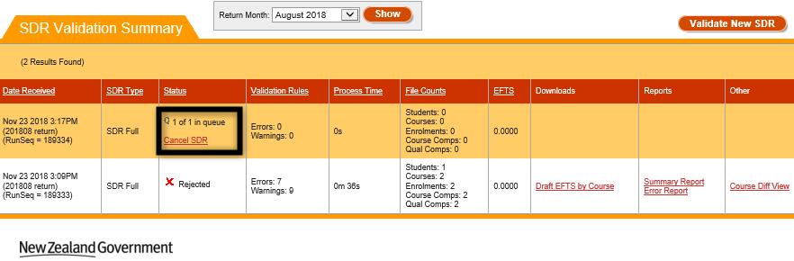
Figure 127 – SDR Processing Queue
Clicking on Cancel SDR will allow you to cancel the SDR Validation before it starts processing. Once the SDR Processing has begun, the status will switch to “In Progress” as shown below:
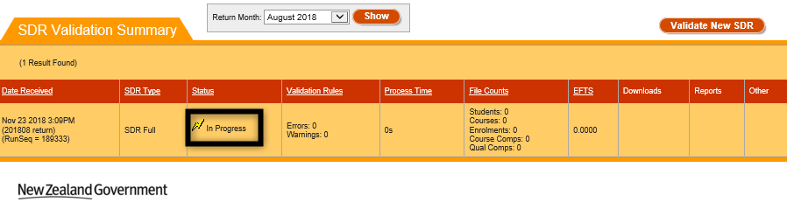
Figure 128 – SDR Validation Processing in Progress
You will be unable to cancel SDR Validation once it is “In Progress”. Clicking while SDR Validation is in progress will refresh the page. When the processing of the SDR Validation has been completed, the results of validation will be shown in the Status field.
If the SDR Validation is successfully processed with no errors (warnings are fine), and the file was processed within the SDR Round period, the following status will be shown as per Figure 129.
If any warnings were present the link Error Report will be shown, which will take you to the Validation Error Report.
Clicking on Submit SDR Full will allow you to perform SDR Submission.
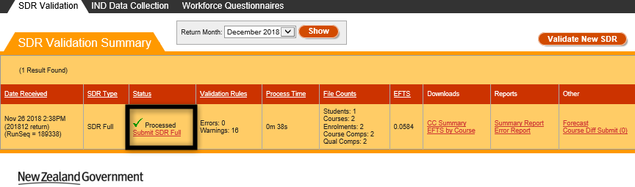
Figure 129 – SDR Processed Successfully during SDR Round
If you processed an SDR Full return successfully within the SDR Round period, but did not submit by the due date for each round, you will not see a Submit SDR Full Link.
Please note that you can contact TEC Sector Helpdesk to arrange for an extension to be granted so you can submit the SDR (as long as the SDR Round window is not over, which coincides with the beginning of the next SDR Round).
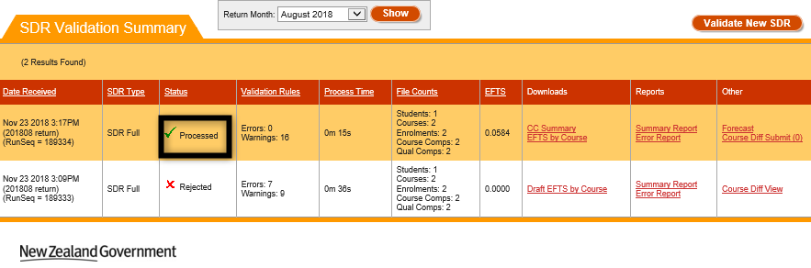
Figure 130 – SDR Processed during SDR Round but round period is expired
If the files were processed, but errors were present during validation, the status will read Rejected (as per Figure 131.
Clicking on the link Error Report will take you to the Validation Error Report.
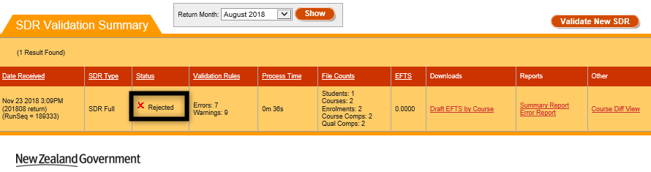
Figure 131 – SDR Processed and Rejected
If the files have some unexpected data issues that could not be handled during processing and validation, the processing will be aborted, and the status will read Unknown Error as shown in Figure 132. Please contact the Education Service Desk for assistance in this situation.
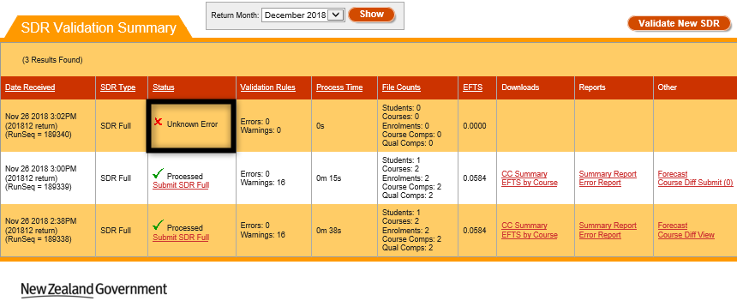
Figure 132 – SDR File Not Processed due to Unknown Error
If your files were processed successfully without errors, but you have missed SDR Submission for the SDR Round window, you will see the “Too late for SDR” message below the Processed Status, as shown in Figure 133:
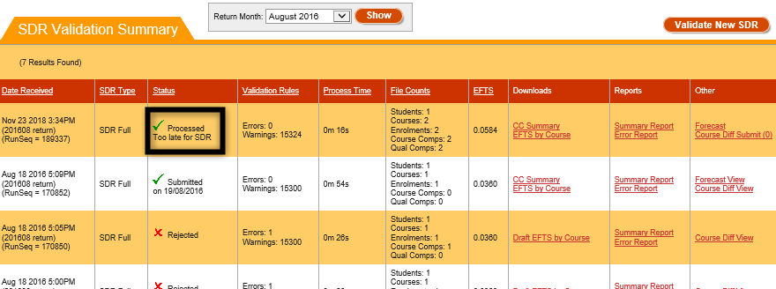
Figure 133 – SDR Processed but Too Late for SDR
If your files were processed successfully without errors, but you have processed them before the SDR Round window, you will see the “Too early for SDR” message below the Processed Status, as shown in Figure 134:
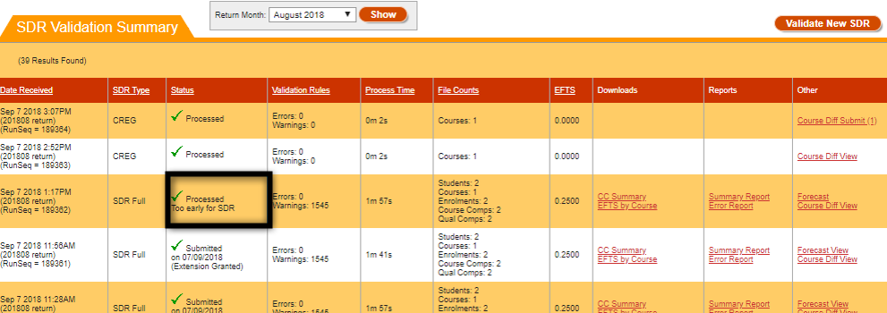
Figure 134 – SDR Processed but Too Early for SDR
If you submitted a single Qualification Completion file for your return, and it was processed successfully, you will see a Submit QUAL link under the processed status:
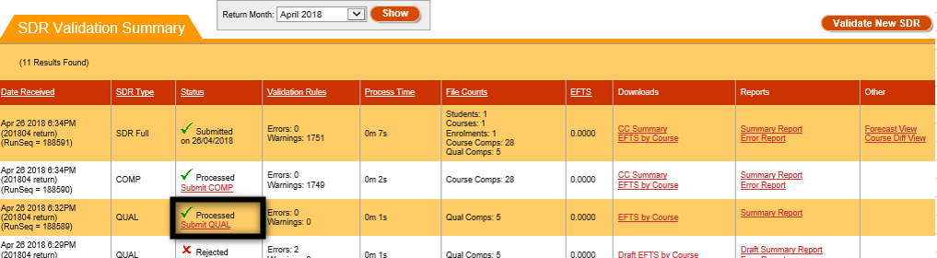
Figure 135 – Qualification Completion Processed Successfully
If you submitted a single Course Completion file for your return, and it was processed successfully, you will see a Submit COMP link under the processed status:
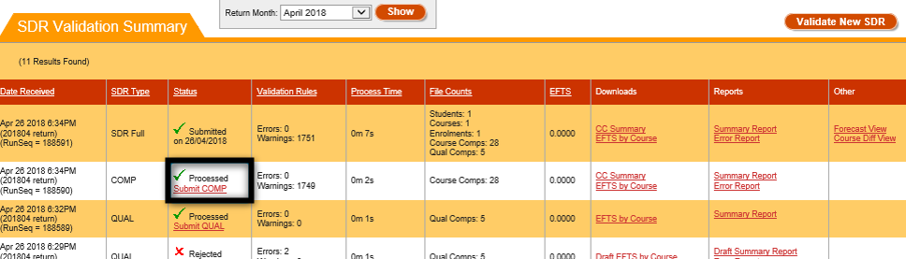
Figure 136 – Course Completion Processed Successfully
Please note that QUAL and COMP files Submission does not require extension to be granted. That is only applicable to SDR Full.
If you submitted a single Course Register file for your return, and it was processed successfully, it will be shown as “Processed” as shown in Figure 137. Please note that CREG files do not require submission as it’s a single phase operation.
Figure 137 – Course Register Processed Successfully

Summary Report
The Summary reports page consists of several reports that you can view after your SDR Validation has been completed. You can access it by clicking on the Summary Report link shown below:
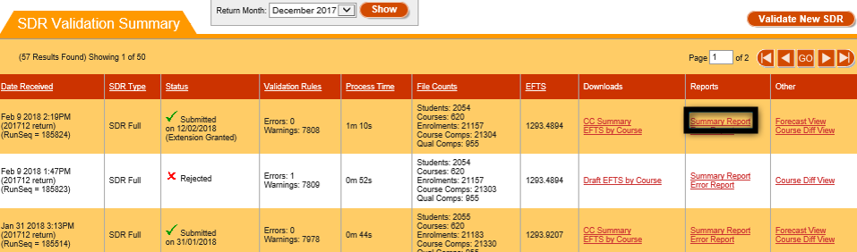
Figure 138 – Accessing Summary Report
The Summary Report page will be shown to you as per the figure below:
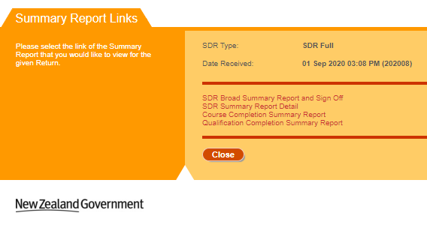
Figure 139 – Summary Report Page for Successfully Validated SDR
Please note that if the SDR Validation was completed with errors, each of the following reports will be preceded with the word Draft as shown in Figure 140.
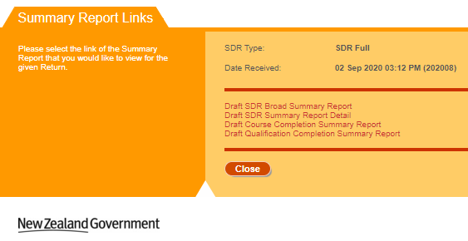
Figure 140 – Summary Report Page for SDR Validation with Errors
The following reports can be accessed by clicking on the respective links:
- SDR Broad Summary Report and Sign Off
- SDR Detailed Summary Report Detail
- Course Completion Summary Report
- Qualification Completion Summary Report
Clicking on will return you to the SDR Validation Summary page.

SDR Broad Summary Report
When you use the validation program a broad summary report is generated. The broad summary is provided so that you can check student numbers and thus ensure that there are no obvious inconsistencies. The broad summary is also used to certify that your data files are accurate and that they have been validated in accordance with the Ministry's standards.
The broad summary report sign-off page must be signed by your Chief Executive or nominee and only the sign-off page is required to be returned via email to the Ministry. Please ensure that the broad summary report sign-off page has been signed BEFORE emailing to the address published on the broad summary report page.
You can access the SDR Broad Summary Report by clicking on the SDR Broad Summary Report and Sign Off or the Draft SDR Broad Summary Report link from the Summary Report page.
Note: There will not be any Sign Off page for the Draft SDR Broad Summary Report.

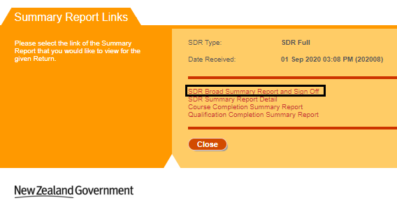
Figure 141 – Accessing SDR Broad Summary Report
When you access the SDR Broad Summary Report, it will be opened in a new tab or window of your web browser. You will be able to print it off as needed.

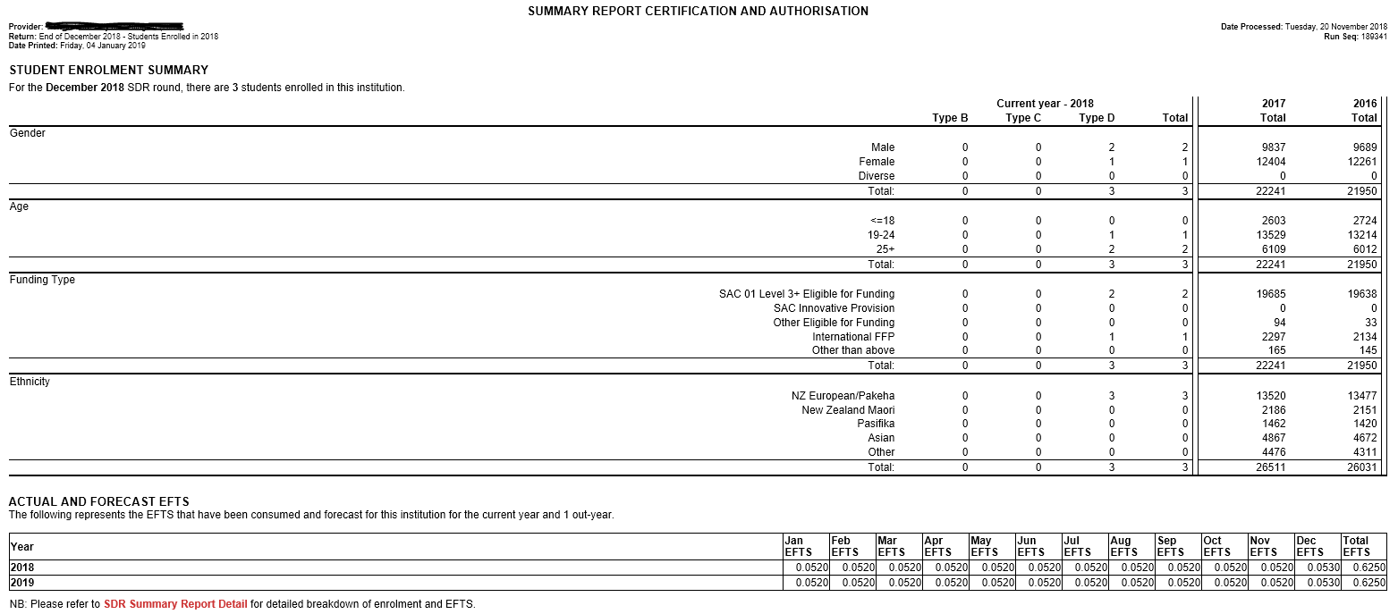
Figure 142 – SDR Broad Summary Report
If you click on the SDR Summary Report Detail link in the SDR Broad Summary Report, you will be taken to the SDR Detailed Summary Report.
The Funding Type section in the SDR Broad Summary Report is classified for different Source of Funding as below:
Funding Type | Source of Funding (SoF)
SAC 01 Level 3+ Eligible for Funding | 01
Other Eligible for Funding | 22, 23, 24, 25, 26, 27, 28, 29, 30, 32, 33, 35, 36
International FFP | 02
SAC Innovative Provision | 34
Other than above | Other SoF which is not listed above

SDR Detailed Summary Report
The SDR Detailed Summary Report contains a more detailed breakdown of enrolment and EFTS than what is contained in the SDR Broad Summary Report.
You can access the SDR Detailed Summary Report by clicking on the SDR Summary Report Detail or the Draft SDR Summary Report Detail link from the Summary Report page or by clicking on the SDR Summary Report Detail link in the SDR Broad Summary Report.

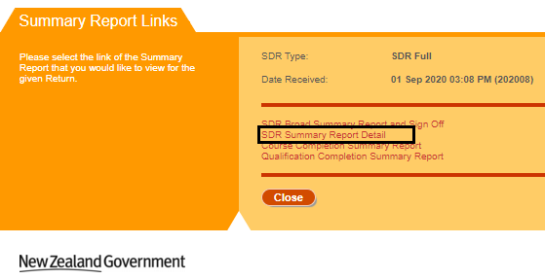
Figure 143 – Accessing SDR Detailed Summary Report
When you access the SDR Detailed Summary Report, it will be opened in a new tab or window of your web browser. You will be able to print it off as needed.
The following sections are shown in the SDR Detailed Summary Report:
- Student Enrolment Summary
This section shows the count of students for each student type and their total count under each listed category. It also shows the total count for two previous years.

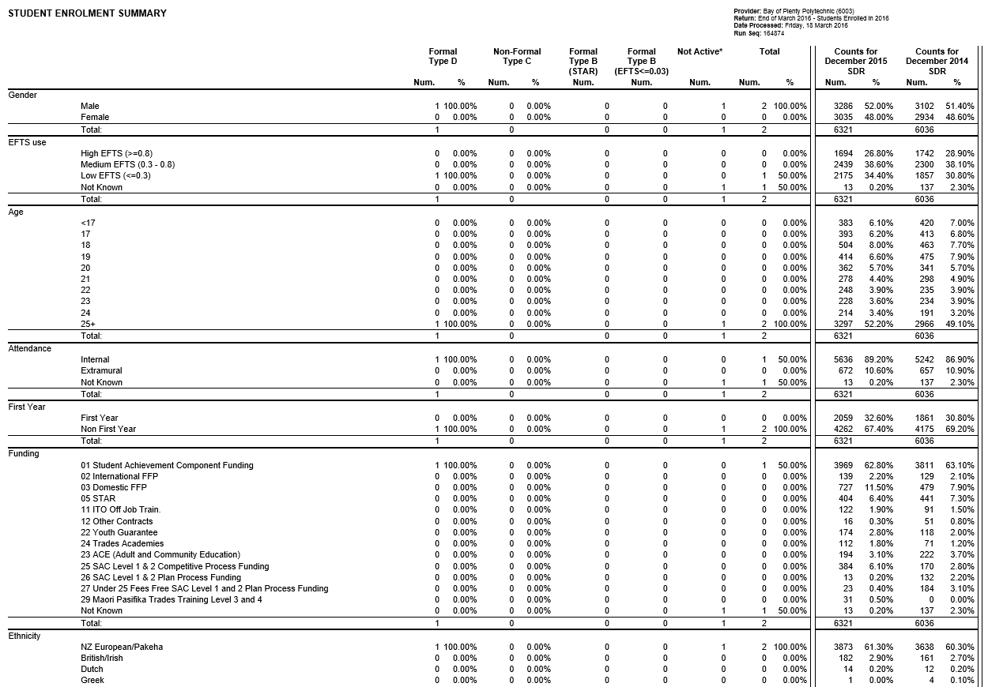
Figure 144 – SDR Detailed Summary Report – Student Enrolment
- EFTS Consumed by Source of Funding
This section shows the monthly EFTS and Total EFTS grouping by the funding source given in the enrolment file.
Figure 145 – SDR Detailed Summary Report – EFTS Consumed
- Actual and Forecast EFTS by Course Classification
This section shows the monthly EFTS and Total EFTS based on the course classification and funding category given in the enrolment file.
Note: The forecast data which are manually updated via the EFTS Forecast Update / View page will be reflected here.
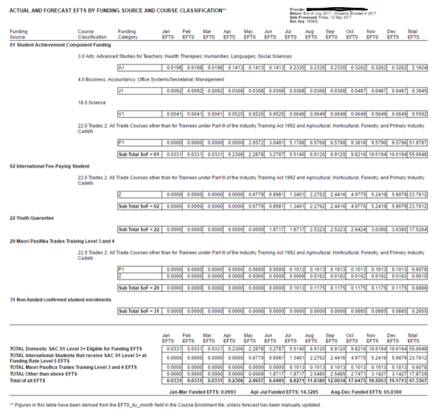
Figure 146 – SDR Detailed Summary Report – Actual and Forecasted EFTS
Note: Any enrolment with Source of Funding different from 01, 29 or 34 will be counted towards Funding Category Z (regardless of which Funding Category was used in the enrolment). Where Source of Funding is 01, 29 or 34 the actual funding category submitted with the enrolment is used and the Course Classification/Funding Category EFTS breakdown is displayed.

- Forecast EFTS
This section shows the Forecast EFTS (monthly and Total) for the funded and non-funded source of funding the student is enrolled for the course for the SDR processed year and four out years.
Note: The forecast data which are manually updated via the EFTS Forecast Update / View page will be reflected here.
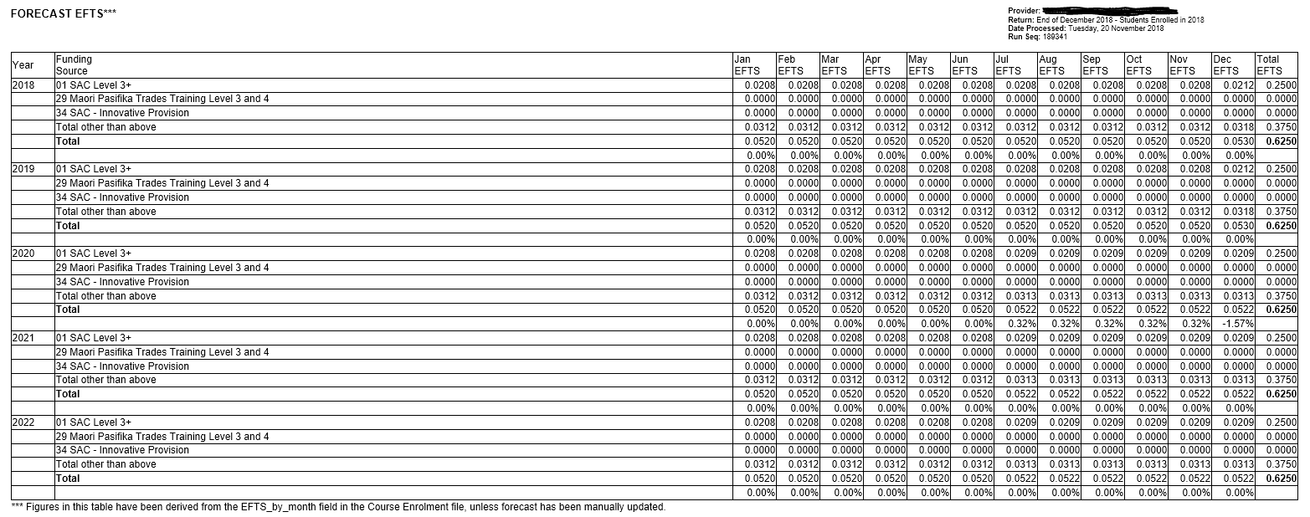
Figure 147 – SDR Detailed Summary Report – Monthly and Total Forecasted EFTS

Course Completion Summary Report
You can access the Course Completion Summary Report by clicking on the Course Completion Summary Report or the Draft Course Completion Summary Report link from the Summary Report page.
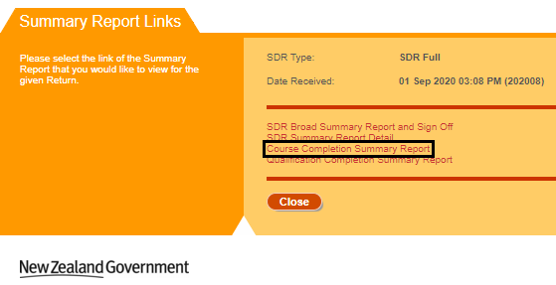
Figure 148 – Accessing Course Completion Summary Report
When you access the Course Completion Summary Report, it will be opened in a new tab or window of your web browser. You will be able to print it off as needed.
The following sections are shown in the Course Completion Summary Report:
- Course Count for Each Year
The first section shown in Figure 151 displays the courses count against each completion code for each year reported in the Course Completion file.

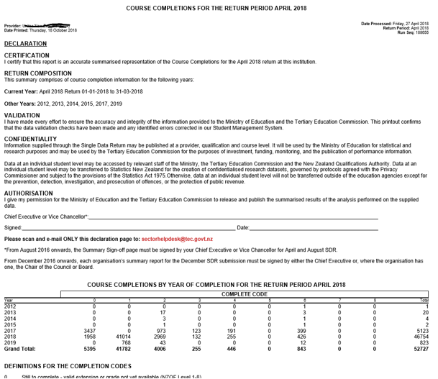
Figure 149 – Course Completion Summary Report – Course Count for Each Year
- Course Count for the SDR Round
The second section shown below displays the courses count against each completion code for the SDR processed round and for all the courses reported in the Course Completion file.
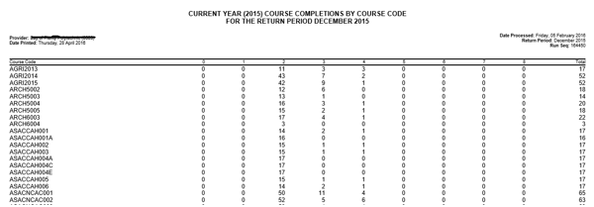
Figure 150 – Course Completion Summary Report – Course Count for SDR Round
- Course Count for PBRF Courses
The third section is displayed only if PBRF courses (i.e. courses that have PBRF flags in either M, D, L or C in Course Register) are entered in the Course Completion file. The section shown below displays the courses count for PBRF courses against each completion code for the SDR processed round and for each PBRF course reported in the Course Completion file.
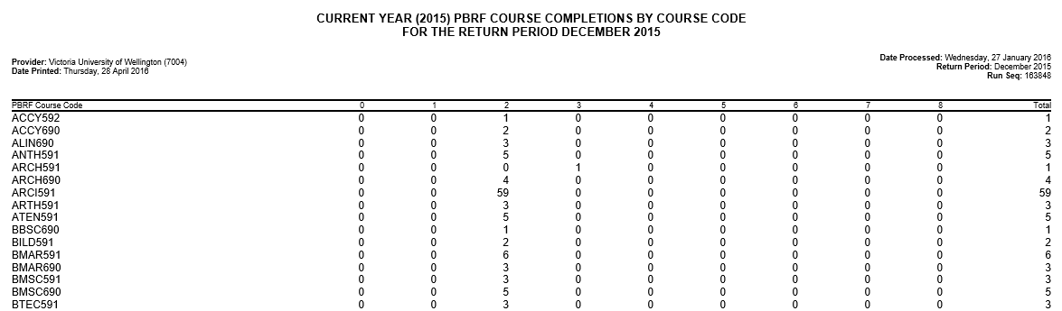
Figure 151 – Course Completion Summary Report – Course Count for PBRF Courses
- Historical Course Count
The additional sections will be displayed for each historical year depending on the historical course completion years if any are reported in the Course Completion file starting from lowest to highest. An example is shown below:
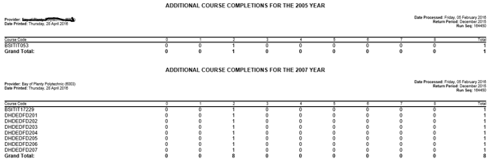
Figure 152 – Course Completion Summary Report – Course Count for Historical Years
- Future Completed Course Count
The last section shows the courses count that will be completed in the next year (SDR processed year + 1) if any are reported in the Course Completion file as below.
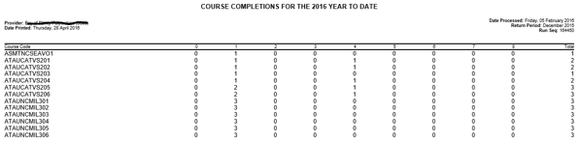
Figure 153 – Course Completion Summary Report – Future Completed Course Count
Please note that if the Course Completion file has any PBRF courses that are completing in the next year (SDR processed year + 1) reported then an additional section will be displayed:
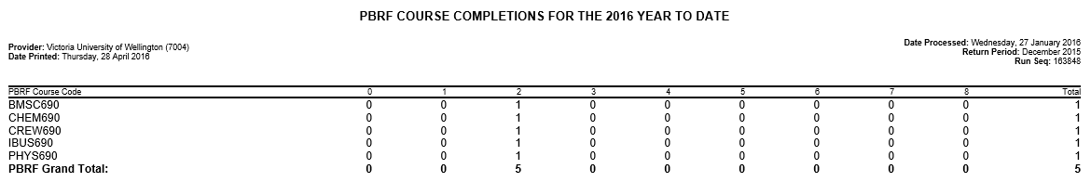
Figure 154 – Course Completion Summary Report – Future Completed PBRF Course Count

Qualification Completion Summary Report
You can access the Qualification Completion Summary Report by clicking on the Qualification Completion Summary Report or the Draft Qualification Completion Summary Report link from the Summary Report page.
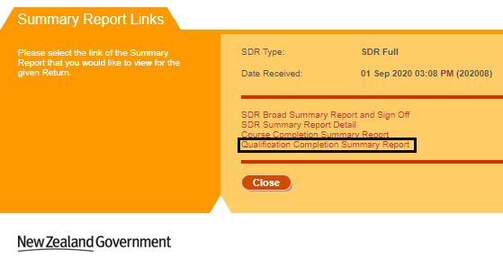
Figure 155 – Accessing Qualification Completion Summary Report
When you access the Qualification Completion Summary Report, it will be opened in a new tab or window of your web browser. You will be able to print it off as needed.
The following sections are shown in the Qualification Completion Summary Report:
- The first section displays the qualifications count for 4 completion years (from SDR processed year to three previous years) for each Qualification Award Category (QAC) reported in the Qualification Completion file shown in Figure 156:
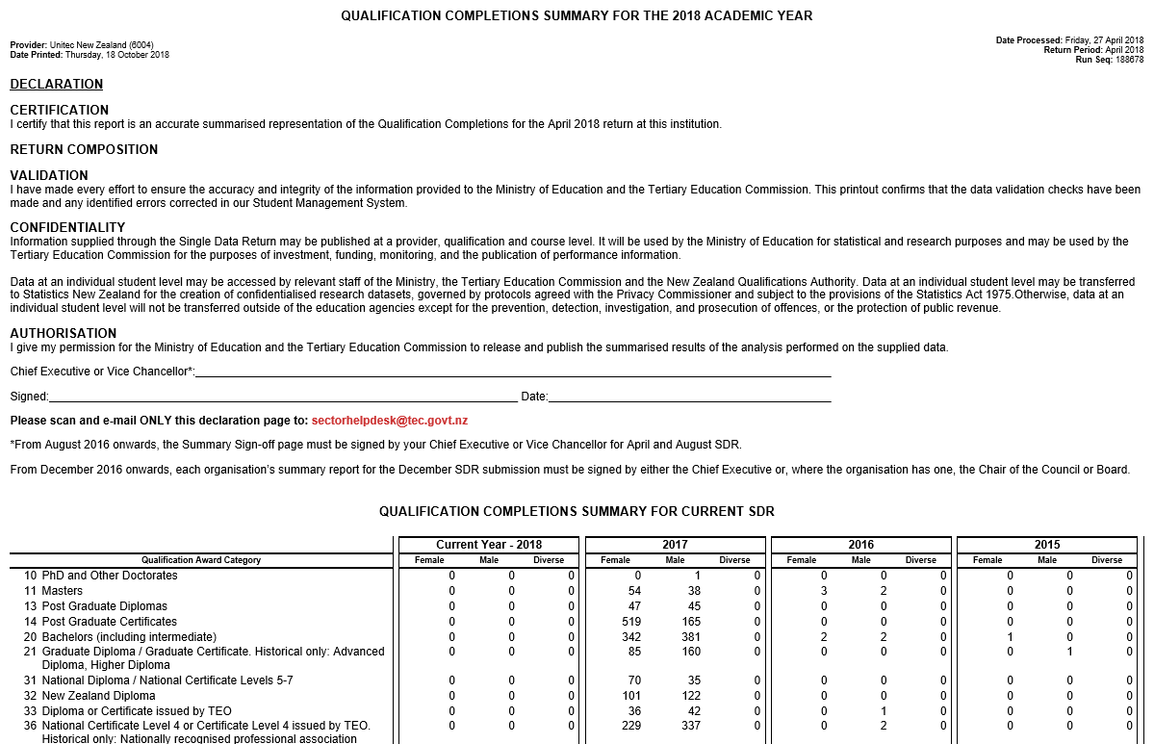
Figure 156 – Qualification Completion Summary Report – Qualification Count for 4 Years for Current SDR

- The next section displays the qualifications count for 4 completion years (from SDR processed year to three previous years) for each Qualification Award Category reported in the Qualification Completion file that are not part of the currently processed SDR but from the latest submitted Qualification Completion data.
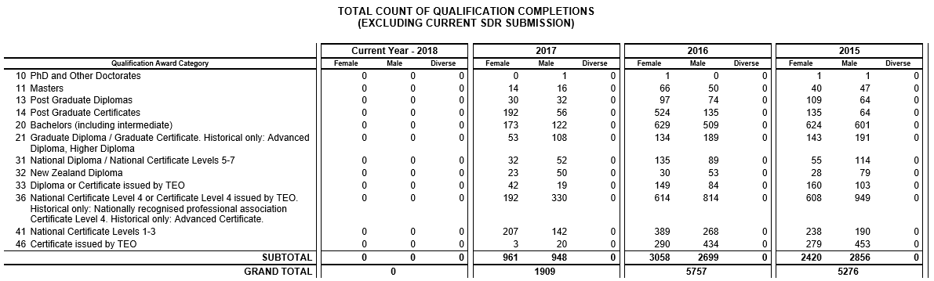
Figure 157 – Qualification Completion Summary Report – Qualification Count for 4 Years not part of Current SDR

- The next section shows the breakdown of qualifications count based on the QAC and Qualification code reported in the Qualification Completion file for the SDR processed year.
Figure 158 – Qualification Completion Summary Report – Qualification Count for Current SDR Year

- The additional sections that show the breakdown of qualifications will be displayed for each historical year depending on the historical qualification completion years if any are reported in the Qualification Completion file starting from lowest to highest. An example is shown below.
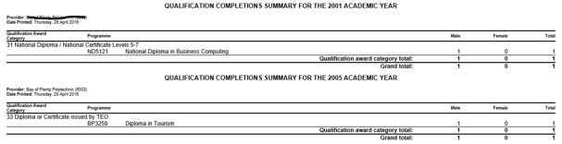
Figure 159 – Qualification Completion Summary Report – Qualification Count for Historical Years

Validation Error Report
If your SDR files were rejected (or successfully validated but with warnings), you can access detailed information about the errors that need to be fixed, and warnings by clicking on the Error Report link in the SDR Validation Summary page:
Note: The list of SDR validation errors and warnings can be found in the latest SDR Manual and Appendices available at http://services.education.govt.nz/steo/sdr/sdr-manuals/.

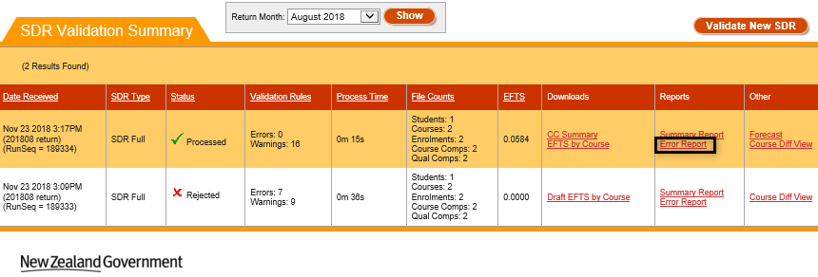
Figure 160 – Accessing Validation Error Report
The following page will be shown to you. You will be able to see all the errors and warnings that occurred during processing and the number of times the error occurred.
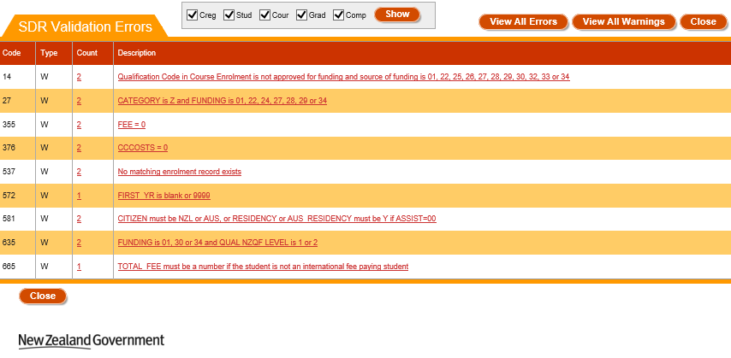
Figure 161 – SDR Validation Errors
You can filter the error and warning list to only display from particular return files by checking the checkboxes (Creg, Stud, Cour, Grad, and Comp) and clicking .
If you click View All Errors or View All Warnings, you be shown a detailed view of all the errors or warnings that occurred during processing in the View All Errors / View All Warnings page.
To view details of a particular error, click on the Description of the error or the Count to access the Validation Error Details.
Clicking on will return you to the SDR Validation Summary page.

View All Errors / View All Warnings
The View All Errors or View All Warnings page shows all errors or warnings that have occurred while processing the files. You can access it by clicking on View All Warnings or View All Errors while you are on the Validation Error Report page:
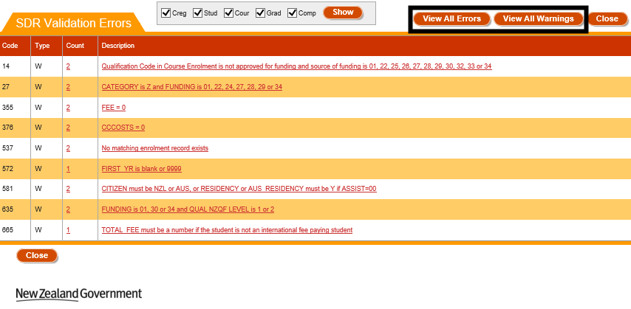
Figure 162 – Accessing View All Errors / View All Warnings
The following page will be shown:
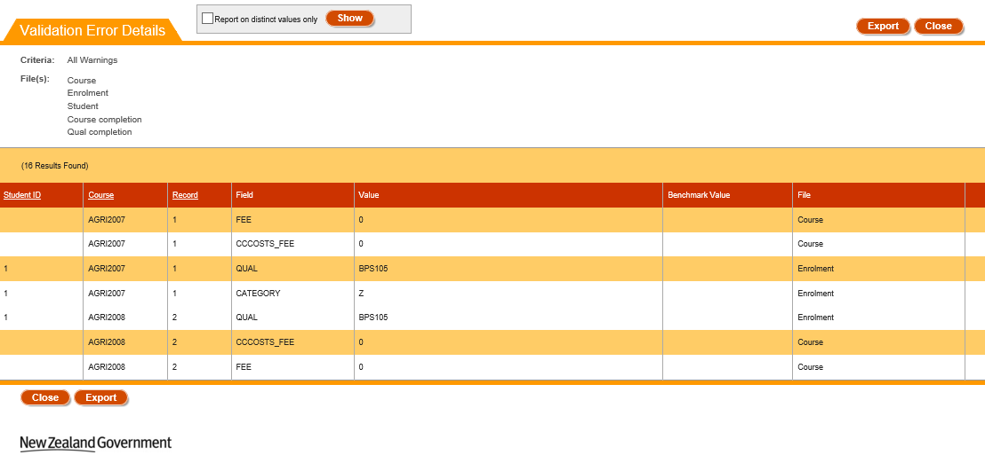
Figure 163 – View All Errors or View All Warnings
You can sort the results by clicking on the column header titles as previously described in the Sorting Search Results section.
You may wish to show only distinct records based on the following columns: Field, Value and File. You may do so by ticking the Report on distinct values only checkbox and clicking.
Some NSN Student errors will provide a link to the student’s NSN record. You can navigate to it by clicking on View NSN Record. Please note that this will open the NSI website (https://nsi.education.govt.nz) in a different window with the Single sign on from ESL if you have access to NSI page.
Clicking on will generate a .csv file that contains all the errors or warnings.
Clicking on will return you to the Validation Error Report page.

Validation Error Details
The Validation Error Details page shows all instances of a particular error or warning that have occurred while processing SDR files.
You can access this page by clicking on the Count or Description link for a given warning or error in the Validation Error Report:
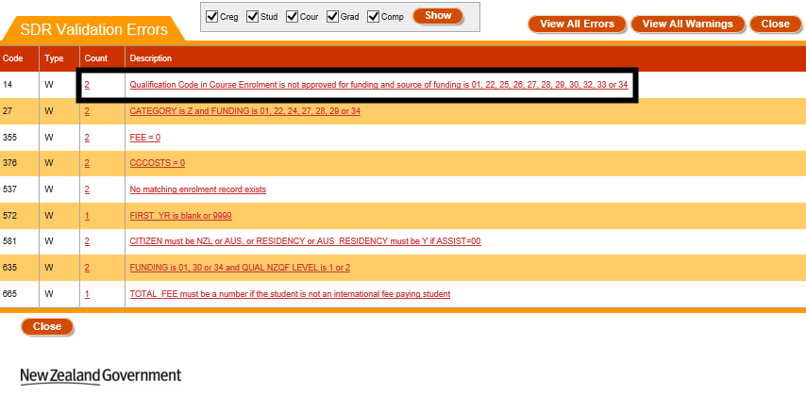
Figure 164 – Accessing Validation Error Details
The following page will be shown:
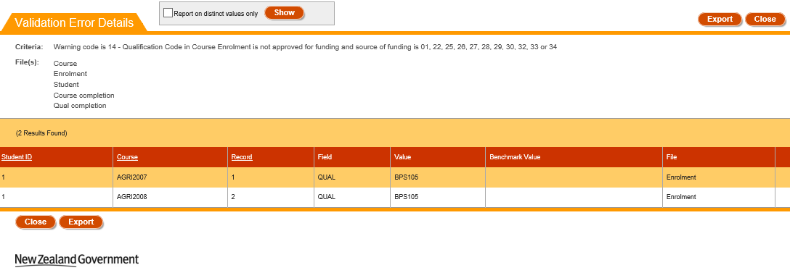
Figure 165 – Validation Error Details
You can sort the results by clicking on the column header titles as previously described in the Sorting Search Results section.
You may wish to show only distinct records based on the following columns: Value and File. You may do so by ticking the Report on distinct values only checkbox and clicking .
Some NSN Student errors will provide a link to the student’s NSN record. You can navigate to it by clicking on View NSN Record. Please note that this will open the NSI website (https://nsi.education.govt.nz) in a new window using your Single Sign On credentials from ESL if you have access to the NSI page.
Clicking on will generate a .csv file that contains all the errors or warnings.
Clicking on will return you to the Validation Error Report page.

EFTS Forecast Update / View
As part of the SDR submission process you need to provide EFTS forecast data for SAC 01 funding only. The information uploaded in your SDR files will produce an auto-generated forecast for the forthcoming periods, calculated for the current year and 4-out years. The current year and the first out year are broken down by month, and the other out years are in six months’ periods.
You can access the EFTS Forecast Update by clicking on the Forecast link, or the EFTS Forecast View by clicking on the Forecast View link from the SDR Validation Summary page.
Please note that the EFTS Forecast Update is only available for SDR Full returns that have been Processed with no errors. If the SDR Full return has been Submitted successfully, you will only be able to go to the EFTS Forecast View.
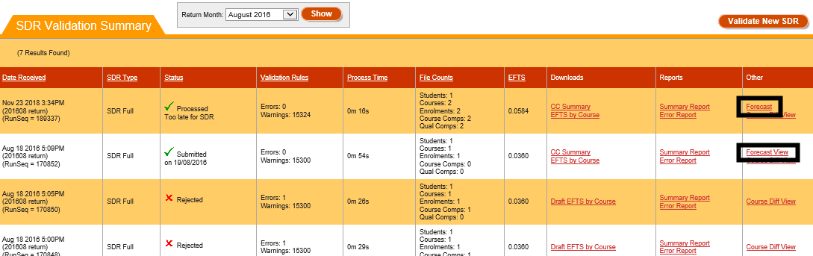
Figure 166 – Accessing EFTS Forecast Update / View
If you click on the Forecast View link, you will only be shown read-only data of the EFTS Forecast for the return:
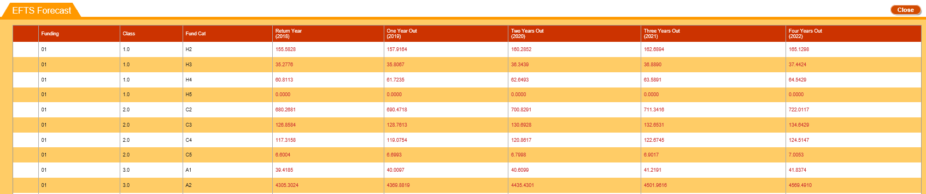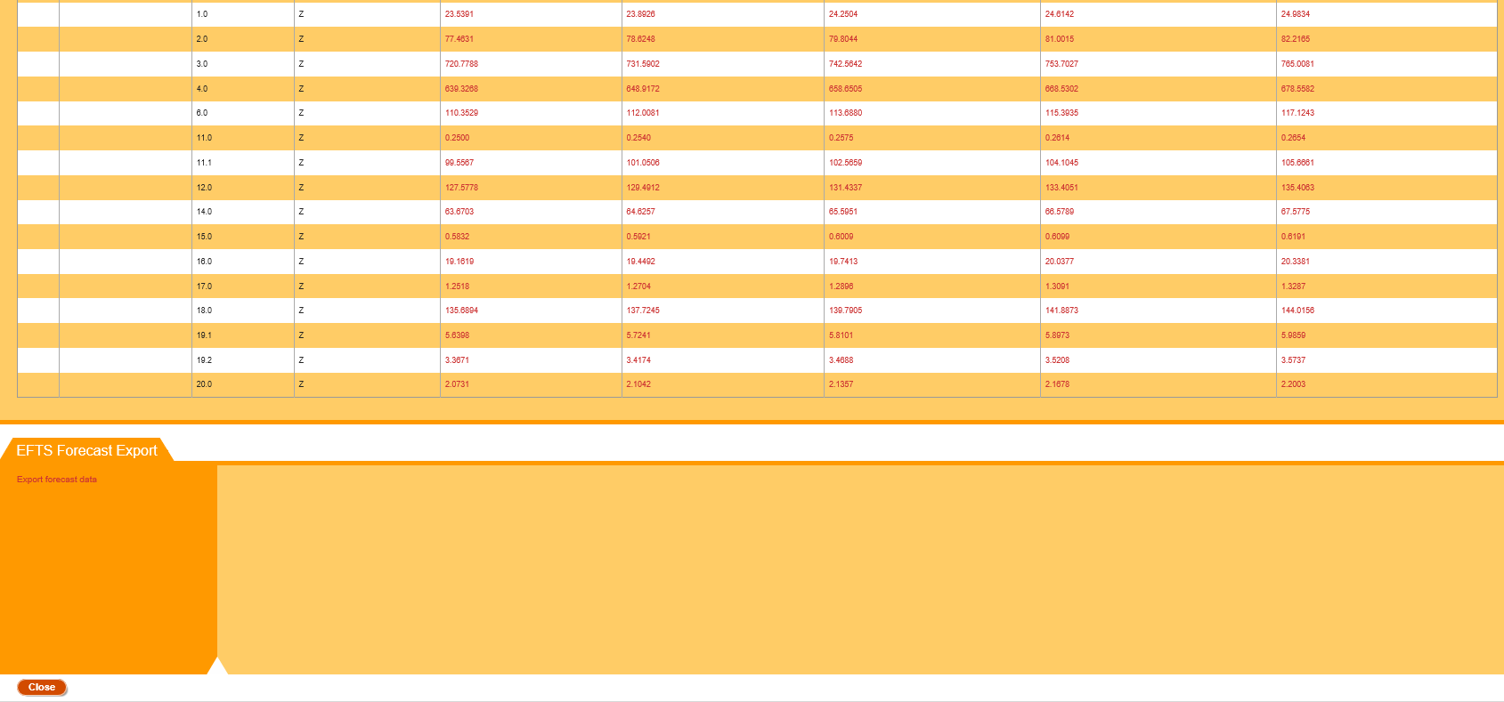
Figure 167 – EFTS Forecast View
Note: Any enrolment with Source of Funding different from 01, 29 or 34 will be counted towards Funding Category Z (regardless of which Funding Category was used in the enrolment). Where Source of Funding is 01, 29 or 34 the actual funding category submitted with the enrolment is used and the Course Classification/Funding Category EFTS breakdown is displayed.
You can click on the Click here to export forecast data link to export the EFTS Forecast data as a .csv file.
Clicking on will return you to the SDR Validation Summary page.
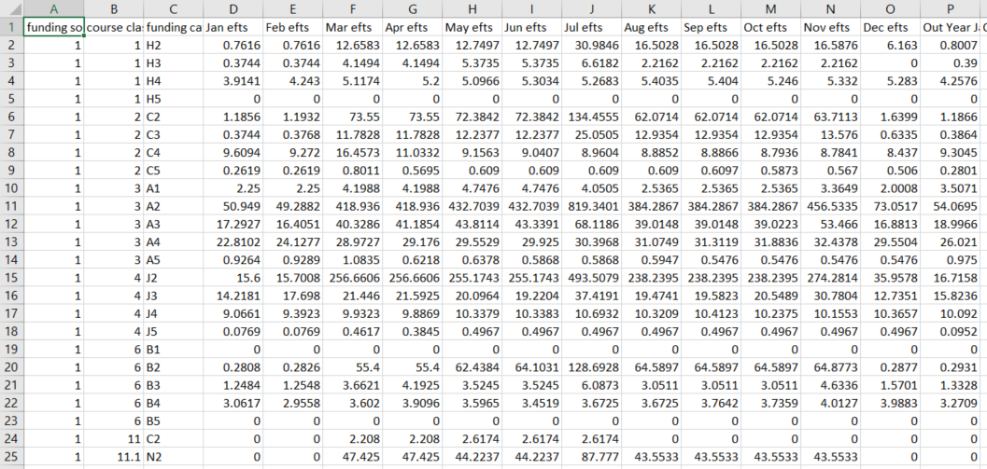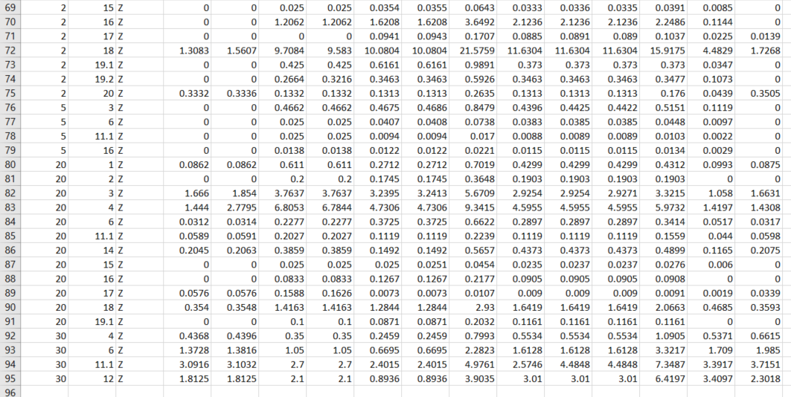
Figure 168 – EFTS Forecast Data Export
If you export the EFTS Forecast Data, you will be prompted to download and open or save the .csv file. It will be presented in a format similar to Figure 168.
If you click on the Forecast link, you will only be shown data of the EFTS Forecast for the return which you can update:

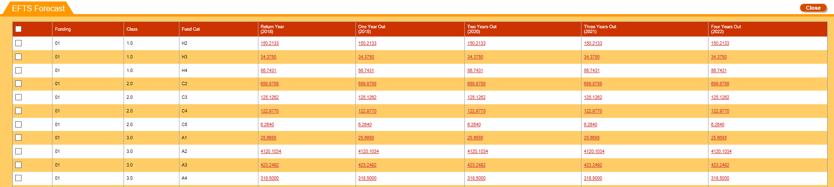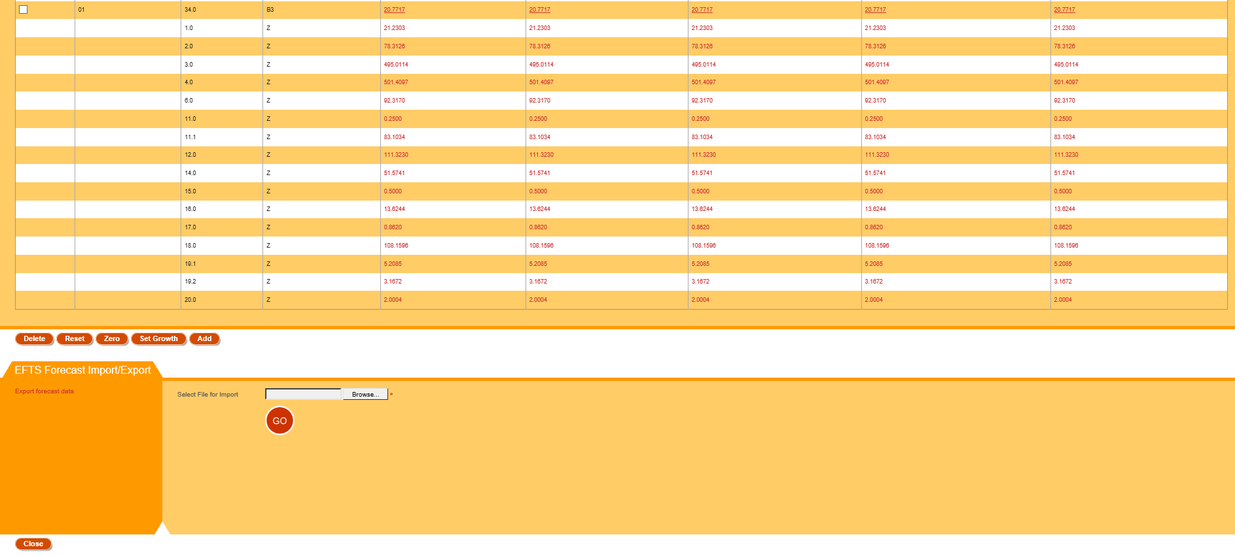
Figure 169 – EFTS Forecast Update

You can click on the Click here to export forecast data link to export the EFTS Forecast data as a .csv file. It will produce a .csv that looks like the one referenced in Figure 168.
You can select a .csv forecast file to import by clicking “Browse” button to add new forecast entries or update the existing values for the Funding Category and Course Class combination as mentioned in EFTS Forecast Upload.
Clicking on an EFTS Forecast row will take you to the Edit EFTS Forecast Entry page.
Clicking on will return all EFTS forecast entries to their initial values. All deleted forecast entries will be restored, and all newly added forecast entries will be removed.
Clicking on will set the values on the One Year Out, Two Years Out, Three Years Out, and Four Years Out fields for all EFTS forecast entries to 0.0000. In addition, this will also set the EFTS Forecast entries for the current year to 0.0000 for forecasted months (ignoring months with actual EFTS data). Refer to Zero EFTS Forecast for more information.
Clicking on will take you to the Set Forecast Growth page.
Clicking on will take you to the Add EFTS Forecast Entry page.
If you select one or more EFTS Forecast rows using the checkboxes and click, you will delete the selected EFTS Forecast entries.
Clicking on will return you to the SDR Validation Summary page.

Add EFTS Forecast Entry
The Add EFTS Forecast Entry page allows you to add a new EFTS Forecast entry to the EFTS Forecast of a return.
You can access this page by clicking on from the EFTS Forecast Update / View page when you are in the Update mode.
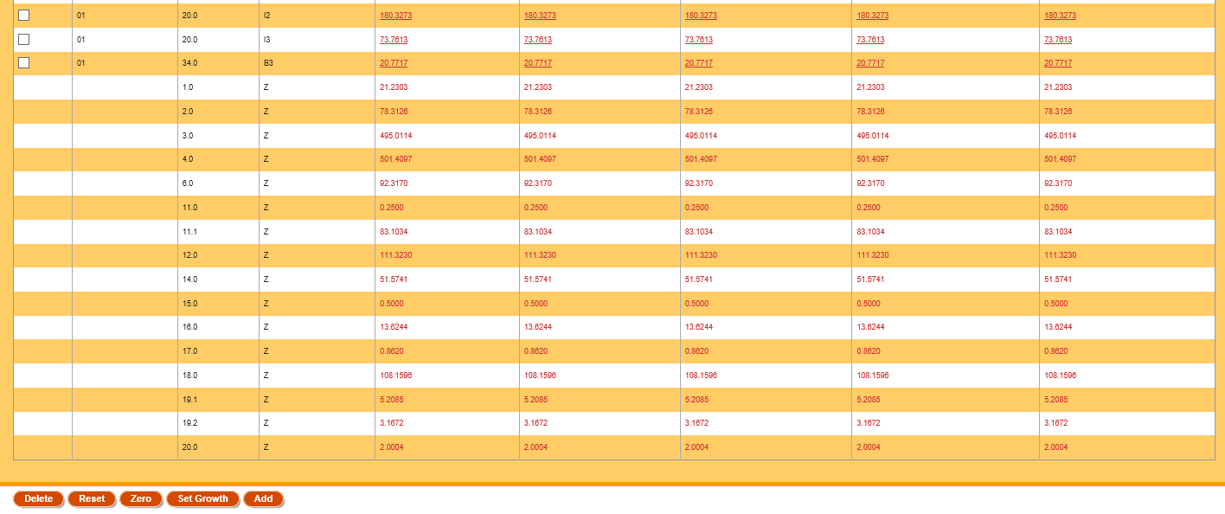
Figure 170 – Accessing Add EFTS Forecast Entry
The following page will be shown:
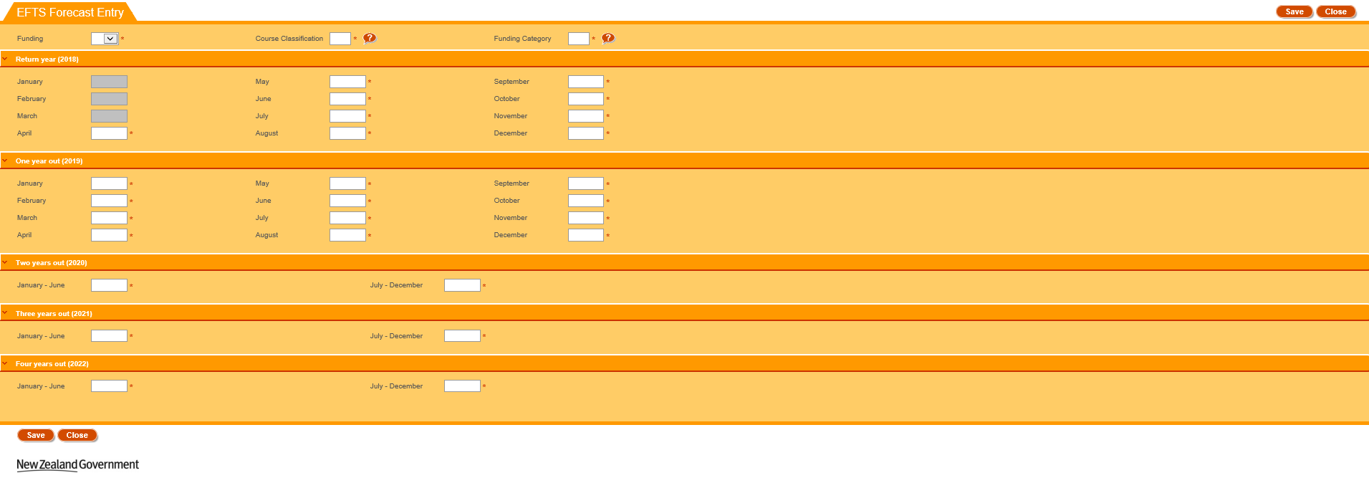
Figure 171 – Add EFTS Forecast Entry
The Funding dropdown allows you to select one of Source of Funding (currently 01, 29 or 34 only) for whom the Forecast entry can be created on the page.
The Course Class and Funding Category fields allow you to look up existing entries by clicking on the button. This is described in further detail in the Lookup Windows section.
Depending on SDR Round (April, August or December) the EFTS Forecast is associated with, some months’ fields for the current (return) year will not be editable as they represent the actual figures that you are not allowed to update. For example, if SDR Forecast is related to the April return, then all months prior to April for return year are greyed out as not editable (as per Figure 171).
Clicking on when you are on the Add EFTS Forecast Entry page will return you to the EFTS Forecast Update / View page.
Clicking on will save all your changes on the Add EFTS Forecast Entry page. If there are no errors, you will be shown a confirmation message:
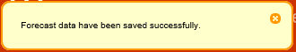
Figure 172 – Add EFTS Forecast Entry Save Confirmation Message

Edit EFTS Forecast Entry
You can access the EFTS Forecast Entry page by clicking on EFTS Forecast row in the EFTS Forecast Update / View page:
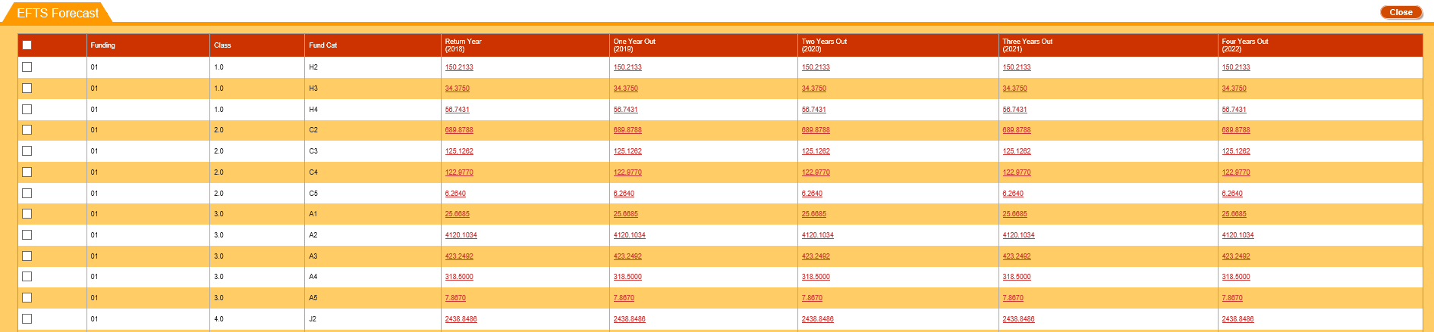
Figure 173 – Accessing EFTS Forecast Entry
The Edit EFTS Forecast Entry page will be displayed to you as below:
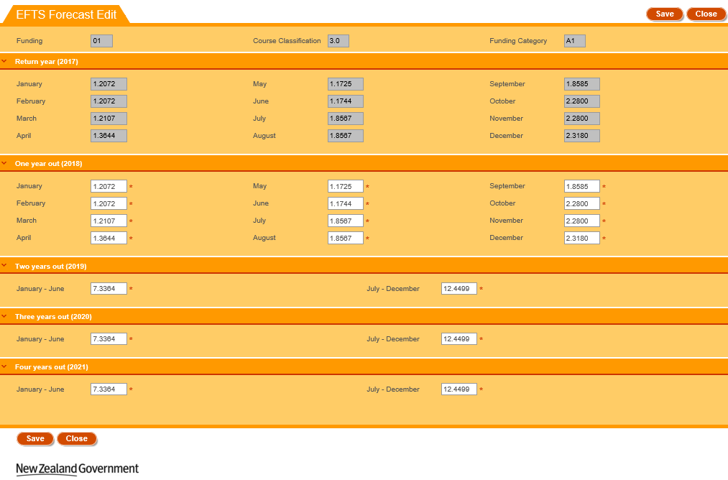
Figure 174 – Edit EFTS Forecast Entry
You will be unable to change the Funding, Class and Funding Category fields.
Depending on SDR Round (April, August or December) the EFTS Forecast is associated with, some months’ fields for the current (return) year will not be editable as they represent the actual figures that you are not allowed to update. For example, if SDR Forecast is related to the December return, then all months for return year are greyed out as not editable (as per Figure 174).
Clicking on when you are on the Edit EFTS Forecast Entry page will return you to the EFTS Forecast Update / View page.
Clicking on will save all your changes on the Edit EFTS Forecast Entry page. If there are no errors, you will be shown a confirmation message:
Figure 175 – Edit EFTS Forecast Entry Save Confirmation Message

Set Forecast Growth
This page allows you to set the forecast growth using either percentage values or EFTS values.
You can access this page by clicking on in the EFTS Forecast Update / View page:
Figure 176 – Accessing Set Forecast Growth
The following page will be shown when you access the Set Forecast Growth page. Please note that the button is hidden until you click .
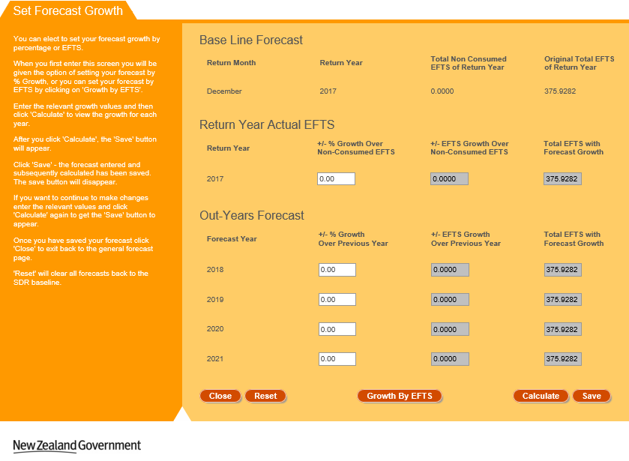
Figure 177 – Set Forecast Growth
The information panel on the left of the page contains instructions for setting the forecast growth.
Clicking on will return you to the EFTS Forecast Update / View page.
Clicking on will return all forecast growth entries to their initial values. The button will be hidden.
Clicking on or will toggle between using EFTS or a percentage value for calculating EFTS growth. The relevant columns (‘+/- % Growth’ or ‘+/- EFTS Growth’) will become editable as you click on the button.
Clicking on will calculate the new forecasted values using your entered inputs. The button will be visible after you click .
Clicking on will save all your changes. If there are no errors, you will be shown a confirmation message:
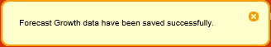
Figure 178 – Set Forecast Growth Save Confirmation Message

EFTS Forecast Upload
You can select a .csv forecast file to import by clicking “Browse” button to add new forecast entries or update the existing values for the Funding Category and Course Class combination. Clicking the “GO” button will initiate the import process, as shown in the following figure:
.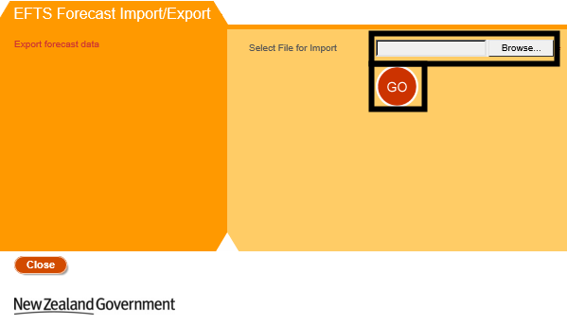
Figure 179 – Importing EFTS Forecast
Please note that you will have to upload a .csv file that is less than 20 megabytes (MB). Further details can be found in Maximum File Size when Uploading.
The uploaded file is subject to the following requirements. Failing any of these requirements will cause the forecast import process to fail, with no new forecast rows being added:
- The file must have the header lines for each column (see Figure 168)
- There must be at least one forecast record in the file
- There must be 33 values in each line. These are:
  - Source of Funding
  - Course Classification
  - Funding Category
  - 12 EFTS Value (One for each month)
  - 12 Out Year EFTS Value (One for each month)
  - 2 Half Out 2-Year EFTS Values
  - 2 Half Out 3-Year EFTS Values
  - 2 Half Out 4-Year EFTS Values
- The Source of Funding values are mandatory and valid
- The Course Classification values are mandatory, and must be numeric and valid
- The Funding Category values are mandatory, and must be numeric, valid, and have length of 2 characters or less
- EFTS forecast value must be positive and numeric
- The Course Classification and Funding Category combination must be valid for the given year
- There must be no duplicate combinations of Course Classification and Funding Category
- Funding Category should be Z if Source of Funding is not 01, 29 or 34
If any of these validations are not passed, processing will not occur, and no new forecast rows are added. You will see an error message as shown in Figure 180 and Figure 181. Some error messages will contain the erroneous line numbers as shown in Figure 181.
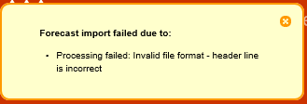
Figure 180 – EFTS Forecast Upload Error Message

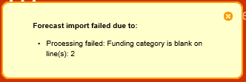
Figure 181 – EFTS Forecast Upload Error Message with Line Numbers

Zero EFTS Forecast
Clicking on from the EFTS Forecast Update / View page in Update mode will set the values on the One Year Out, Two Years Out, Three Years Out, and Four Years Out fields for all EFTS forecast entries to 0.0000.
In addition, this will also set the EFTS Forecast entries for the current year to 0.0000 for forecasted months (ignoring months with actual EFTS data as described in Edit EFTS Forecast Entry). As such, it is possible that the EFTS figure for the Return Year will not be set to 0.0000.
This will change the values of the data as shown in Figure 182 to that as shown in Figure 183:
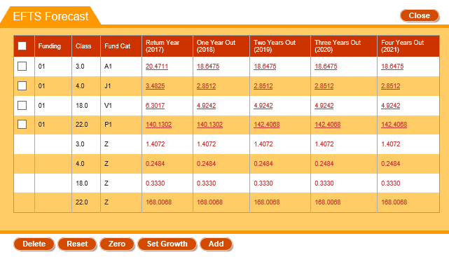
Figure 182 – EFTS Forecast (Original)

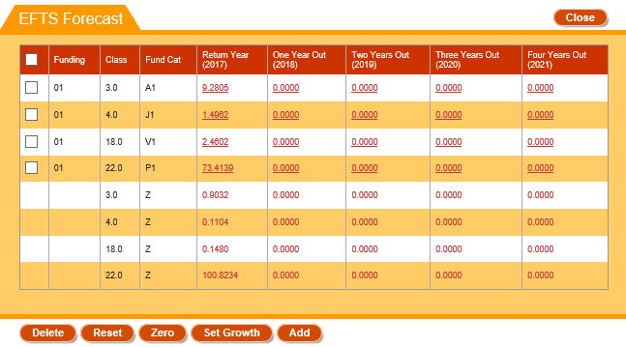
Figure 183 – EFTS Forecast (After Zero)
Please note that the EFTS forecast values for individual months will also be set to 0. The months that will be set to 0 will be the months that are editable as described in Edit EFTS Forecast Entry as shown in Figure 184 and Figure 185:
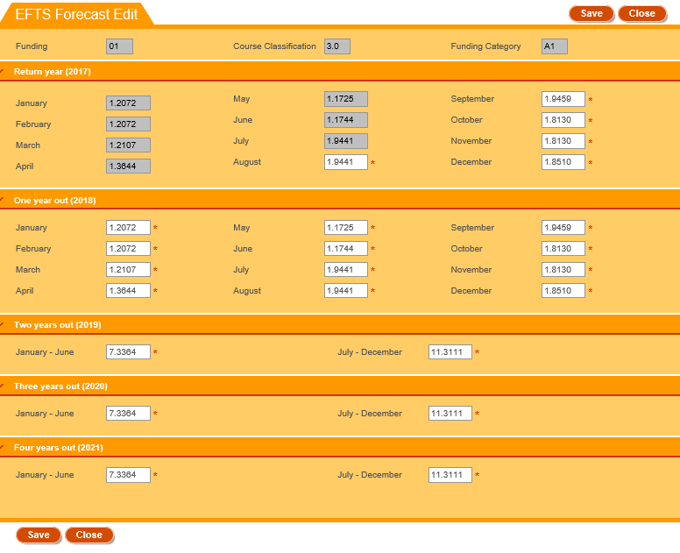
Figure 184 – EFTS Forecast Entry (Original)
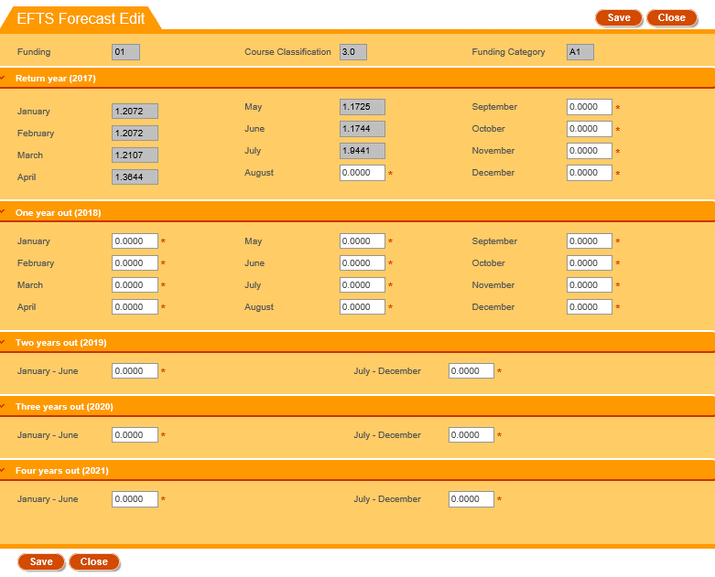
Figure 185 – EFTS Forecast Entry (After Zero)

Course Difference Submit / View
When you process your files, in some instances it is permitted for some differences to exist between the values you have submitted in your Course Register (CREG) file and what has been already approved and held in the TEC Course Register. When this happens it will generate ‘course differences’ that can be seen in the course differences screen. Note that you will only see the course differences link when you have processed an error free SDR Full or a Course Register file.
You can access the Course Difference Submit or Course Difference View page by clicking on the Course Diff Submit or Course Diff View links from the SDR Validation Summary page.
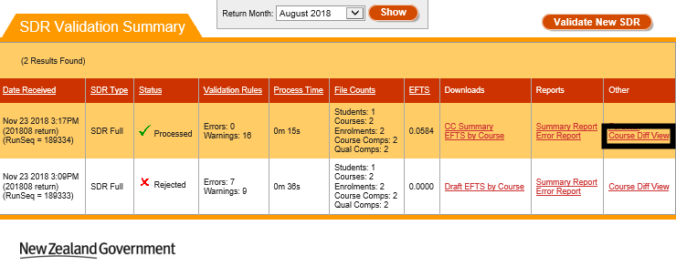
Figure 186 – Accessing Course Difference View

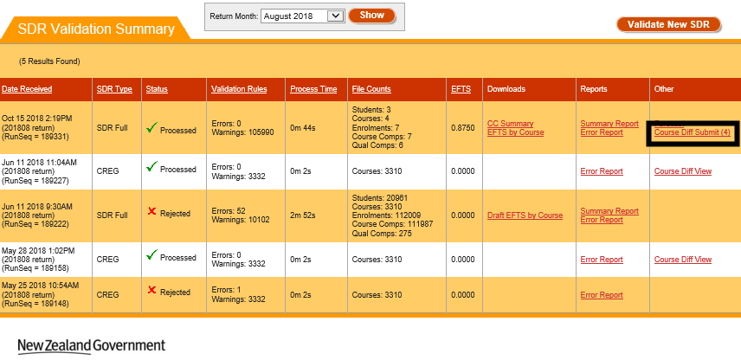
Figure 187 – Accessing Course Difference Submit
If you access the Course Difference View page, you will see the following page:
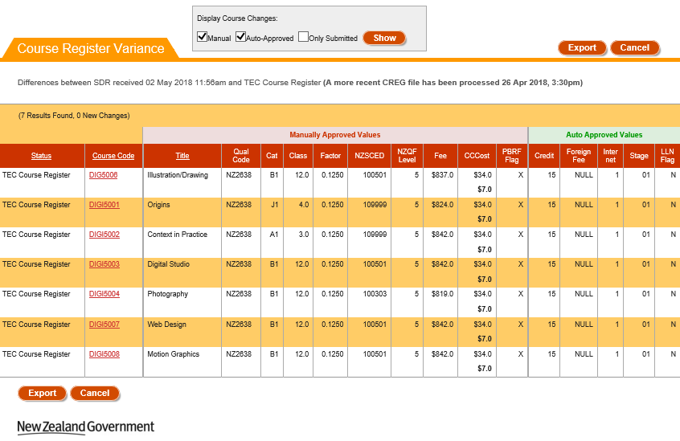
Figure 188 – Course Difference View
You will be shown 25 course differences per page. The values that are displayed in bold are the values that have been changed.
Clicking on the Course Code will take you to the View Course Details page.
You can filter to selectively show Manual, Auto-Approved and Only Submitted course changes by using the checkboxes in the Display Course Changes section and clicking .
Clicking on will return you to the SDR Validation Summary page
You can also export the course differences by using the checkboxes in the Display Course Changes section and clicking . This will generate a .csv file that contains the course differences as shown below:
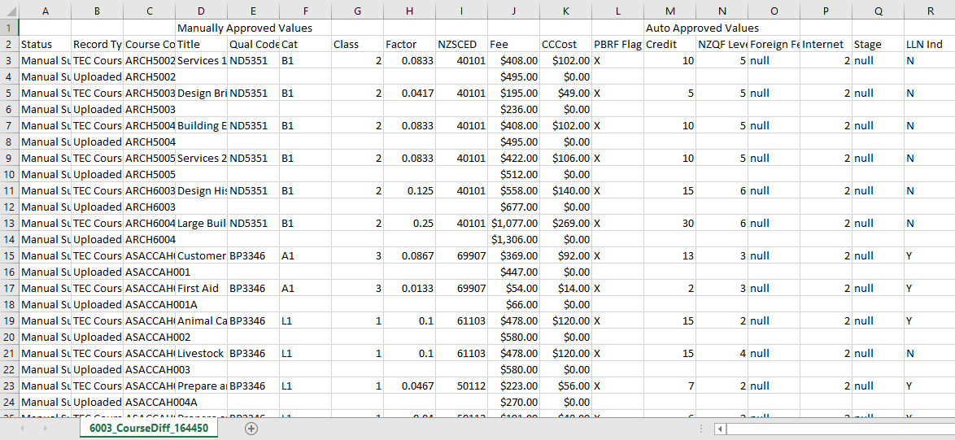
Figure 189 – Course Difference Export
If you access the Course Difference Submit page, you will instead see the following page:
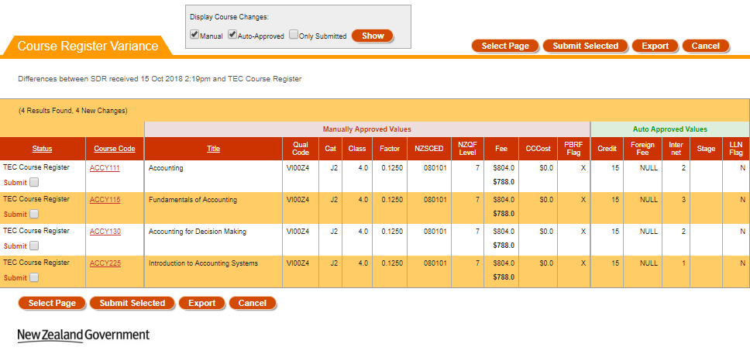
Figure 190 – Course Difference Submit
You will be shown 25 course differences per page. The values that are displayed in bold are the values that have been changed. For a new course (that is processed by CREG file) the TEC Course Register values will be displayed blank.
Clicking on the Course Code will take you to the View Course Details page.
You can filter to selectively show Manual, Auto-Approved and Only Submitted course changes by using the checkboxes in the Display Course Changes section and clicking .
You can also export the course differences by using the checkboxes in the Display Course Changes section and clicking . This will generate a .csv file that contains the course differences as shown in Figure 189.
The button will select all course differences on the current page you are on.
Clicking on the button will submit all the selected course differences as course change requests. You will be able to view these Course Change Requests in the Pending Course CRs (Change Requests) section.
Note: If the changes are available for Auto Approved values, upon clicking the button, those changes will be auto approved to the Course Register and no pending Course Change Requests will be created. The changes to Manually Approved values will go through the normal pending course change request process discussed in Pending Course CRs (Change Requests).
All pending course change requests should be resolved (either approved or rejected for a change by Advisors) before you can proceed with SDR Submission.
Clicking on will return you to the SDR Validation Summary page

Downloads
You can access up to two downloadable files in the Downloads column for every submitted return.
The files you can download are:
- Course Completion Summary
- EFTS by Course
Both files are generated as CSV files and can be viewed as a spreadsheet via MS Excel.

Course Completion Summary
You can access the Course Completion Summary by clicking on the CC Summary link for the particular file return.
Please note that the Course Completion Summary is not available if the return has a status of Rejected.
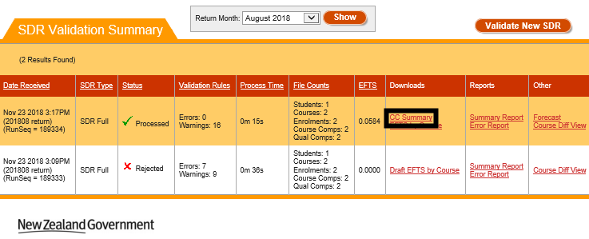
Figure 191 – Accessing Course Completion Summary
You will be prompted to download and open or save the course completion summary spreadsheet. It will be formatted as shown below:
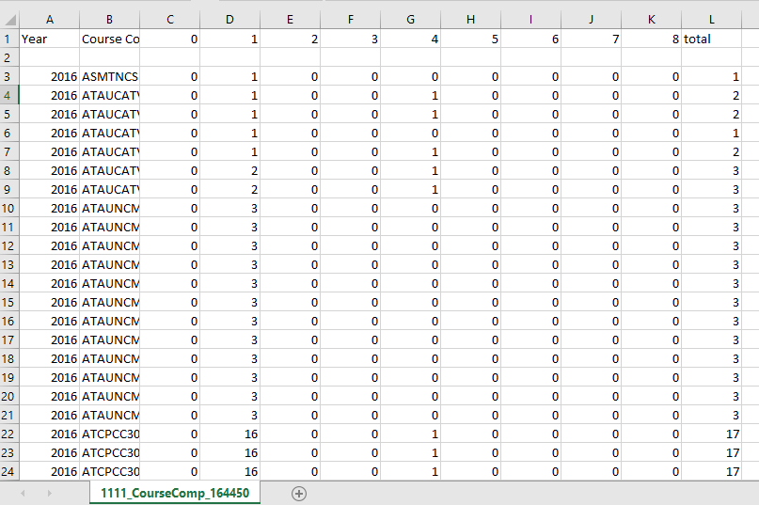
Figure 192 – Course Completion Summary

EFTS by Course
You can access the EFTS by Course file by clicking on the EFTS by Course link for the particular file return.
Please note that the file will be called Draft EFTS by Course if the return has a status of Rejected.
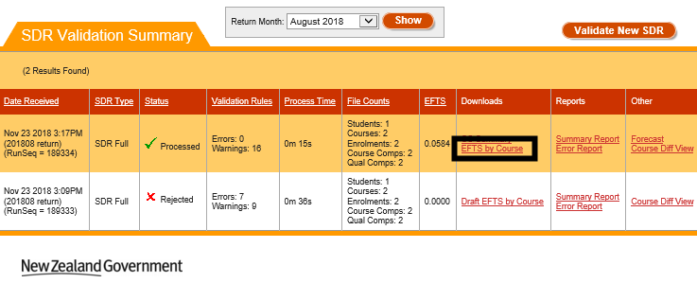
Figure 193 – Accessing EFTS by Course

You will be prompted to download and open or save the EFTS by Course spreadsheet. It will be formatted as shown below:
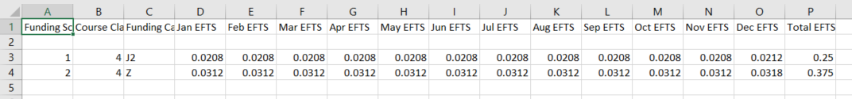
Figure 194 – EFTS by Course

SDR Submission
The last step in the SDR processing is SDR Submission. You will need to submit your SDR data validated successfully by clicking the red Submit SDR Full link in the SDR Validation Summary page.
Figure 195 – Submitting SDR Full
If you’ve arranged for an extension within the current SDR window, you will see the details of the extension as shown below:
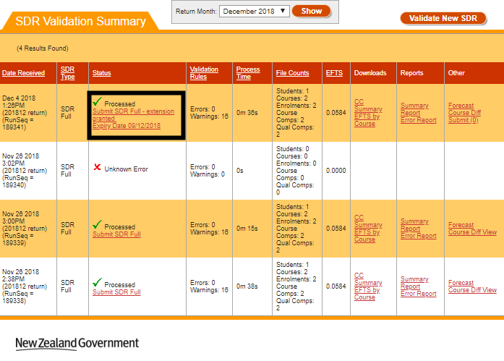
Figure 196 – Submitting SDR Full with Extension
If the extension period has lapsed, you will be unable to submit the SDR, as shown below:
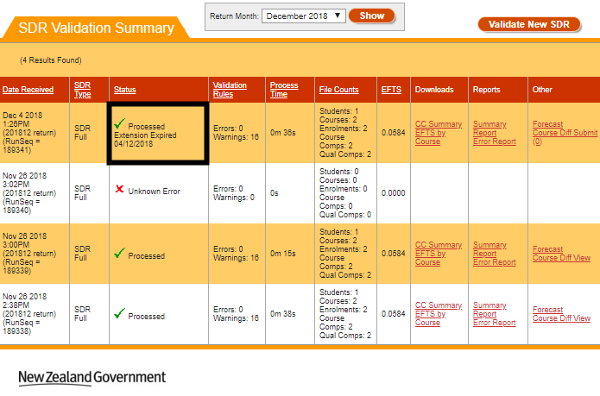
Figure 197 – Extension Expired for Submitting SDR Full
On clicking the Submit SDR Full link, the following prompt will be shown for you to confirm submission:
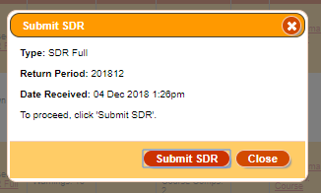
Figure 198 – SDR Submission Confirmation Prompt
Clicking will proceed with the submission process.
Clicking will cancel the submission process and return you to the SDR Validation Summary page.
The STEO site will perform some pre-submission validations before proceeding with the submission process. These are:
- Forecast Validation
- Check if Course Differences Exist
- Check if Course Pending Change Requests Exist
- Check if Workforce Questionnaire Submitted
If any of these pre-submission validations are not passed, the submission process will be stopped. You will be able to address these issues and try again.
Otherwise, if all pre-submission validations are passed, the submission process will proceed, as shown below:
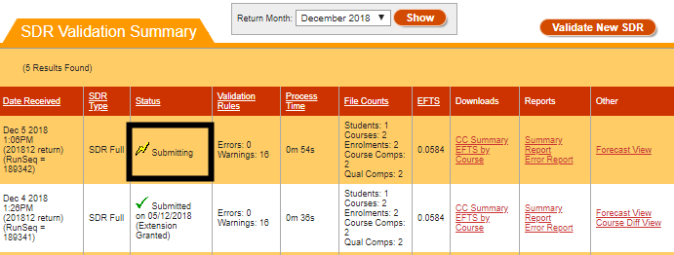
Figure 199 – SDR Full Submission
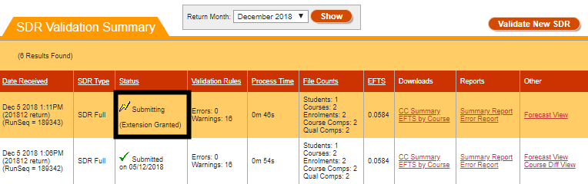
Figure 200 – SDR Full Submission with Extension Granted
If the submission process has completed successfully, the Status will be updated to say Submitted, as shown below:
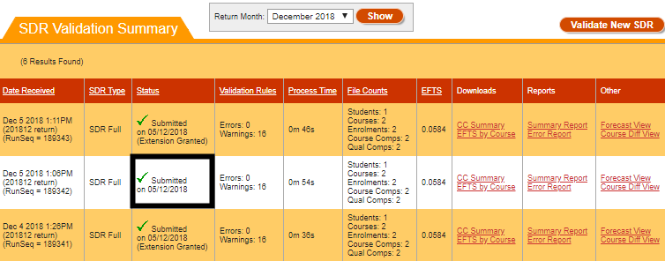
Figure 201 – SDR Full Submitted

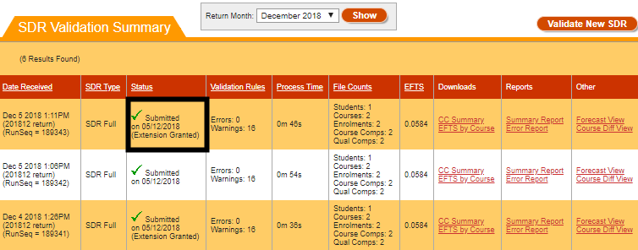
Figure 202 – SDR Full Submitted with Extension Granted
Sometimes the SDR process will pass the pre-submission validations but may rarely encounter some other issues. In this scenario, SDR submission will fail and the Status field will read Failed to Submit, as shown in Figure 203 and Figure 204 below.
Please contact the MoE or TEC helpdesk (details are located at Education Service Desk and TEC Sector Help Desk) for assistance with investigating and resolving this issue.
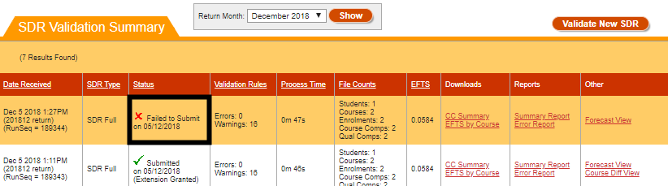
Figure 203 – SDR Full Failed to Submit

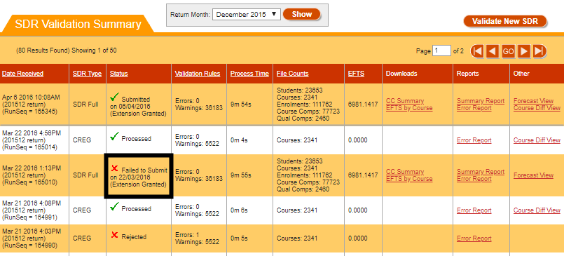
Figure 204 – SDR Full Failed to Submit with Extension Granted

Forecast Validation
The forecast validation checks that funding category and course classification combinations in Forecast data for a given SDR (created during SDR Validation) are valid for the Year of SDR return and the following year.
If this validation does not pass, you will see the following error message with the invalid Funding Category/Course Class combinations listed:
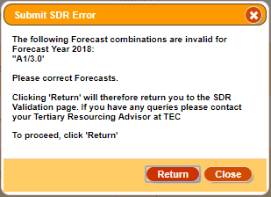
Figure 205 – Forecast Validation Failed Error Message
Clicking on will take you back to the SDR Validation Summary page.

Check if Course Differences Exist
The course difference checks validate that there are no differences between the submitted course register (CREG) file and the existing Course Register. This check does not apply if you are only submitting a single Qualification Completion or a single Course Completion file.
If this validation does not pass, you will see the following error message:
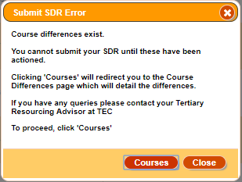
Figure 206 – Course Difference Check Failed Error Message
Clicking on will take you to the Course Difference Submit / View page.

Check if Course Pending Change Requests Exist
The Course Pending Change Request Check validates that there are no current pending course change requests for your organisation. This check does not apply if you are only submitting a single Qualification Completion or a single Course Completion file.
If this validation does not pass because there are pending change requests that would result (or have resulted) from the processing of your SDR files, the following error message is shown:
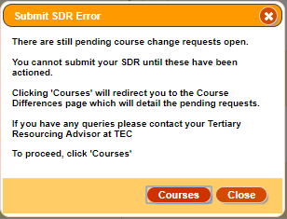
Figure 207 – Course Pending Change Request Check Failed from Current SDR
Clicking on will take you to the Course Difference Submit / View page.
If this validation does not pass because there are pending change requests from using the Edit Course Details functionality, you will instead see the following error message:
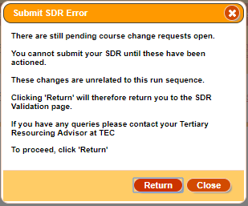
Figure 208 – Course Pending Change Request Check Failed from Edit Courses
Clicking on will take you back to the SDR Validation Summary page.

Check if Workforce Questionnaire Submitted
The Workforce Questionnaire check ensures that you have submitted a Workforce Questionnaire (WFQ) for the current year prior to submitting the SDR return. Currently December SDR is the set SDR Round for checking that a WFQ has been submitted. This check does not apply if you are only submitting a single Qualification Completion or a single Course Completion file.
You can find out more about WFQs in the Workforce Questionnaires (WFQ) section.
If a WFQ has not been submitted for the year you are trying to perform the SDR Submission, you will see the following error message:
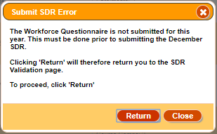
Figure 209 – Workforce Questionnaire Check Failed
Clicking on will take you back to the SDR Validation Summary page.

IND (SDR) Data Collection
The Indicative (SDR) Data Collection (IND) is a set of three SDR data files that are specifically required by the Ministry of Education to give early indicators of demand shifts and trends that may impact vote management and affect future policy developments. This indicative SDR is low compliance as it has fewer validations than a full (five file) SDR.
The purpose of the IND is to provide early information on tertiary demand to inform policy development or changes, and allow responsiveness to sudden changes in economic conditions. The collection shows trends over time – establishing statistical models that facilitate prediction of full-year outcomes
The latest copy of the IND User Guide can be found here at http://services.education.govt.nz/steo/sdr/indicative-data-collection-ind/.
The IND Data Collection tab allows you to access the following pages and functionalities:
- IND Validation Summary
- Validate New IND
- Validation Error Report
You can navigate to this section by clicking on SDR, then IND Data Collection in the main menu.
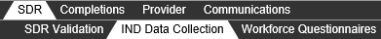
Figure 210 – Accessing IND Data Collection

IND Validation Summary
The IND Validation Summary is the default page when you navigate to the IND Data Collection tab.
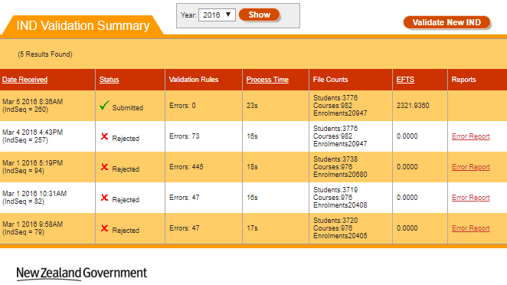
Figure 211 – IND Validation Summary
You can sort the results by clicking on the column header titles as previously described in the Sorting Search Results section. The Year is defaulted to the current calendar year.
You can view IND submissions from other years by selecting a different year from the Year dropdown.

Validate New IND
You can access the Validate New IND page by clicking on the Validate New IND link, as shown below:
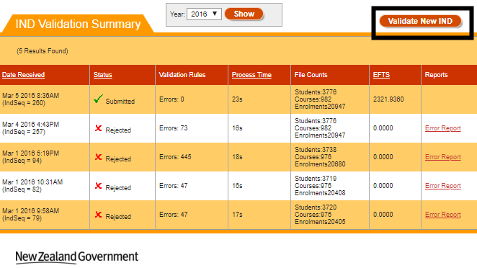
Figure 212 – Accessing Validate New IND
The IND Validation process is a multi-step process, with the following steps:
- Select Return Year and Notification Contacts
- Upload IND ZIP File
- Confirmation

Select Return Year and Notification Contacts
The first page of the IND Validation step is shown below:

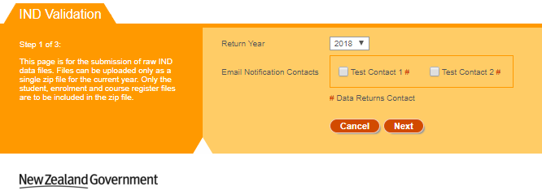
Figure 214 – Step 1 of IND Validation
The Return Year will default to the current year.
You may optionally select one or more contacts to specify who receives email notifications about the processing progress. The contacts are populated from the list of contacts in your organisation in the Contacts List who are not EDUMIS contacts.
Contacts marked with a red hash symbol (#) are contacts that have the Contact Role “Data returns” assigned to them, as shown below:
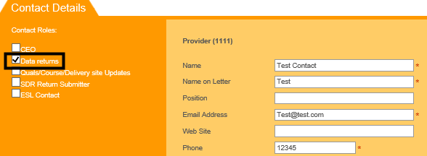
Figure 213 – Data Return Contacts
Clicking on will take you to the Upload IND ZIP File step of the Validate New IND process.
Clicking on will take you to the default page as per Figure 214.

Upload IND ZIP File
The second page of the IND Validation step is shown below:
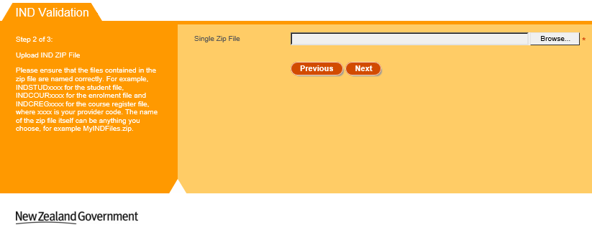
Figure 214 – Step 2 of IND Validation
Click Browse and select the relevant .zip file to upload. The student file, enrolment file and course register file are expected to be uploaded in a single .zip file. Please ensure that the files in the .zip file are named correctly, e.g. for the provider code 1111 the following files are expected:
- INDSTUD1111.txt
- INDCOUR1111.txt
- INDCREG1111.txt
Please note that if the compressed zip file is larger than 20 megabytes (MB), you will not be able to process the IND Data collection. Further details can be found in Maximum File Size when Uploading.
Clicking on will take you to the Confirmation step of the Validate New IND Process.
Clicking on will take you to the Select Return Year and Notification Contacts step of the Validate New IND Process.

Confirmation
The third and final page of the IND Validation step is shown below:

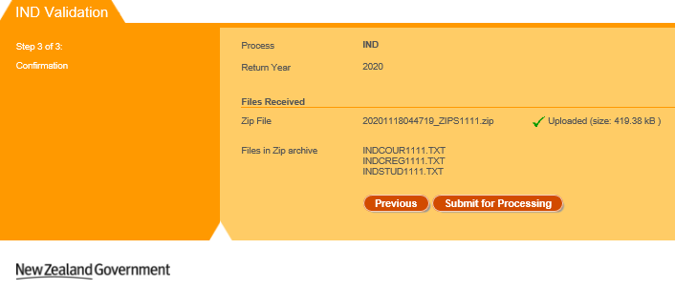
Figure 215 – Step 3 of IND Validation
This page displays a brief summary of the uploaded files and the return year.
Clicking on will add the uploaded IND data files to the queue for processing. See IND Submission and Results for more information.
Clicking on will take you to the Upload IND ZIP File step of the Validate New IND Process.

IND Submission and Results
After you click in the final step of the IND Validation process (Confirmation), the uploaded files will be added to the queue for processing, as shown below:
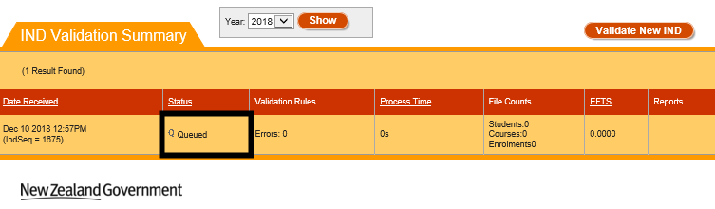
Figure 216 – IND Processing Queue
Once the IND Processing has begun, the status will switch to “In Progress” as shown below:

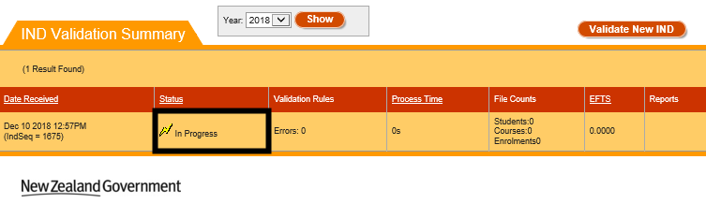
Figure 217 – IND Processing In Progress
You may click the button to refresh the page. When the processing of the IND Validation has been completed, the results of validation will be shown in the Status field.
The status will read “Submitted” as per Figure 218 if the IND Validation is successfully processed with no errors
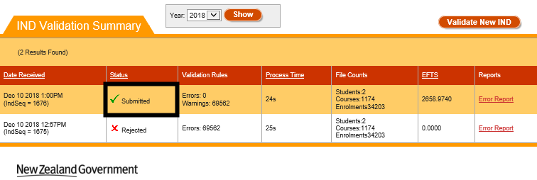
Figure 218 – IND Data Submitted Successfully
If the files were processed, but errors were present during validation, the status will read Rejected (as per Figure 219.
Clicking on the link Error Report will take you to the Validation Error Report.

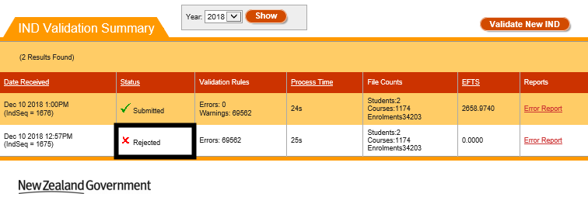
Figure 219 – IND Files Rejected

Validation Error Report
If your IND files were rejected, you can access detailed information about the errors that need to be fixed by clicking on the Error Report link in the IND Validation Summary page:
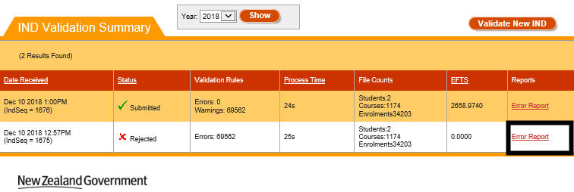
Figure 220 – Accessing IND Validation Error Report

The following page will be shown when you access the IND Validation Error Report:
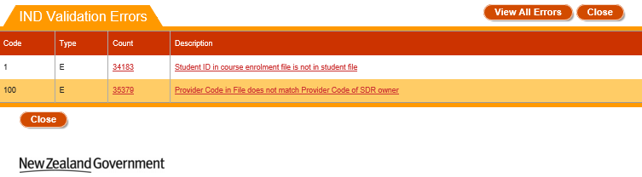
Figure 221 – IND Validation Error Report
If you click View All Errors, you be shown a detailed view of all the errors that occurred during processing in the View All Errors page.

To view details of a particular error, click on the Description of the error or the Count to access the Validation Error Details page.
Clicking on will return you to the Validation Error Report page.

View All Errors
The View All Errors page shows all errors that have occurred while processing the files. You can access it by clicking View All Errors while you are on the Validation Error Report page:
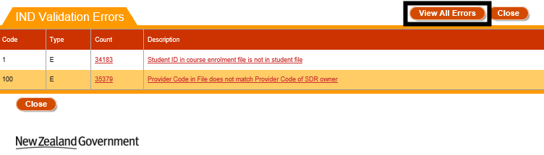
Figure 222 – Accessing View All Errors
The following page will be shown:
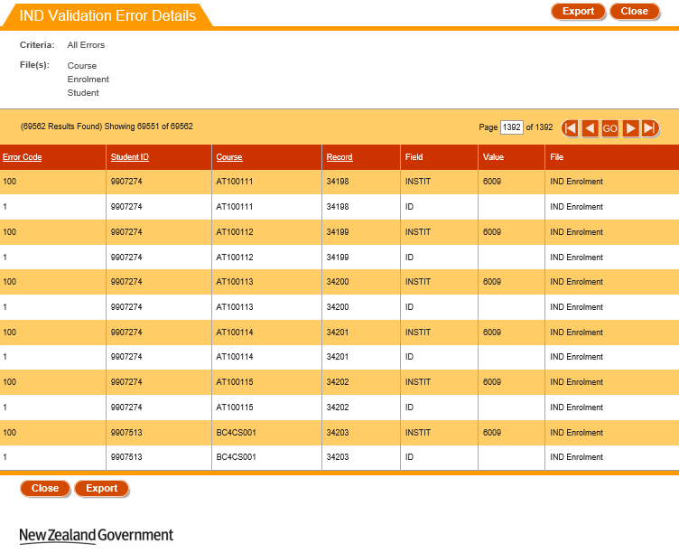
Figure 223 – IND Validation View All Errors

You can sort the results by clicking on the column header titles as previously described in the Sorting Search Results section.
Clicking on will generate a .csv file that contains all the errors, as shown in Figure 224.
Clicking on will return you to the Validation Error Report page.
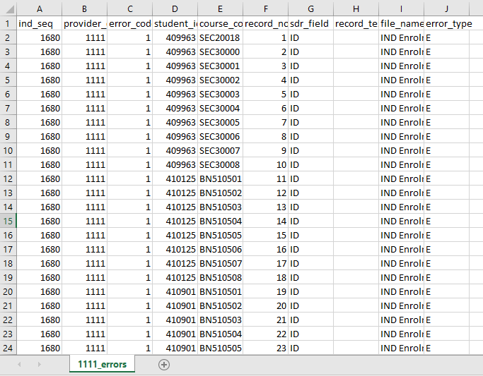
Figure 224 – IND Validation Error Export

Validation Error Details
The Validation Error Details page shows all instances of a particular error that have occurred while processing the file.
You can access this page by clicking on the Count or Description link for a given error in the Validation Error Report:
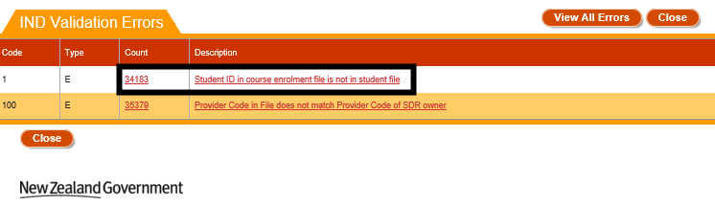
Figure 225 – Accessing IND Validation Error Details
The following page will be shown:
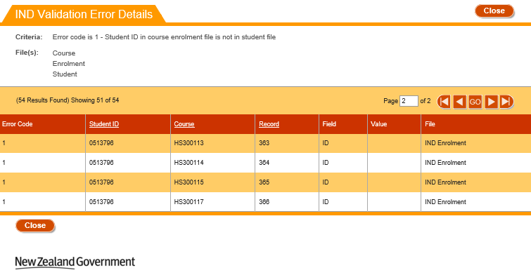
Figure 226 – IND Validation Error Details
You can sort the results by clicking on the column header titles as previously described in the Sorting Search Results section.
Clicking on will return you to the Validation Error Report page.

Workforce Questionnaires (WFQ)
The Workforce Questionnaire collects data on staff employed in tertiary education providers that complete an SDR. The Workforce Questionnaire now captures workforce data for the complete year and must be returned to the Ministry prior to Submission of the December SDRs (current arrangement as discussed in SDR Submission) using the SDR system.
For TEIs, staffing usage will be required for numbers of staff and full-time equivalents by designation, ethnicity, age group and gender.
For PTEs, staffing usage (numbers of staff and full-time equivalents) will be required for teaching, executive and support staff by ethnicity, age group and gender.
The Workforce Questionnaires (WFQ) tab allows you to access details for previously uploaded WFQs, download the WFQ template, and upload new WFQs.
The Workforce Questionnaires tab allows you to access the following pages:
- WFQ History
- WFQ Upload
- Download WFQ Template
- View WFQ Details
- WFQ Error Report
You can navigate to this section by clicking on SDR, then Workforce Questionnaires in the main menu.
Figure 227 – Accessing Workforce Questionnaires

WFQ History
The WFQ History is the default page that is shown when you navigate to the workforce questionnaires tab.
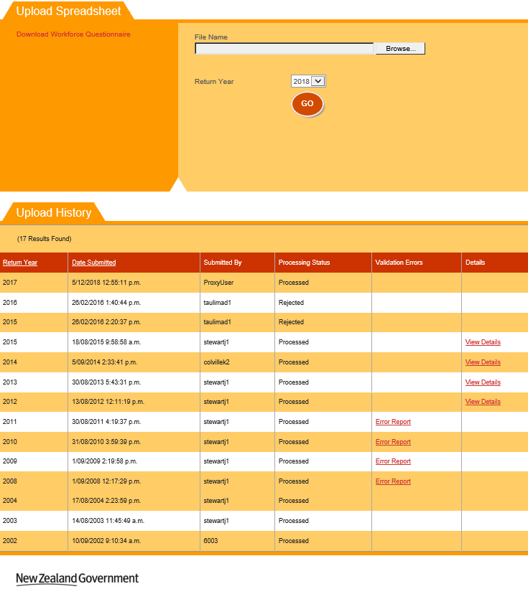
Figure 228 – WFQ History Page
Return Year selection is defaulted to the current calendar year.
You can view all previously uploaded WFQs in the Upload History section. Only one WFQ Return per year (the latest uploaded) is preserved for your organisation by the system. Remembering that from 2016 the templates are for a complete year of data (not a snapshot).
If you click on , select a file and click , you will perform a WFQ Upload.
Clicking on the Download Workforce Questionnaire link will Download WFQ Template that you can use. There are a few templates supported by the system each designed for a specific TEO type.
Clicking on View Details of a previously uploaded WFQ will allow you to View WFQ Details.
Please note that WFQ Details are available for Returns submitted since year 2012 when the current WFQ templates were introduced.

WFQ Upload
The Upload Spreadsheet section of the page allows you to upload a new WFQ file. It is accessible when you navigate the Workforce Questionnaires tab.
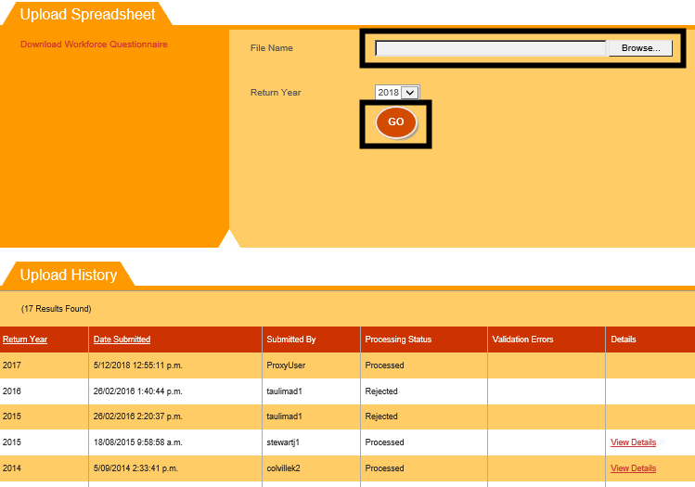
Figure 229 – Using the WFQ Upload Functionality
Clicking on Browse will allow you to select a completed workforce questionnaire on your computer.
After you select a file and the return year that it is for, click the button to perform the upload. Please note that the uploaded file size must not exceed 20 megabytes (MB). Further details can be found in Maximum File Size when Uploading.
Please ensure that the uploaded WFQ file is of the file type .xls (newer Microsoft Excel formats like .xlsx will not be accepted). If you upload a file that is not of the type .xls, the following error as shown in Figure 230 will be displayed and the WFQ processing will not proceed.
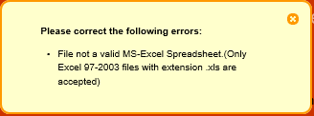
Figure 230 – WFQ Upload Incorrect File Type Error Message
If the file being uploaded does not match the expected template format, you will be shown the following error message:
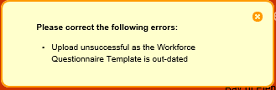
Figure 231 – WFQ Upload Incorrect Template Error Message
You may also be shown the following error message if you upload a template for a provider type that does not match your organisation type:
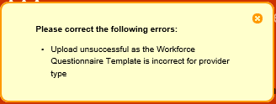
Figure 232 – WFQ Upload Invalid Provider Type Template
If your file upload was successfully uploaded, you will see a success message as shown below:
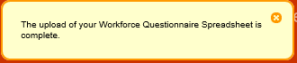
Figure 233 – WFQ Successfully Uploaded
If the file was successfully uploaded and processed without errors, the View Details link will be visible. Clicking on it will take you to the View WFQ Details page.
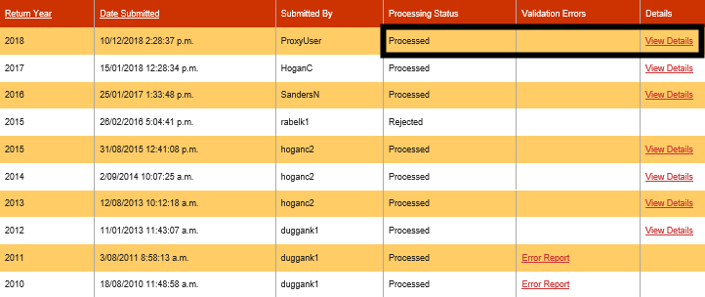
Figure 234 – WFQ Uploaded and Processed without Errors
If your upload was not successful (e.g. with invalid data or template does not match expected new format or invalid provider type), and your WFQ upload could not be processed, it will be shown as Rejected and Error Report link will be displayed if any data validation errors were found. Clicking on it will take you to the WFQ Error Report page
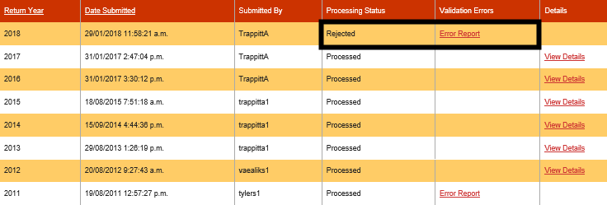
Figure 235 – WFQ Uploaded and Rejected with Errors
Note: Rejected WFQ is displayed only if the latest uploaded one is Rejected for the given year. If any successful WFQ upload is done after, then only the latest Processed will be displayed for the year.
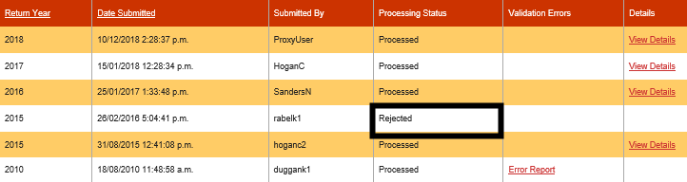
Figure 236 – WFQ Upload Rejected
For any historical WFQ processed prior to 2012, no View Details link will be visible. If there are any errors, you can view them by clicking the Error Report link that will take you to the WFQ Error Report page.
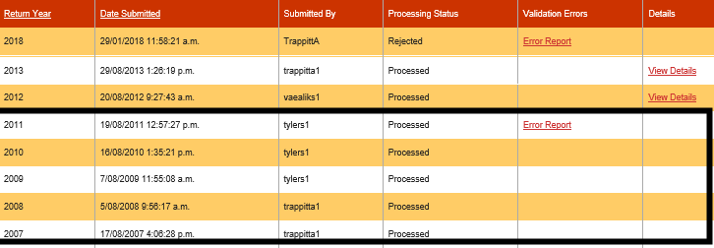
Figure 237 – Historical WFQ Uploaded and Processed with Errors

Download WFQ Template
You can download a WFQ template by clicking on the Download Workforce Questionnaire link.
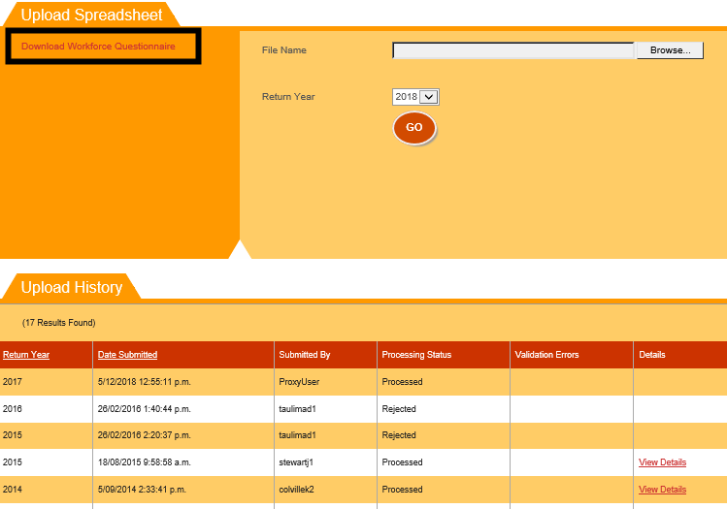
Figure 238 – Downloading the Workforce Questionnaire Template
Clicking it will prompt you to save the Excel (.xls) file to your local computer. The template will be different depending on your organisation type (e.g. polytechnic, university, PTE and so on).
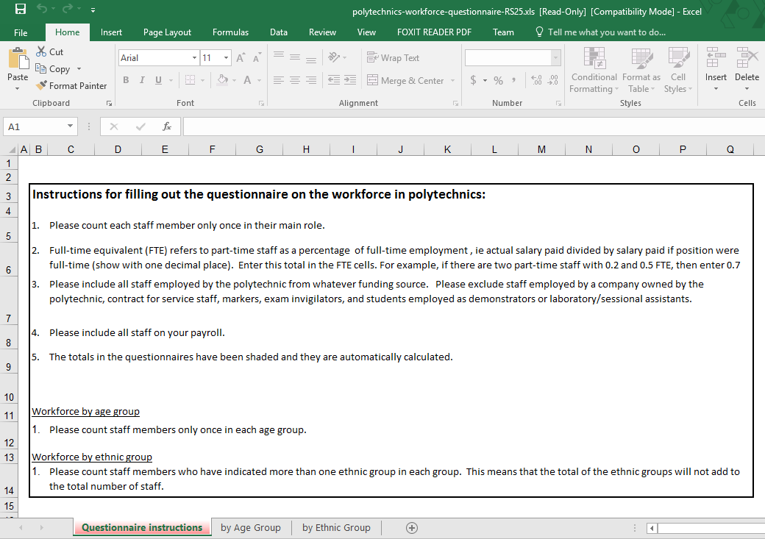
Figure 239 – Workforce Questionnaire Template
The example shown above is a template for polytechnic organisations.

View WFQ Details
Clicking on the View Details link in the WFQ History section allows you to inspect the details of a recently uploaded WFQ that was successfully processed.
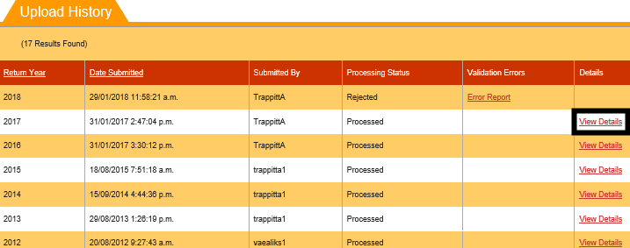
Figure 240 – Accessing WFQ Details
You will be shown the following page when you access the WFQ Details:
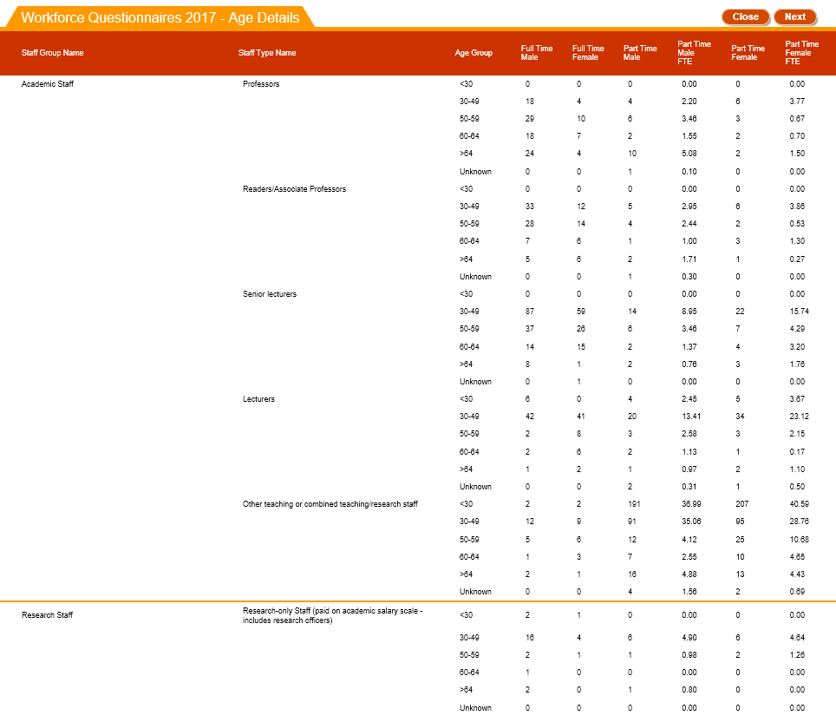
Figure 241 – WFQ Details

The WFQ Details page has four pages – Age Details, Ethnicity Details, Subsidiary by Age and Subsidiary by Ethnicity. Clicking on or allows you to navigate between these pages.
Clicking on will return you to the WFQ History page.

WFQ Error Report
If your WFQ Upload was processed with errors, you will be able to access the error report. You can do so by clicking on the Error Report link.
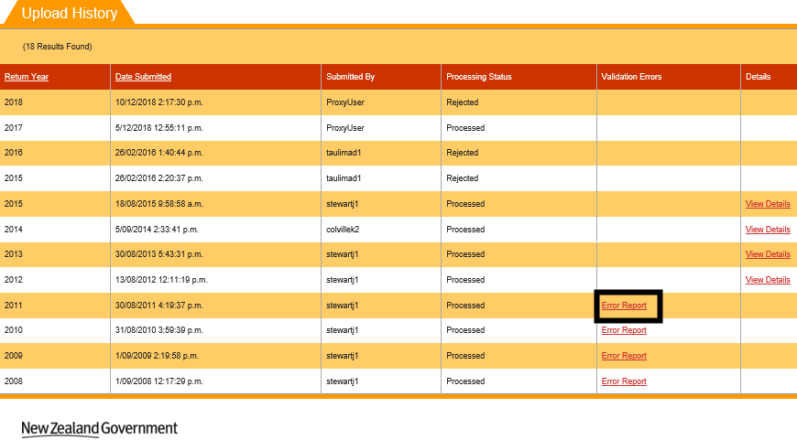
Figure 242 – Accessing WFQ Error Report
The WFQ Error Report will be shown as per the figure below:
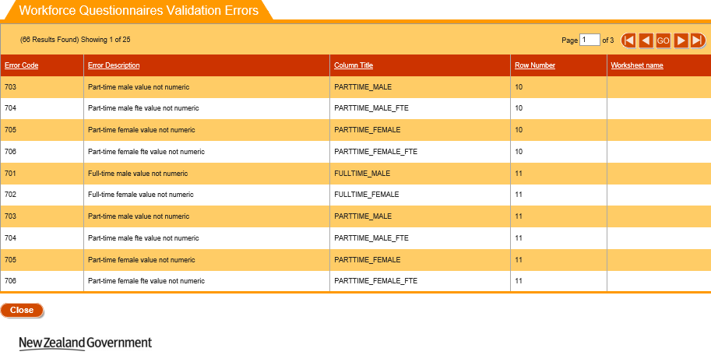
Figure 243 – WFQ Error Report
You can click on any of the column headers to resort them, as described in Sorting Search Results.
If there is more than one page of errors, you can navigate through them as described in Navigating through Result Pages.
Clicking on will return you to the WFQ History page.

Course Completion Summary
The course completion summary tab allows you to access details on the course completion for courses offered by your organisation.
You can access it by clicking on Completions (you will automatically be navigated to Course):
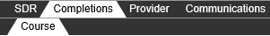
Figure 244 – Accessing Course Completion
The Course Completion Summary Search page is the default page when navigating to the Course Completions tab.
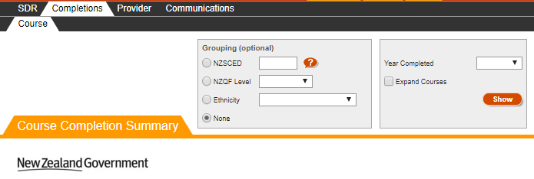
Figure 245 – Course Completion Summary Search
The Course Completion Summary Search page is blank the first time it is accessed when logging in. After that, it will retain the search criteria of the last performed search when you return to the page.
You can search for all existing course completions against your organisation by optionally entering search criteria into any of the fields shown in the search box and clicking . The NZSCED field allows you to look up existing entries by clicking on the button. This will direct you to the relevant lookup as described in the Lookup Windows section.

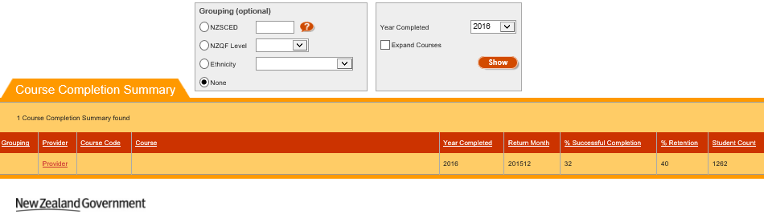
Figure 246 – Course Completion Summary Search Results

The search results based on the criteria entered will be shown as per Figure 246 and Figure 247, with 50 course completions shown per page.
You can sort the results by clicking on the column header titles as previously described in the Sorting Search Results section.
If there is more than one page of courses, you can browse through the other pages using the navigation buttons as described in Navigating through Result Pages.
You may expand the courses to show a more detailed version of this by clicking on the Expand Courses checkbox and repeating the search, as indicated in Figure 247:
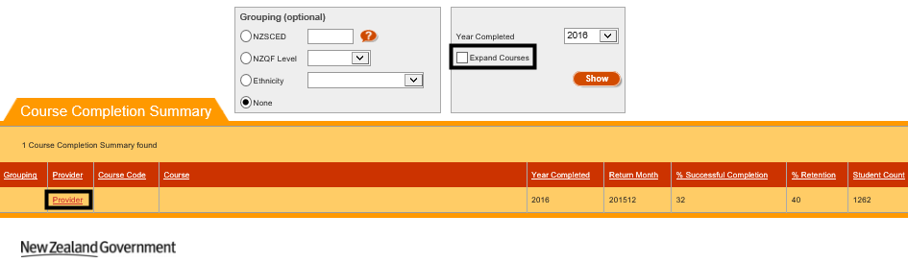
Figure 247 – Expanding Courses in Course Completion Summary
This will show a more detailed view of the course completions, with the course codes and names displayed:
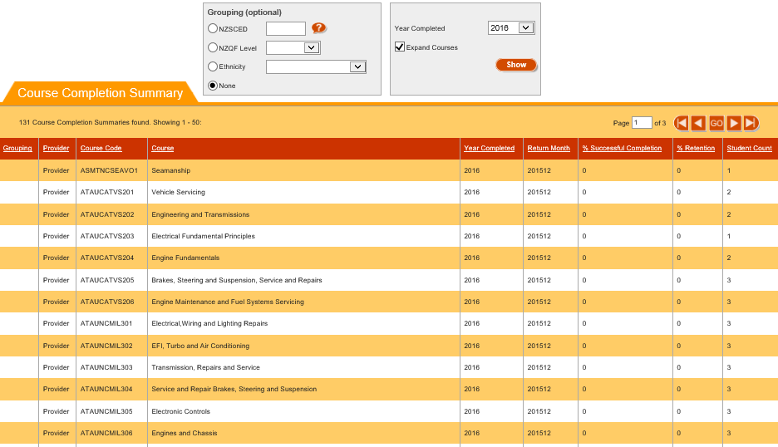
Figure 248 – Expanded Course Completion Summary

Communications
The communications tab is used by the Agency to provide files to your organisation that you can download. You can access it by clicking on Communications (File Downloads will be automatically accessed).
Figure 249 – Accessing Communications Tab

File Downloads
The File Downloads page is the default page that is shown when you navigate to the communications tab:
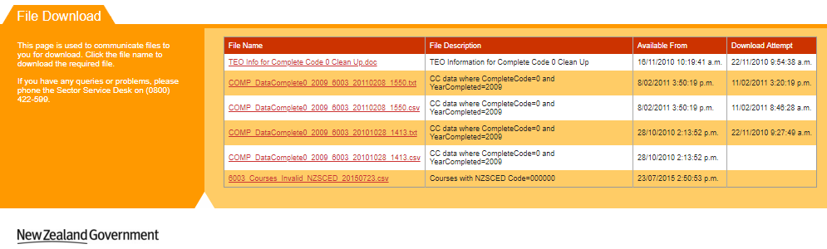
Figure 250 – File Downloads Page
To download a file, you just need to left-click on one of the file links, as indicated below:
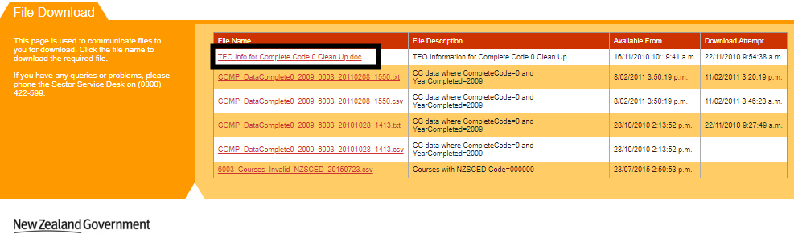
Figure 251 – Downloading a File
You will be prompted to download and open or save the requested file.

Non SDR Provider
If you are a Non SDR Provider that are signatories to the Code of Practice (that is have international students) you must return a Unfunded International Provider (UIP) data return (see the relevant section of the https://services.education.govt.nz website ) . If you are a Non SDR Provider and do not have international students, you will have to perform the RS20 statistical return through a different set of pages as shown below:
Figure 252 – Non SDR Provider Main Menu
Non SDR providers will have access to the RS20 main menu tab.

RS20
The RS20 is a census collected annually containing data on the students and staff at private training establishments. If your organisation is not one that returns a Single Data Return, you will be required to complete a RS20 statistical return.
You can navigate to the RS20 section by clicking on RS20 from the Main Menu:
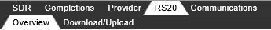
Figure 253 – Accessing RS20
You will be automatically directed to the overview page:
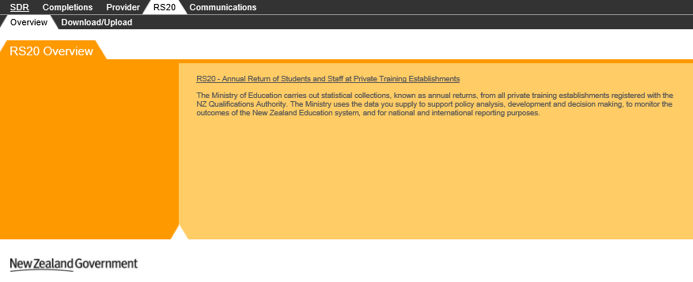Figure 254 – RS20 Overview
You can access the RS20 functionality by clicking the Download/Upload tab:
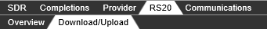
Figure 255 – Accessing RS20 Download/Upload

RS20 History
The RS20 Download/Upload tab is shown below, with the Return Year defaulted to the current year:
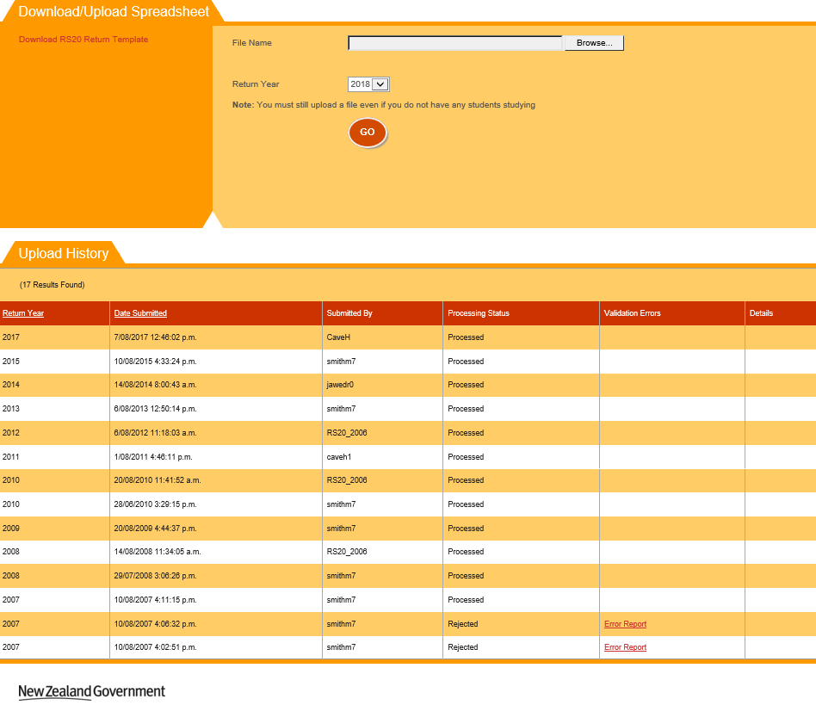
Figure 256 – RS20 Download/Upload Page
You can view all previously uploaded RS20 Returns in the Upload History section.
If you click on , select a file and click , you will perform a RS20 Upload.
Clicking on Download RS20 Return Template will Download RS20 Template that you can use.

RS20 Upload
The Download/Upload Spreadsheet section of the page allows you to upload new RS20 returns. It is accessible when you navigate to the Download/Upload tab.
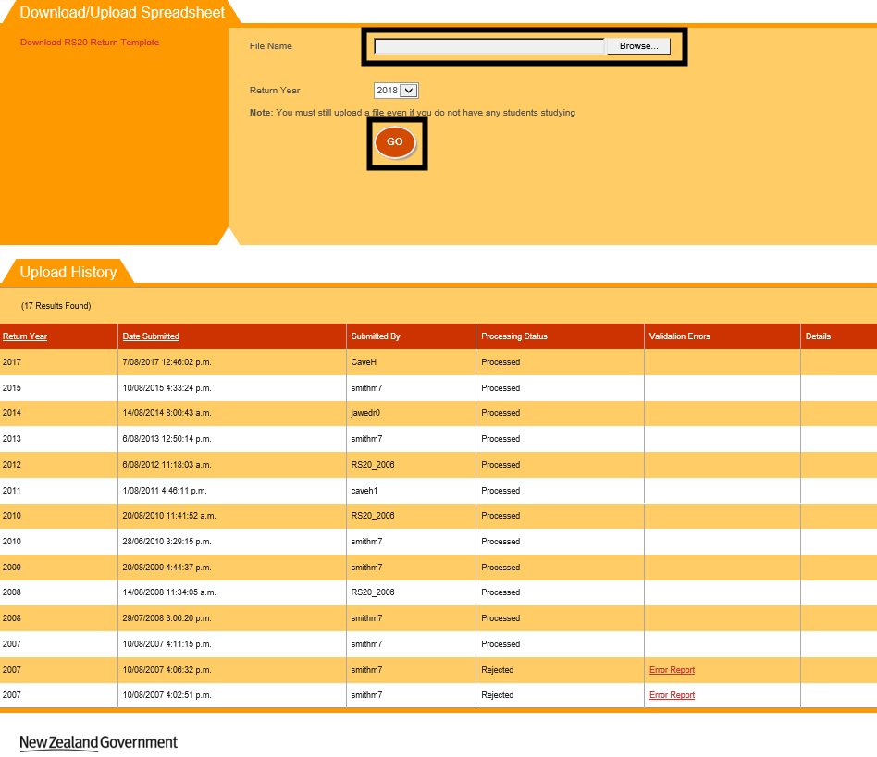
Figure 257 – Using the RS20 Upload Functionality
Clicking on Browse will allow you to select a completed RS20 return on your computer. Please ensure that the uploaded RS20 return file is of the file type .xls (newer Microsoft Excel formats like .xlsx will not be accepted). If you upload an invalid file type (not .xls file), you will see the error message as shown in Figure 258:
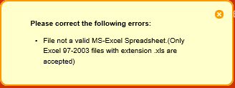
Figure 258 – RS20 File Not Valid Excel Spreadsheet Error Message
Please note that the uploaded file must be less than 20 megabytes (MB). You may refer to Maximum File Size when Uploading for more information.
After you select a file and the return year that it is for, click the button to perform the upload.
If the file being uploaded is incorrect, you will be shown the following error message:
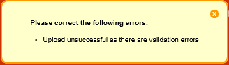
Figure 259 – RS20 File Invalid Error Message
If your file was successfully uploaded, you will see a success message as shown below:
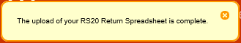
Figure 260 – RS20 File Successfully Uploaded

Download RS20 Template
You can download a RS20 template by clicking on the Download RS20 Return Template link.
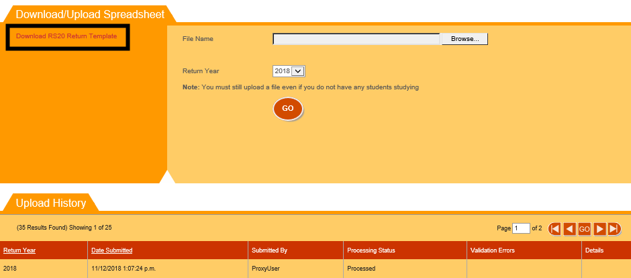
Figure 261 – Accessing the RS20 Return Template
Clicking it will prompt you to save the Excel (.xls) file to your local computer. The Return Template is shown below:
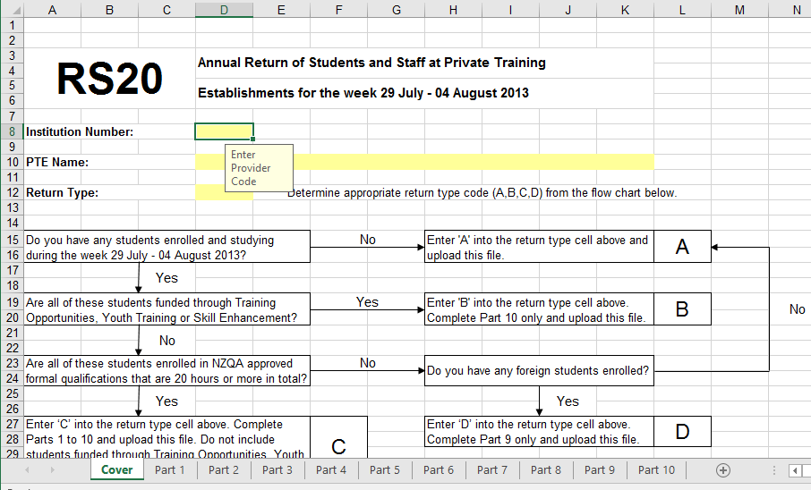
Figure 262 – RS20 Return Template

RS20 Error Report
If your RS20 Return was processed with errors, you will be able to access the error report. You can do so by clicking on the Error Report link.
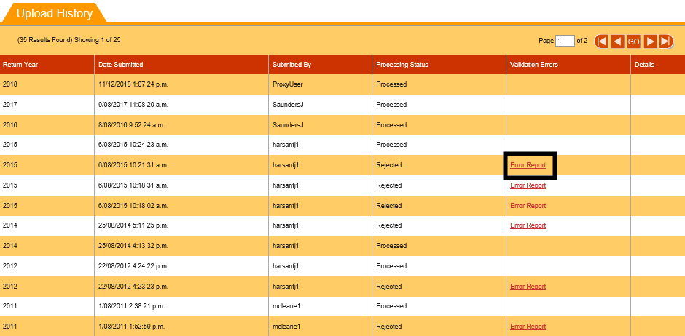
Figure 263 – Accessing RS20 Error Report
The RS20 Error Report will be shown as per the figure below:
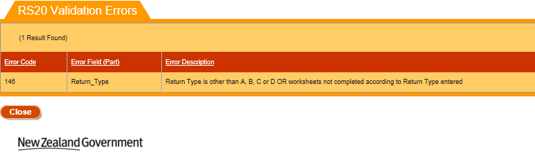
Figure 264 – RS20 Validation Errors

You can click on any of the column headers to resort them, as described in Sorting Search Results.
If there is more than one page of errors, you can navigate through them as described in Navigating through Result Pages.
Clicking on will return you to the RS20 History page.

